Class discussion: Cardinality
revised

14 November 2017

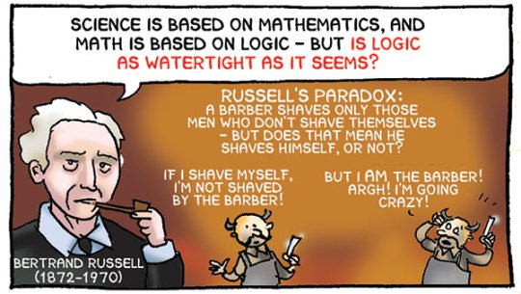

I What does it mean to say that two sets have the same cardinality? What does it mean to say that a set is countably infinite?
II Show that each of the following sets is countable:
- The set of non-negative integers.
(b) The set of integers greater than or equal to 13.
(c) Z
(d) The set of positive even integers.
(e) The set of even integers.
(f) The set of odd integers.
(g) The set of rational numbers strictly between 0 and 1.
III (a) Show that a subset of a countable set is either finite or countable.
(b) Show that if A and B are disjoint countable sets then so is the union of A and B. What if A and B are not disjoint?
(c) Show that if A and B are countable sets then so is the Cartesian product of A and B.
(d) Prove that a countable union of countable sets is countably infinite.
(e) Prove that the set of rational numbers strictly between 0 and 1 is uncountable.
(f) Demonstrate that Q is countable.
IV Show that if S is a collection of sets, then cardinality is an equivalence relation on S.
V Using Cantor’s diagonal argument, prove that R is not countable.
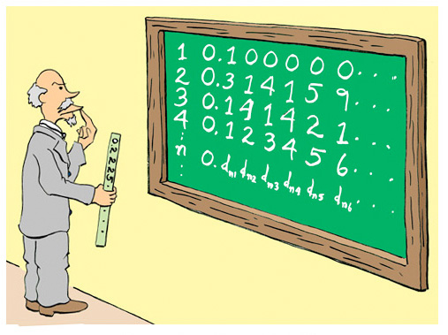
VI (a) Let X be a set. Recall the definition of the power set, P (X), of X.
- Show that the power set of a finite set is finite. In such case, describe the relationship between |X| and | P (X)|.
- Let X = {a, b, c, d} and let F: X → P (X) be defined by:
F(a) = {a, c, d}, F(b) = {a, d}, F(c) = φ, F(d) = {d}
Find D* = $\left\{j∈X| j∉F(j)\right\}$
- Let X = Z⁺ and let G: X → P(X) be defined by:
G(a) = {all prime numbers, p, such that a ≤ p ≤ 2a}
Find D* = $\left\{j∈X| j∉G(j)\right\}$
- Let X = Q and let H: X → P (X) be defined by:
$H\left(z\right)=$ {all prime numbers, p, such that z ≤ p ≤ 2z}
Find D* = $\left\{q∈X| q∉H(q)\right\}$
- Let X = R and let V: X → P (X) be defined by:
$V(a)=\left\{\begin{aligned}\left\{0\right\} if a≤0 \\ \left(a, a+1\right) if a∈Q^{+}\sim Z \\ \left[a-1, a\right] if a is a positive irrational number \\ \left\{a, a+3\right\} if a∈Z^{+} \end{aligned}\right.$
Is V well-defined? If so, find D* = $\left\{z∈X| z∉V(z)\right\}$

- Prove Cantor’s Theorem: X and P(X) are not of the same cardinality.

Highly recommended:
MIT lecture notes on cardinality, 24.118 (paradox and infinity)
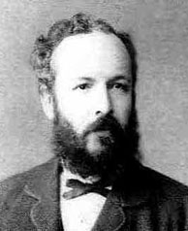
Georg Ferdinand Ludwig Cantor (1845 – 1918) is best known for
his discovery of transfinite numbers and the creation of Set Theory.

Lenore nodded. ‘Gramma really likes antinomies. I think this guy here, ’looking down at the drawing on the back of the label, ‘is the barber who shaves all and only those who do not shave themselves’.
- David Foster Wallace, The Broom of the System

Course Home Page Department Home Page Loyola Home Page

