Class Discussion, Nov 7th, Mappings (revised)

I Let X and Y be non-empty sets, and let F: X→Y be a function (or mapping). What does it mean to say that F is well-defined? an injection? a surjection? a bijection?

II In the following, let N, Z, Q, R denote the set of natural numbers, the set of integers, the set of rational numbers, and the set of real numbers, respectively. For each mapping below, first determine if it is well-defined. If so, then determine if it enjoys any of the properties of being injective, surjective, bijective.

- F: N→N given by F(n) = n + 1
- G: N→N given by G(n) = n – 1
- H: Z→N given by H(m) = |m|
- f: Z→N given by f(m) = |m| + 1
- α: Q→Z given by α(a/b) = a + b
- β: Q→Z given by β(x) = ab where x = a/b (where a and b are nonnegative) or –a/b (where a and b are nonnegative) and gcd(a,b)=1
- F: N→N given by F(n) = n²
- G: R→R given by G(x) = (x-1)(x-2)(x-3)
- H: Z→Z given by H(m) = z + 11
- id: X→X given by id(m) = m
- p: N→Q given by p(j) = 1/j
- F: N→Q given by F(n) = n/13
- z: N→N given by z(m) = sum of the digits in the decimal representation of m.

III Let X, Y, Z be non-empty sets. Assume that F: X→Y and G: Y→Z are (well-defined) mappings. For each of the following statements give a proof or counterexample.

- If F and G are injective then G$∘$F is injective.
- If F and G are surjective then G$∘$F is surjective.
- If F and G are bijective then G$∘$F is bijective.
- If G$∘$F is injective, then G is injective.
- If G$∘$F is injective, then F is injective.
- If G$∘$F is surjective, then F is surjective.
- If G$∘$F is surjective, then G is surjective.

IV Let f: X→Y be a function. When does f possess an inverse?
For each of the following, decide if an iverse exists. If yes, find it.
- f: N→Z defined by f(j) = -j
- f: R→ R defined by f(x) = x⁵
- g: R→ (0, $∞)$ defined by g(x) = e^{x}
- h: Z → Z defined by h(j) = j + 13
- f: (0, $∞)$ → (0, $∞)$ defined by f(x) = 1/x
- G:[0, $∞)$ → [0, $∞)$ defined by f(x) = x²

V: Find a bijection from
- R to R
- N to Z
- Z to N
- [0, 5] to [7, 17]
- (0, 1) to R
- N to Q$∩$ (0, 1)

VI Show that a mapping G: X→ Y may also be regarded as a mapping from P(X) to P(Y).

University of Maine notes with many examples.

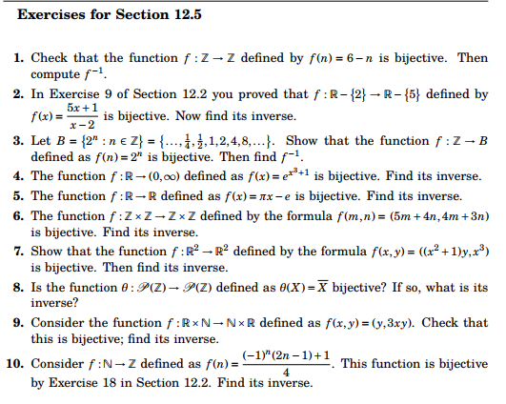
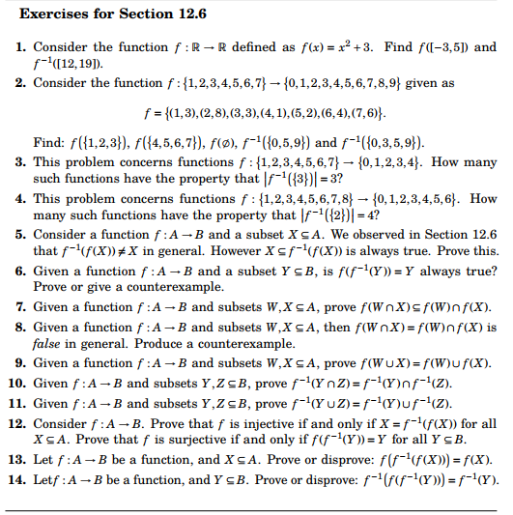

Course Home Page Department Home Page Loyola Home Page

