Class Discussion: 12 October 2017

Part I:

- State the well-ordering principle.
- Using the WOP, prove the division algorithm.

Part II:

- Let a, b be integers. Then a$a≡b \left(mod 6\right) if and only if a≡b \left(mod 2\right) and a≡b (mod 3)$
- Prove by contradiction that $\sqrt{3} is irrational.$
- Prove by contradiction that if x is irrational then so is x^{1/2}.
- Prove by contradiction that 2^{1/3} is irrational.
- Suppose n ∈ Z. Prove that n is odd if and only if n² is odd.
- Prove by contradiction that if 0 ≤ t ≤ π/2 then cos t + sin t ≥ 1.
- Let a and b be integers. If a² + b² = c², then a or b is even.
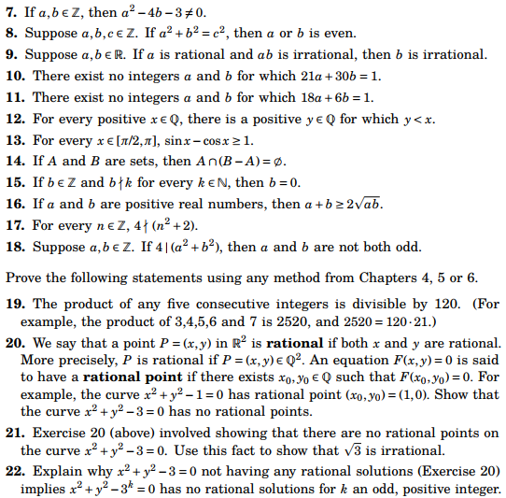

23. Proof or counter-example: if a $ac≡bc \left(mod n\right) then a≡b (mod n)$

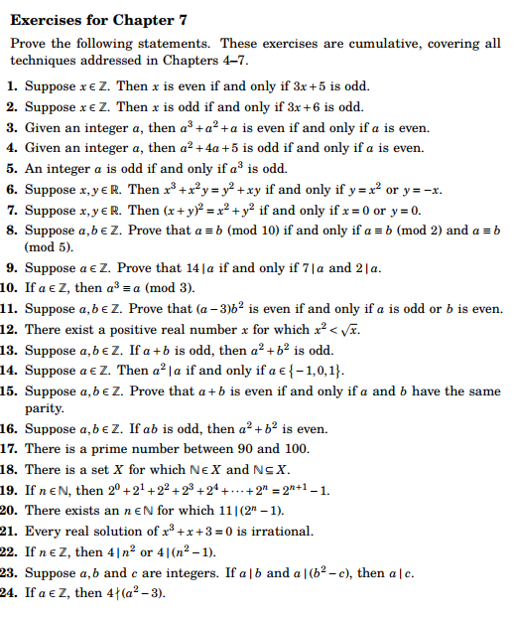

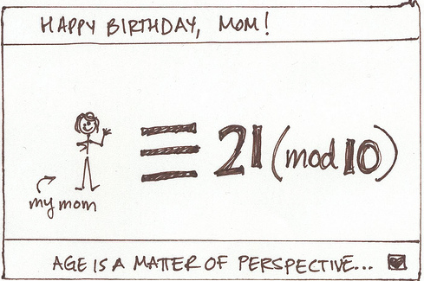

Course Home Page Department Home Page Loyola Home Page

