Class discussion: 3rd October 2017

Proof by contrapositive
Prove each of the following by the contrapositive method.
- If x and y are two integers for which x + y is even, then x and y have the same parity.
- If x and y are two integers whose product is even, then at least one of the two must be even.
- If x and y are two integers whose product is odd, then both must be odd.
- If n is a positive integer of the form n = 3k + 2, then n is not a perfect square.
- Let x$∈Z. If x^{2}-6x+5 is even, then x is odd.$
- Let x$, y∈Z. If 7∤xy, then 7∤x and 7∤y.$

R. Hammack, Book of Proof, chapter 5, Contrapositive Proof
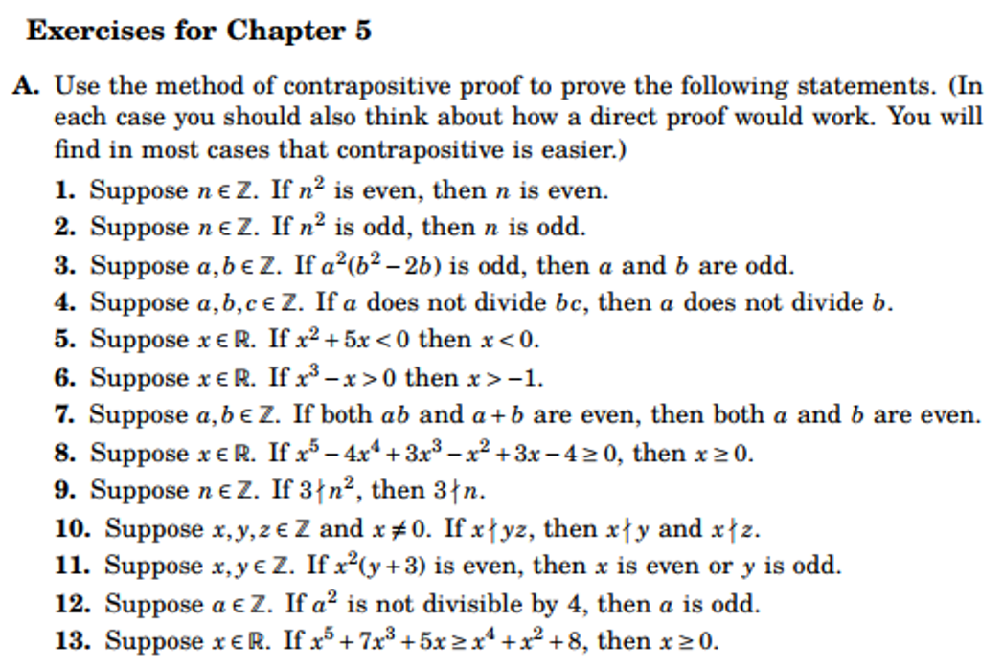
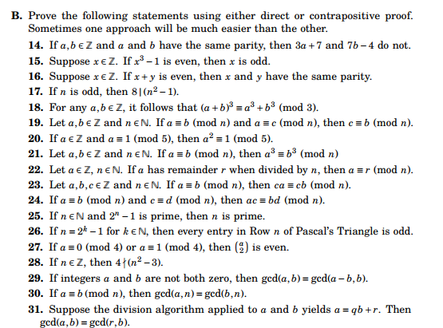

MODULAR ARITHMETIC: Define a ≡ b mod m (for m > 0). Show that this is an equivalence relation on the set of integers, Z. In the following, assume that a, b, c, d, m are integers and that m > 0.

    - Show that if a ≡ b mod m, then
      - a + c ≡ b + c mod m
      - a – c ≡ b – c mod m
      - ac ≡ bc mod m
    - Show that if ac ≡ bc mod m (and c is not 0) then it need not follow that a ≡ b.
    - Show that if d = gcd(c,m) and ac ≡ bc mod m, then a ≡ b mod m/d.
    - Show that as a special case of the above we have:
If c and m are relatively prime and ac ≡ bc mod m, then a ≡ b mod m.
    - Suppose that a ≡ b mod m and c ≡ d mod m. Prove that:
- a + c ≡ b + d mod m
- a – c ≡ b – d mod m
- ac ≡ bd mod m
    - Define addition and multiplication in Z₄ and in Z₅.

III Using modular arithmetic,
- find the remainder when 2¹²⁵ is divided by 7.
- find the remainder when (4¹⁹)(7⁹⁹) is divided by 5.

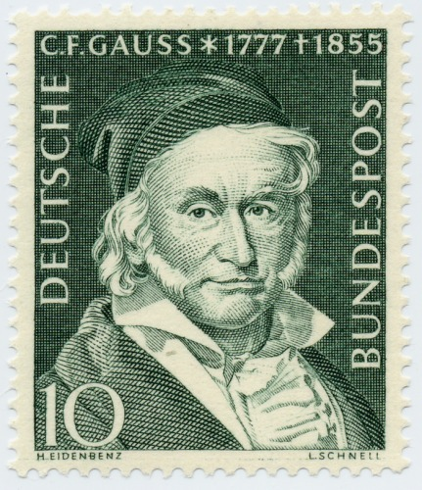
Johann Carl Fredrich Gauss introduced modular arithmetic.

