Class Discussion: Proof by Contradiction; 5 Oct.

Method
In order to prove a proposition P by contradiction:
- Write, “We use proof by contradiction.”
- Write, “Suppose P is false.”
- Deduce a logical contradiction.
- Write, “This is a contradiction. Therefore, P must be true.”

Example
Remember that a number is rational if it is equal to a ratio of integers. For example, 3.5 = 7/2 and 0.1111… = 1/9 are rational numbers. On the other hand, we’ll prove by contradiction that$\sqrt{2}$ is irrational.
Proposition: $\sqrt{2}$ is irrational.

Proof. We use proof by contradiction. Suppose the claim is false; that is, $\sqrt{2}$ is rational.
Then we can write 2 as a fraction a/b in lowest terms.
Squaring both sides gives 2 = a²/b² and so 2b² = a².
This implies that a is even; that is, a is a multiple of 2.
Therefore, a² must be a multiple of 4. Because of the equality 2b² = a², we know 2b² must also be a multiple of 4.
This implies that b² is even and so b must be even. But since a and b are both even, the fraction a/b is not in lowest terms.
This is a contradiction. Therefore, $\sqrt{2}$ must be irrational.

Potential Pitfall
Often students use an indirect proof when a direct proof would be simpler. Such proofs aren’t wrong; they just aren’t excellent. Let’s look at an example. A function f is strictly increasing if f(x) > f(y) for all real x and y such that x > y.
Theorem. If f and g are strictly increasing functions, then f + g is a strictly increasing function.
Let’s first look at a simple, direct proof.
Proof. Let x and y be arbitrary real numbers such that x > y. Then:
f(x) > f(y) | (since f is strictly increasing)
g(x) > g(y) | (since g is strictly increasing)
Adding these inequalities gives:
f(x) + g(x) > f(y) + g(y)
Thus, f + g is strictly increasing as well.
Now we could prove the same theorem by contradiction, but this makes the argument needlessly convoluted.
Proof. We use proof by contradiction. Suppose that f + g is not strictly increasing. Then there must exist real numbers x and y such that x > y, but
f(x) + g(x) ≤ f(y) + g(y)
This inequality can only hold if either f(x) ≤ f(y) or g(x) ≤ g(y). Either way, we have a contradiction because both f and g were defined to be strictly increasing. Therefore, f +g must actually be strictly increasing.

Exercise1: If a is even then a² is even. Prove by contradiction.

If a, b ∈ Z and a ≥ 2, then a - b or a - (b +1).

Exercise2: If a, b ∈ Z and a ≥ 2, then $a∤b or a∤(b+1)$
Study the following proof (from our textbook). Is it logically correct?
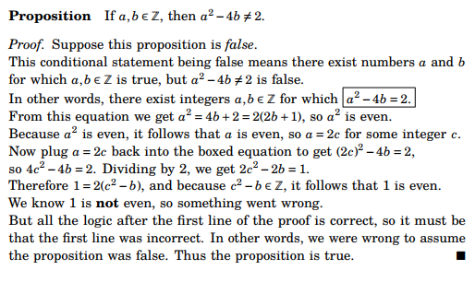
Exercises:

- Prove by contradiction that there exists no largest even integer.
- Prove by contradiction that $\sqrt[3]{1332}>11.$
- There exist no integers a and b for which 21a+30b = 1.
- Prove by contradiction that there exists no smallest positive real number.
- Prove by contradiction that there exists no largest prime number. (Euclid’s proof)
- Prove by contradiction that $\sqrt{3} is irrational.$
- Prove by contradiction that if x is irrational then so is x^{1/2}.
- Prove by contradiction that 2^{1/3} is irrational.
- Suppose n ∈ Z. If n is odd, then n² is odd.
- Suppose n ∈ Z. If n² is odd, then n is odd.
- Prove by contradiction that if 0 ≤ t ≤ π/2 then cos t + sin t ≥ 1.
- Let n be a positive integer. Prove that log₂ n is rational if and only if n is a power of 2.
- Prove the arithmetic – geometric mean inequality by contradiction.
- Employing the method of proof by contradiction show that for any non-degenerate triangle (that is, every side has positive length), the length of the hypotenuse is less than the sum of the lengths of the two remaining sides.
- Let a and b be integers. If a² + b² = c², then a or b is even.
- Prove that there are infinitely many prime numbers (Euclid).
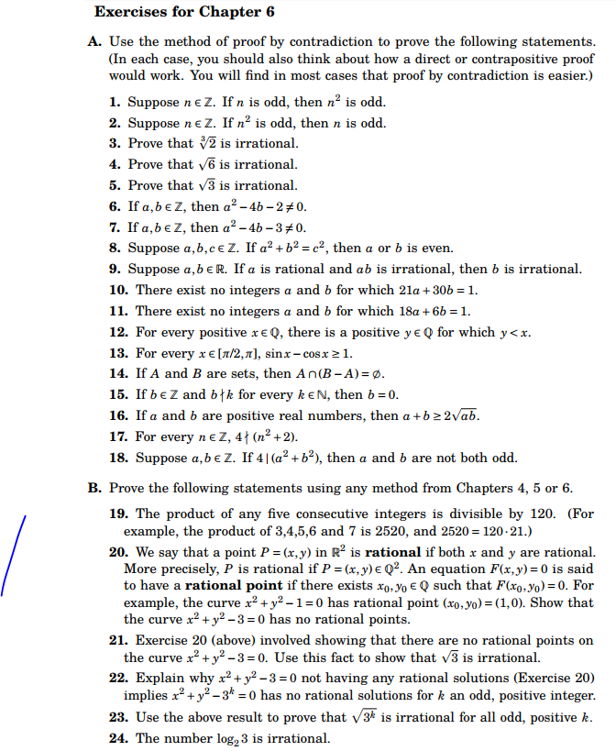

G. H. Hardy described proof by contradiction as "one of a mathematician's finest weapons", saying "It is a far finer gambit than any chess gambit: a chess player may offer the sacrifice of a pawn or even a piece, but a mathematician offers the game."
- G. H. Hardy, A Mathematician’s Apology

Course Home Page Department Home Page Loyola Home Page

