Math 201: Class Discussion I (29 Aug 2017)

Problems/riddles from Raymond Smullyan, What is the Name of this Book?, Dover (1978)

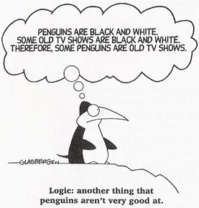

- A question of international law. If a plane crashes right on the border of the United States and Canada, in which country would you bury the survivors?
- Who is this man?
- Boris was looking at a portrait. Someone asked him, "Whose picture are you looking at?" He replied: "Brothers and sisters have I none, but this man's father is my father's son."
Whose picture was Boris looking at?
- What if the statement had been: "Brothers and sisters have I none, but this man's son is my father's son"?
- The Lion and the Unicorn. When Albertine entered the Forest of Forgetfulness, she did not forget everything; only certain things. She often forgot her name, and the one thing she was most likely to forget was the day of the week. Now, the Lion and the Unicorn were frequent visitors to the forest. These two are strange creatures. The Lion lies on Mondays, Tuesdays, and Wednesdays, and tells the truth on the other days of the week. The Unicorn, on the other hand, lies on Thursdays, Fridays, and Saturdays, but tells the truth on the other days of the week.
One day Albertine met the Lion and the Unicorn resting under a tree. They made the following statements:
Lion: Yesterday was one of my lying days.
Unicorn: Yesterday was one of my lying days too.
From these two statements, Albertine (who is a bright Loyola first-year student) was able to deduce the day of the week. What day was it?
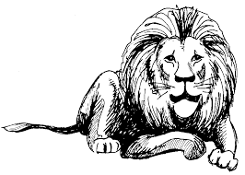
- A Question of Grammar.
Those of you who are interested in questions of good grammatical usage, is it more correct to say the yolk is white or the yolk are white?
5. Problem of the Two Coins.
Two American coins add up to thirty cents, yet one of them is not a nickel. What coins are they?

- Those of you who know anything about Catholicism, do you happen to know if the Catholic Church allows a man to marry his widow's sister?
- A Rate-Time Problem. A train leaves from Boston to New York. An hour later, a train leaves from New York to Boston. The two trains are going at exactly the same speed. Which train will be nearer to Boston when they meet?
8. A Question of Slope. On a certain house, the two halves of the roof are unequal pitched; one half slopes downward at an angle of 60° and the other half at an angle of 70°. Suppose a rooster lays an egg right on the peak. On which side of the roof would the egg fall?
9. How Many 9's? A certain street contains 100 buildings. A sign-maker is called to number the houses from 1 to 100. He has to order numerals to do the job. Without using pencil and paper, can you figure out in your head how many 9' s he will need?
10. The Racetrack. A certain snail takes an hour and a half to crawl clockwise around a certain racetrack, yet when he crawls counterclockwise around that same racetrack it takes him only ninety minutes. Why this discrepancy?
11. We have two people A, B, each of whom is either a knight or a knave. Suppose A makes the following statement: "If I am a knight, then so is B." Can it be determined what A and B are?
12. Someone asks A, "Are you a knight?" He replies, "If I'm a knight, then I'll eat my hat!" Prove that A has to eat his hat.
13. A says, "If I'm a knight, then two plus two equals four." Is A a knight or a knave?
14. A says, "If I'm a knight, then two plus two equals five." What would you conclude?
15. Given two people, A, B, both of whom are knights or knaves. A says, "If B is a knight then I am a knave." are A and B?
16. Two individuals, X and Y, were being tried for participation in a robbery. A and B were court witnesses, and each of A, B is either a knight or a knave. The witnesses make the following statements:
A: If X is guilty, so is Y.
B: Either X is innocent or Y is guilty. Are A and B necessarily of the same type? (We recall that two people from the island of knights and knaves are said to be of the same type if they are either both knights or both knaves.)
17. On the island of knights and knaves, three inhabitants A, B, C are being interviewed. A and B make the following statements:
A: B is a knight.
B: If A is a knight, so is C.
Can it be determined what any of A, B, C are?
18. What, if anything is wrong with the sentence: Let’s eat grandma.

Course Home Page Department Home Page Loyola Home Page

