Math 201: Class Discussion (31 Aug 2017)

Naïve set theory

Study carefully sections 1.1 – 1.7 of Hammack

- List the elements of each of the following sets: (a) {x∈ R : x⁴ – 1 = 0} (b) {x∈ Z : -1/3 < x < 5.99}
(c) {x ∈ N | x ≤ 4} (d) {unicorns| unicorn lives in Illinois} (e) {} (f) {φ}
(g) {1, {2}}

- Write in set notation: (a) {4, 9, 16, 25, …} (b) {1/1, 1/3, 1/5, 1/7, …} (c) {…l/8, ¼, ½, 1, 2, 4, 8, …}

- Determine the cardinality of each set in (1).

- Find each of the following cardinalities:
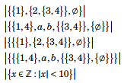

- Sketch the following sets of points in the xy-plane.
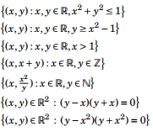

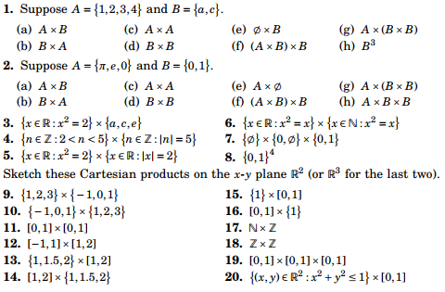

- Find the power set of each of the following sets:

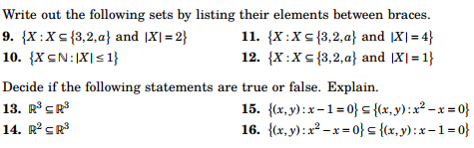

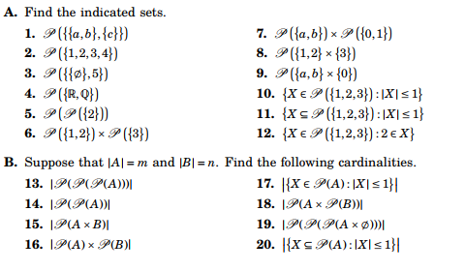

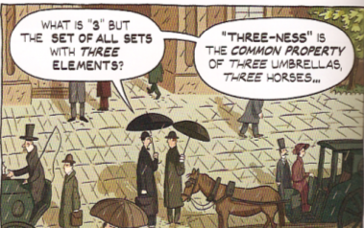

Course Home Page Department Home Page Loyola Home Page

