Class discussion: 14 September 2017

Counting: part I

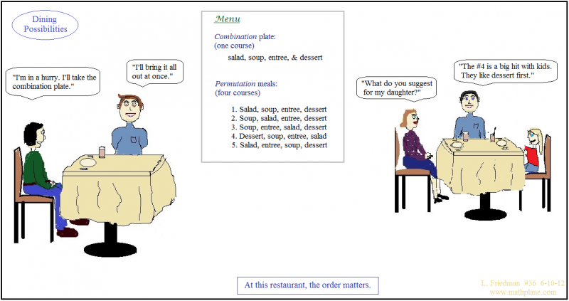

- Define: P(n, r) and $\left(\begin{aligned}n \\ r\end{aligned}\right).$

- Derive a formula for P(n, r).

- Using the result from (2), derive a formula for $\left(\begin{aligned}n \\ r\end{aligned}\right).$

- Give a story proof (as opposed to a computational proof) for each of the two identities:

The latter identity is known as “Pascal’s identity” even though many mathematicians had “discovered” it before Pascal was born.
(Hint: For Pascal’s identity, consider selecting an unordered set of r people from a collection of n people, where one of the n is “Albertine.”)

- Give a story proof of Vandemonde’s identity, viz.

(Hint: Consider choosing a set of r animals from a collection of m zebras and n sloths.)
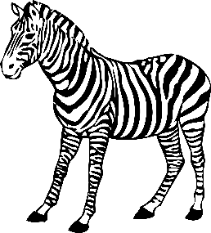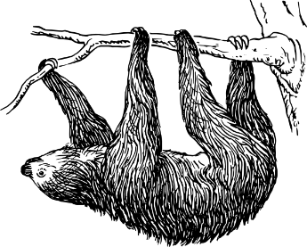
- Consider the word POISSON.
- Find the number of arrangements of this word.
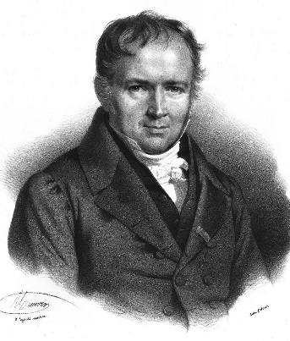

Simeon Poisson (1781-1840)

- Find the number of arrangements if the two Ss must be together.
- Find the number of arrangements if the two Os must be apart.
- Find the number of arrangements if the two Ss must be together and the two Os not together.

- Given a group of 13 married couples. In how many ways can one choose a subset of 5 individuals from this group which contains no married couple?

- In how many ways can A, B, C, D, E, F line up if
- A must be in front of B?
- A must be in front of B and B must be in front of C?

- Philanthropist David Coke wishes to distribute 7 golden eggs, 6 silver spheres, and 5 platinum cubes to 4 lucky children. In how many different ways can he distribute these precious objects to the four children? (Hint: First consider only the golden eggs.)

- In how many ways can 8 people be seated in a row if
- there are exactly 5 men and they must sit next to one another?
- there are 4 married couples and each couple must sit together?
- Three distinguishable dice are thrown. In how many ways can the maximum of the 3 numbers occurring equal 5?

- Twenty-five students show up at the OZ Fitness & YOGA Center looking for open classes. Only 3 classes are still open: one has 8 spots, one has 11 spots, and one has 6 spots. In how many different ways can the students be arranged in the 3 classes?

- Albertine lives in a city with a square grid of numbered streets which run east-west and numbered avenues that run north-south. Her house is located on the corner of 0th Street and 0th Avenue. Odette, her aunt, lives at the corner of 5th St. and 3rd Ave.

(a) How long is the shortest route (along streets or avenues) to her aunt’s house?
How many direct routes can Sally take to her aunt’s house?

(b) There is an ATM machine at the corner of 2nd St. and 2nd Ave. If Albertine needs to stop at the store on her way to her Aunt’s, how many direct routes to her Aunt’s house take her through the intersection of 2nd St. and 2nd Ave?

- At her Aunt’s house Albertine hears on the radio that there has been an accident at the corner of 1st St. and 2nd Ave. Assuming that she avoids this intersection, how many direct routes can Albertine take home?

- Consider a standard well-shuffled deck of 52 cards. Swann is dealt (an unordered) hand of 5 cards. In how many ways can he have:
- Ace of diamonds, Jack of spades, 9 of clubs, 9 of spades, and 3 of clubs
- A full-house (containing three cards of one rank and two cards of another rank, such as 3♣ 3♠ 3♦ 6♣ 6♥ )
- Four of a kind.
- Exactly two pairs.
- No two of the same rank.
- No two of the same suit.

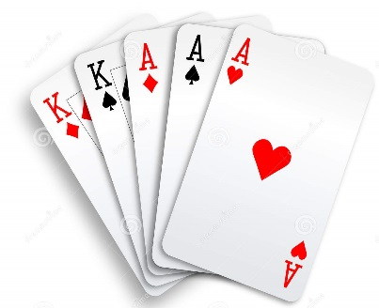

How many really basic mathematical objects are there? One is surely the `miraculous' jar of the positive integers 1, 2, 3 . . . Another is the concept of a fair coin. Though gambling was rife in the ancient world and although prominent Greeks and Romans sacrificed to Tyche, the goddess of luck, her coin did not arrive on the mathematical scene until the Renaissance. Perhaps one of the things that had delayed this was a metaphysical position which held that God speaks to humans through the action of chance. . . . The modern theory begins with the expulsion of Tyche from the Pantheon. There emerges the vision of the fair coin, the biased coin. This coin exists in some mental universe and all modern writers on probability theory have access to it. They toss it regularly and they speculate about what they 'observe.'

- Philip Davis & Reuben Hersh, The Mathematical Experience

Course Home Page Department Home Page Loyola Home Page

