Homework: MATH 201
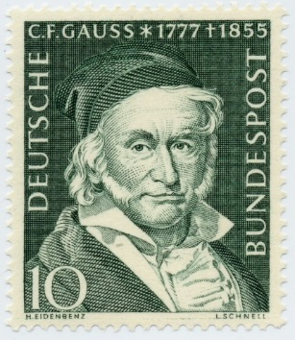
Homework 0: Due: Tuesday, September 12th
Briefly relate (in one or two paragraphs) information about yourself that will help me get to know you. If you wish, you may let the following questions serve as a guide: When did you take Math 161 and 162 (or their equivalents)?; why are you taking Math 201 now? (for example: "major requirement", “minor requirement”, "just for fun because I love mathematics", "nothing else fits my schedule", "my parents forced me to take this course", "I am looking for an easy A to raise my gpa"); what is your major?; what is your career goal?; what has been the nature of your previous experience with math either in high school or in college (that is, have you enjoyed math in the past?).
(Please post your response as a private message in Piazza no later than midnight, Tuesday. For “Subject” write “201 Homework 0”) Thank you.

Homework 1: Watch the famous Abbott and Costello video at https://www.youtube.com/watch?v=kTcRRaXV-fg
Write an analysis of whether the language of the video makes any sense.
Either precisely explain why the statements are logical or explain why this routine is nonsense.
Post your solution in Piazza (as a private message). Be certain that you are clear and unambiguous in what you write. I hope you find this to be an enjoyable exercise.
Homework 2: Due: Tuesday, 12th September
Study chapter 1 of Hammack.
Learn the proof of the Division Algorithm (using the Well-Ordering Principle) [deferred].
- Let X = {0, 1, 2, 3, 4, 5, 6}
- What is |X|?
- $Let Y=\{A∈ P\left(X\right)\left| S\left(A\right)= 5\right\} where$
$$S\left(A\right) is defined to be the sum of all the elements of A.$$
$$For example S(\left\{3, 5, 6\right\})=14.$$
$$List all the elements of Y. Find \left|Y\right|.$$
- Let A = {4, {0}, {1, 3}}, B = {{1, 2}, 3, 4, {3, 4}, {0}} and
C = {{1, 3}, {0, 1, 5}, 3, {4}, {0}, 4}.
Find |B|, |C|, |A$∪$B|, |A$∩$B|, |A – B| by listing the elements of each set.
- Let A, B and C be non-disjoint subsets of the set S. Using only the operators for union, intersection, difference and complement as well as the letters A, B and C write down expressions for events A, B and C where
(a) at least one event is true
(b) only the event A is true
(c) A and B are true but C is not
(d) all events are true
(e) none of the events is true
(f) exactly one event is true
(g) at most two events are true
(h) exactly two events are true

Briefly explain, using full sentences, each of your answers. (Note that answers are not-unique.)
- Prove, using the method discussed in class, that for sets A, B, and C,
A ∩ (B ∪ C) = (A ∩ B) ∪ (A ∩ C)
Use complete sentences.
- Let X = {p, q}. List all the elements of P(P(X)).

Homework 3: Due: Tuesday, 19th September
Study chapter 2 of Hammack. Solve the following exercises.
- Proof without words: Using the clever picture below, give a precise and clear proof of the Arithmetic Mean – Geometric Mean Inequality
$\frac{a+b}{2}≥\sqrt{ab}$ with equality iff a = b
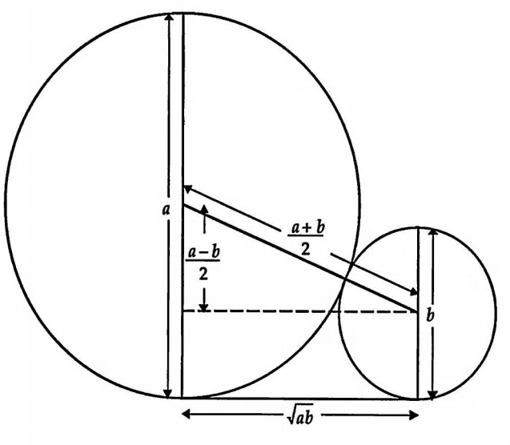
- (a) In propositional logic, modus ponendo ponens (Latin for "the way that affirms by affirming"; generally abbreviated to MP or modus ponens) or implication elimination is a rule of inference. It can be summarized as "p implies q and p is asserted to be true, so therefore q must be true", viz,$\left(p ∧\left(p⇒q\right)\right)⇒q.$ The history of modus ponens goes back to antiquity. Using a truth table, prove modus ponens.
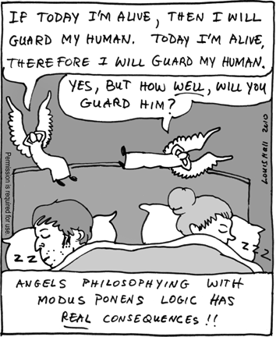
(b) Consider the two sentences $A$ and $B$ defined by:
$$A: \left(p∧q\right)⇒r$$
$$B: p⇒(q⇒r)$$
$Does A⇒B ?$
$Does B⇒A ?$
(Of course, use truth tables to answer these questions.)
(c) Negate each of the following sentences:
$\left(i\right) a ⇒$ b $∧c$
$\left(ii\right) (a∧b) ∨$ (a $∧b)$
$\left(iii\right) \left(a∧b\right)⟺(\sim a ∨\sim b)$
$\left(iv\right) \left(a⇒b\right) ⇒(\sim c ⇒(b⇒a)$
- Express each of the following statements in predicate logic. Define your “atomic predicate symbols”; also, give the domain of every variable that you use.
- Jack ran up the hill, but Jill stayed behind.
- If either Jack or Jill is tired, then neither will climb the hill.
- Nobody in Math 201 is smarter than everybody in Math 162.
- Everyone likes Albertine except Albertine herself.
- If Odette can do the task, anyone can.
- (A) Decide whether each of the following statements is true or false, where$x, y, z ∈Z$. Give proof or counterexample. If false, then write the negation of the sentence.
- $∀x ∃y \left(2x-y=0\right)$
- $∃y ∀x \left(x-2y=0\right)$
- $∀x ∃y\left(x-2y=0\right)$
- $∀x x<10 ⇒∀y \left(y<x⇒y<9\right)$
- $∃y ∃z y+z=100$
- $∀x ∃y (y>x ∧ ∃z y+z=100)$
(B) Repeat part (A) now assuming that x, y, z $∈R.$
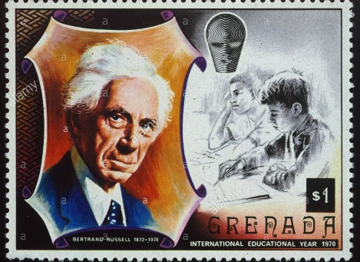
Bertrand Russell
Homework 4: Due: Thursday, 5th October
Study chapters 3 and 4 of Hammack. Solve the following exercises.
- If 7 | (3x + 2) prove that 7 | (15x² − 11x − 14).

2. (a) How many non-negative integer solutions are there to the equation: x₁ + x₂ + x₃ + x₄ + x₅ = 99?
(b) Same question as (a), but now assume that the solution must consist of positive integers.
(c) Same question as (a) except at least one of the components of a solution (x₁, x₂, x_{3,} x_{4,} x₅) must be 0. For example, 97 + 1 + 0 + 0 + 1 = 99 is one such solution.

3. (a) Consider a 2 × 2 × 2 cube, as illustrated below. A spider wants to travel from A to B; it can only walk on the lines. The path must be the shortest (i.e., 2 up, 2 left, and 2 forward). In how many ways can the spider travel?
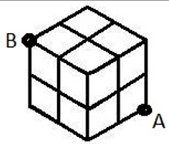
(b) Developing increased self-confidence, the spider now wishes to travel on a 3 × 3 × 3 cube subject to the same conditions as in part (a). In how many ways can the spider travel? (extra credit problem!)
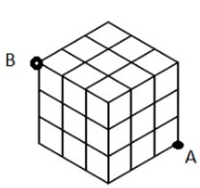
4. (a) By considering two cases, show that the product of any two consecutive integers is even.
(b) Prove that if n is an odd integer then 32| (a² + 3)(a² + 7)

Homework 5: Due: Thursday, 12th October
Study chapters 5 and 6 of Hammack. Solve the following exercises.
110/12, 18, 20; 118/6, 10, 14
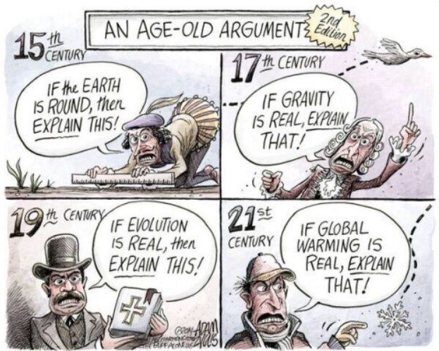

Homework 6: Due: Thursday, 19th October
Learn the proof of the Division Algorithm (page 29). Review chapter 6. Study carefully chapter 7.
Solve: 118/B 24; 110/A 8, B 22; 129/6, 10

Homework 7: Due: Thursday, 26th October
Prepare for Test 2. Review chapters 4 – 7, 9 – 10, as well as the Division Algorithm (pg. 29 – 30),
Solve: 169/8, 12

Homework 8: Due: Monday, 6th November [revised]
Solve 207/4, 6
3rd problem: Using Fermat’s little theorem, compute 3³¹ (mod 7), 29²⁵ (mod 11), and 128¹²⁹ (mod 17)
4th problem: (a) Find 2017! (mod 1789)
(b) Find 97! (mod 101)

Nov 5, 2017 - Daylight Saving Time Ends
Sunday, November 5, 2017, 2:00:00 am clocks are turned backward 1 hour to
Sunday, November 5, 2017, 1:00:00 am local standard time instead.
Sunrise and sunset will be about 1 hour earlier on Nov 5, 2017 than the day before.

Homework 9: Due: Thursday, 8th November
Review sections 1 and 2 of chapter 12.
A brief summary of concepts:
https://brilliant.org/wiki/bijection-injection-and-surjection/
Solve: 200/2; 204/2, 4, 6, 8, 14, 16, 18
Homework 10: Due: Thursday, 16th November
Read sections 12.4, 12.5, 13.1, 13.2
Solve: 210/10; 214/6; 222/A4, B16; 228/2, 10, 12
Here is a copy of Vilenkin’s classic In Search of Infinity
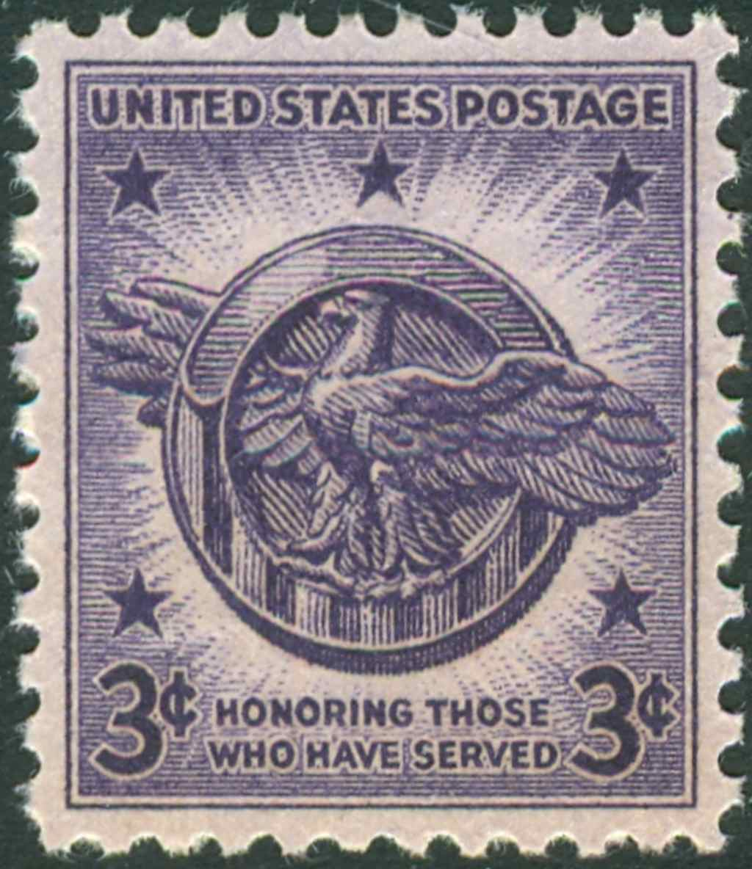

Homework 11: Due: Tuesday, 5 pm, 21st November
Read sections 13.3; 11.0, 11.1, 11.2, and 11.3 of Hammack
Solve: 231/8; 178/4; 183/8
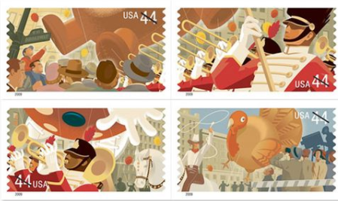
Homework 12: Due: Thursday, 5 pm, 7th December
Note: This HW grade will replace your lowest HW score.
Read carefully section 12.6 of Hammack
Solve: 214/ 8; 216/ 6, 8, 10

Course Home Page Department Home Page Loyola Home Page

