MATH 201 Solutions: TEST II
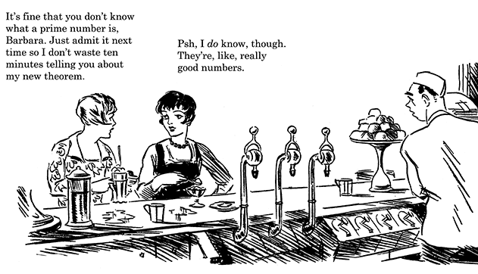

Instructions: Answer any 9 of the following 12 problems. You may answer more than 9 to earn extra credit.

- Let a be an integer. Prove that a³ + a² + a is even if and only if a is even.

We separate this “if and only if” proposition into two separate proofs.
Part I: Let a be given. Assume the right-hand side of the assertion is true, that is,
$∃t∈Z$ a = 2t.
Then a³ + a² + a = (2t)³ + (2t)² + (2t) = 2(4t³ + 2t² + t).
Since 4t³ + 2t² + t is an integer, we have proven that a³ + a² + a is even.

Part II: We will argue by proving the contrapositive. Assume the right-hand side of the assertion is true, that is, toward this end, assume that we are given an odd number a. Then $∃s∈Z$ a = 2s + 1.
Now, using algebra,
a³ + a² + a =
(2s + 1)³ + (2s + 1)² + (2s + 1) =
8s³ + 12s² + 6s + 1 =
2(4s³ + 6s² + 3s) + 1.
Since 4s³ + 6s² + 3s is an integer, a³ + a² + a is odd.
Hence the contrapositive has been verified.

- Prove that if a$≡b \left(mod m\right)and c≡d \left(mod m\right) then ac≡bd \left(mod m\right).$

Proof: Since a$≡b \left(mod m\right), ∃k∈Z a-b=km.$
Similarly, since c $≡d \left(mod m\right), ∃q∈Z c-d=qm.$
Now a = b + km, and c = d + qm
Thus ac = (b + km) (d + gm) = bd + (dk + bg + gkm)m
Letting s = dk + bg + gkm
So ac = bd + sm.
This is the result we seek: $ac≡bd \left(mod m\right).$

- What, if anything, is wrong with this proof? Select an answer and explain! (No explanation results in no credit.)

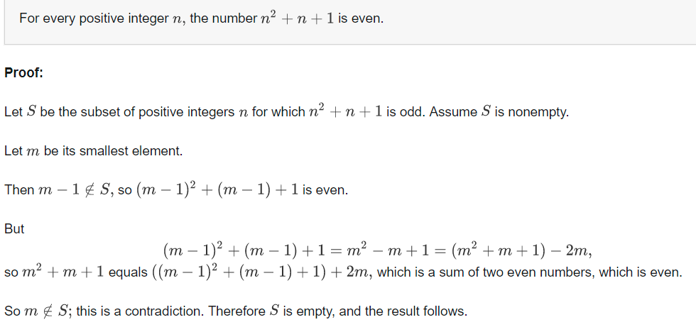
Select an answer and explain.
- m – 1 is not necessarily a positive integer, so the third paragraph is wrong.
That is, if m = 1, then m – 1 = 0 and so m would still be declared as the smallest integer in S.

- Suppose that we wish to prove that any amount of postage greater than or equal to K cents can be formed using only 4 cent and 5 cent stamps.

- What is the smallest value of K that is appropriate?
Answer: Testing small values of K, we quickly realize that k = 1, 2, 3, 6, 7 are impossible.
So we conjecture that K = 8 is the smallest positive that is appropriate.
Of course, we cannot be certain until we prove the result in 4(b).

- Prove the result using strong induction.
Proposition: Let n ≥ 8. Define
P(n): n cents postage can be formed using only 4 cent and 5 cent stamps.
Proof:
Base case: If n = 8: two 4 cent stamps.
If n = 9: one 4 cent stamp and one 5 cent stamp.
If n = 10: two 5 cent stamps
Inductive step: We know from the base case that P(n) is true for n = 8, 9, and 10.
Let n ≥ 10 be fixed.
Our inductive hypothesis is P(n): Assume that P(k) is true for 10 ≤ k ≤ n.
Now consider P(n + 1): We know that P(n – 2) is true by our inductive hypothesis.
So we add one 3 cent stamp to the set of stamps of P(n – 2). We now have n + 1 cents in postage stamps.

- Prove that $\sqrt[3]{2}$ is irrational.
Proof: We will use the method of contradiction.
We begin by assuming $\sqrt[3]{2}$ is rational. That is, $∃ p, q ∈Z such that \sqrt[3]{2}= \frac{p}{q}$.
Without loss of generality, we assume that p and q are positive integers with no common positive factor other than 1.
Now, $\sqrt[3]{2}= \frac{p}{q} ⇒p^{3}=q \sqrt[3]{2}$
$⟹p^{3}= 2q^{3}$ (equation *)
Hence p³ is even. This implies that p is even.
So $∃t∈Z p=2t.$
Substituting in equation * we find that ${\left(2t\right)}^{3}=2q^{3}.$
Hence q³ = 4t³.
Now this means that q³ is even. This implies that q is even.
Since 2 is a divisor of p and of q, we have a contradiction.

- Prove: If you choose any five numbers from the integers 1 to 8, then two of them must add up to nine.
Hint: Every number can be paired with another to sum to nine: for example, 2 and 7. How many such pairs are there? Now use the pigeon-hole principle. Be sure to identify the pigeons as well as the pigeon-holes.

Solution: Consider the 4 pairs {1, 8}, {2, 7}, {3, 6}, {4, 5}. These will be the pigeon-holes.
Let the 5 chosen numbers serve as the pigeons. Each pigeon will fly to the pigeon hole that contains its number. The pigeon hole principle asserts that two pigeons must land in the same pigeon hole. This pigeon hole now contains two numbers that add up to 9.
- Suppose that hot dog buns come in packages of 34, and hot dogs come in packages of 8.
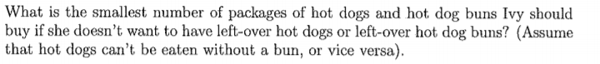
Hint: Consider 34 (mod 8)

Solution: Let x be the number of hot dog buns required and y be the number of hot dog packages. Now 34x must be a multiple of 8, for there to be no left-over hot dogs. In other words, we must solve the equation 34x = 8y.
Now, working mod 8: 2x ≡ 0 (mod 8).
The smallest positive solution to this equation is x = 4.
Checking, we see that 4 packages of hot dog buns and 17 packages of hot dogs is the desired minimum.

- (a) Compute 3²⁰¹⁷ (mod 11). Show your work!
Solution: Using Fermat’s Little Theorem, we know that 3¹⁰ ≡ 1 (mod 11).
Thus 3²⁰¹⁷ = (3¹⁰)²⁰¹ (3⁷) ≡ (1)²⁰¹ (3⁷) = 3⁷ = (81)(27) ≡ 4 (5) = 20 ≡ 9 (mod 11).

(b) Find the remainder when $(46)($23) is divided by 7. A calculator solution will earn no credit.
Solution: $(46)($23) ≡ (4)(2) = 8 ≡ 1 (mod 7)

- Find a counterexample for each of the following statements:
- All prime numbers are odd.
Let p = 2
- If n is an integer for which n⁵ – n is even, then n is even.
Let n = 1. Then n⁵ – n = 0 is an even number, yet 1 is odd.
- If s and t are positive irrational numbers, then s + t is irrational.
Let s $=1+ \sqrt{2} and t= 1- \sqrt{2}$. Then s + t = 2, a rational number.

- If s and t are positive irrational numbers for which $s ≠t$, then st is irrational.
Let s $=1+ \sqrt{2} and t= 1- \sqrt{2}$. Then st = -1, a rational number.
- Any two multiples of 3 are congruent to each other (mod 6).
Let a $=0 and b=3. Then each of a and b is a multiple of 3.$
$$But 0 is not congruent to 3 \left(mod 6\right) since 3-0=3,$$
$$which is not a multiple of 6.$$

- Prove the that the square a² of an integer a must be of the form 4K or 4K+1.

Proof: Let $a∈Z be fixed.$ We consider two cases.
Case I: a is even
If a is even then $∃c∈Z a=2c.$
$And so a^{2}=4c^{2}$.
Let K = $c^{2}. Then a^{2}=4K.$
Case 2: a is odd
If a is odd then $∃d∈Z a=2d+1.$
$And so a^{2}=4d^{2}$ + 4d + 1 = 4($d^{2}+d$) +1
Let L = $d^{2}+d. Then a^{2}=4L+1$
Hence, since every integer is either odd or even, the stated result has been proven.
- Fix the following proof so that it will earn full-credit from your grader.
Proposition: For all n ≥ 1, $\frac{\left(3n\right)!}{{(3!)}^{n}}$ is an integer.
Proof: We will use the method of mathematical induction.
Let us imagine that there exists an integer n for which $\frac{\left(3n\right)!}{{(3!)}^{n}} is an integer.$
Now $\frac{ \left(3n+1\right)!}{{(3!)}^{n+1}}$= $\frac{\left(3n\right)!(1!)}{{\left({(3!)}^{n}\right)}^{1}}= \frac{ \left(3n+1\right)!}{{(3!)}^{n+1}} = \frac{\left(3n\right)!}{{(3!)}^{n}}$ $which must be an integer from our assumption.$
Thus we have proven the case n + 1 and the induction is complete.

Solution: This “proof” contains many errors, but the result is correct.
Proposition: For all n ≥ 1, $\frac{\left(3n\right)!}{{(3!)}^{n}}$ is an integer.
Proof: For each n 1, let H_{n} represent the statement $\frac{\left(3n\right)!}{{(3!)}^{n}}$ is an integer.
We will use the method of mathematical induction.
Base case: n = 1: $\frac{\left(3(1)\right)!}{{(3!)}^{1}}$ = 1 Z.
Inductive step: Assume that n 1 is given and that H_{n} is true.
Now (3(n+1))!/(3!)^{n+1} = (3n + 3)! / (3!)^{n+1} $=\left(\frac{\left(3n\right)!}{{\left(3!\right)}^{n}}\right) \left(\frac{\left(3n+1\right)\left(3n+2\right)\left(3n+3\right)}{3!}\right)=$
$\left(\frac{\left(3n\right)!}{{\left(3!\right)}^{n}}\right)(n+1)\frac{(3n+1)(3n+2)}{2}$
Now, by inductive hypothesis, $\left(\frac{\left(3n\right)!}{{\left(3!\right)}^{n}}\right)$is an integer. Furthermore, the product of two consecutive integers is even. $Hence 2 is a divisor of (n+1)(3n+1)(3n+2)$
Thus (3n+1)(3n+2) is divisible by 2, and we have proven H_{n+1}.

- Proposition: For all n ∈ N, 4|(3^{2n} + 7).
Proof: For n ∈ N let S_{n} be the statement 4|(3^{2n} + 7).
Base Case: n=1 is true, since 3² + 7 = 16 is divisible by 4.
Inductive Step:
For a given k ≥ 1, assume that the proposition is true for n =k, so that 4|(3^{2k} + 7). Then 3^{2k} + 7 = 4L for some L∈ Z.
Now, 3^{2(k+1)} + 7 = 9(3^{2k}) + 7 = 8(3^{2k}) + 3^{2k} + 7 = 8(3^{2k}) + 4L = 4(2(3^{2k}) + L).
So 4|(32^{(k+1)} + 7), and we see that the proposition is true for n = k+1.
Therefore, by the principle of mathematical induction, the proposition is true for all n ∈ N.

Which of the following statements is correct?
The proposition is false but the proof is correct.
The proof contains arithmetic mistakes which make it incorrect.
The proof incorrectly assumes what it is trying to prove.
- The proof is a correct proof of the stated result.
None of the above is true.

A first fact should surprise us, or rather would surprise us if we were not used to it. How does it happen there are people who do not understand mathematics? If mathematics invokes only the rules of logic, such as are accepted by all normal minds ... how does it come about that so many persons are here refractory?

- Henri Poincaré, quoted in The World of Mathematics, by J. R. Newman.

