Homework: MATH 201
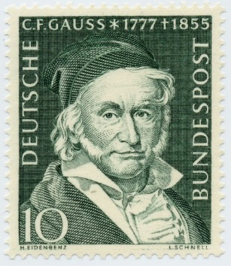
Homework 0: Due: Friday, 18th January
Briefly relate (in one or two paragraphs) information about yourself that will help me get to know you. If you wish, you may let the following questions serve as a guide: Which other courses in math have you taken now or concurrently with Math 201. Why have you chosen to take Math 201 now? (for example: "major requirement", “minor requirement”, "just for fun because I love mathematics", "nothing else fits my schedule", "my parents forced me to take this course", "I am looking for an easy A to raise my gpa"); what is your major?; what is your career goal?; what has been the nature of your previous experience with math either in high school or in college (that is, have you enjoyed math in the past?).
(Please post your response as a private message in Piazza no later than midnight, Tuesday. For “Subject” write “201 Homework 0”) Thank you.

Homework 1: Due: Wednesday, 23rd January
Read sections 1.1 through 1.7 of Hammack. Note that all of his exercises have answers or solutions at the end of the book. So you would profit by doing many of the exercises in these sections and, if you wish, check your answers.
- Watch the famous Abbott and Costello video at https://www.youtube.com/watch?v=kTcRRaXV-fg
Write an analysis of whether the language of the video makes any sense.
Either precisely explain why the statements are logical or explain why this routine is nonsense.
Be certain that you are clear and unambiguous in what you write. I hope you find this to be an enjoyable exercise.
- Let X = {0, 1, 2, 3, 4, 5, 6}
- Find |X|?
- $Let Y=\{A∈ P\left(X\right)\left| S\left(A\right)= 5\right\} where$
$$S\left(A\right) is defined to be the sum of all the elements of A.$$
$$For example S(\left\{3, 5, 6\right\})=14.$$
$$List all the elements of Y. Find \left|Y\right|.$$
- Let A = {4, {0}, {1, 3}}, B = {{1, 2}, 3, 4, {3, 4}, {0}} and
C = {{1, 3}, {0, 1, 5}, 3, {4}, {0}, 4}.
Find |B|, |C|, |A$∪$B|, |A$∩$B|, |A – B|, by listing the elements of each set.
- Let A, B and C be non-disjoint subsets of the set S. Using only the operators for union, intersection, difference and complement as well as the letters A, B and C, write down expressions for each of the following.
(Note that “event” is simply another way of referring to a subset.)
- at least one event is true
- only event A is true
- A and B are true but C is not
- all events are true
- none of the events is true
- exactly one event is true
- at most two events are true
- exactly two events are true

Briefly explain, using complete sentences, each of your answers. (Note that answers are not unique.)

Course Home Page Department Home Page Loyola Home Page

