Math 201 - Discrete Mathematics and the Theory of Numbers

Fall Semester 2017
Section 002: TTh 2:30 – 3:45 pm (120 Dumbach Hall)

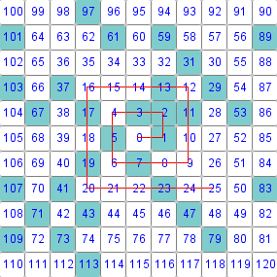

the prime spiral (aka the Ulam spiral)

Notice that the blue numbers (all primes but for 1) tend to line up along diagonal lines.
In a passage from his 1956 novel The City and the Stars, author Arthur C. Clarke describes the
prime spiral seven years before it was discovered by Ulam. Clarke did not notice the pattern
revealed by the prime spiral because he never actually performed the experiment.

- Ground Rules
- Piazza
- Homework & Reading Assignments
- Groupwork
- Class discussion problems
- Test Solutions
- Useful References
- History of Number Theory

On the other hand, it is impossible for a cube to be written as
a sum of two cubes or a fourth power to be written as a sum of
two fourth powers or, in general for any number which is a
power greater than the second to be written as a sum of two like
powers. For this I have discovered a truly wonderful proof,
but the margin is too small to contain it.

– P. Fermat

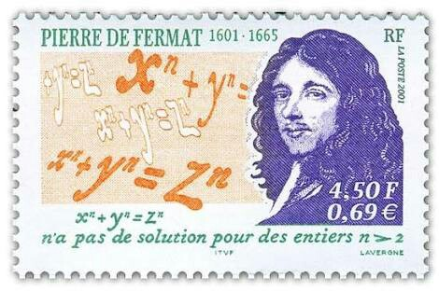
Department Home Page Loyola Home Page

