Questions for class discussion (14 January)
Vectors in 2-space and 3-space
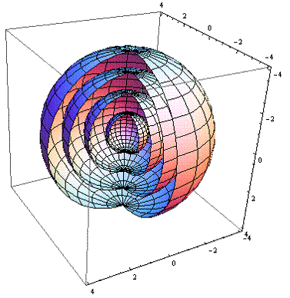
Concentric spheres drawn with Mathematica
1. Find the distance between the two points (3, -1, 4) and (5, 5, -3).
2. Find the equation of a sphere with center (1, 2, 3) and radius 4.
3. Consider the sphere defined by the equation
(x – 2)² + (y – 5)² + (z – 8)² = 8.
Find the equation of the sphere centered at (7, 17, 21) that is tangent to the given sphere. Hint: Begin with a picture.
4. Do the two spheres (x – 1)² + (y – 2)² + (z – 2)² = 4 and
(x + 1)² + (y + 2)² + (z – 3)² = 4 intersect? Why?

5. Let v = i + 2 j and w = 4 i + 3 j. Compute v + w and display its geometrical meaning.
6. Referring to problem (5), compute the norm of v, the norm of w, and the norm of v+w.
7. Find a unit vector in the direction of v = i + 3 j + k.
8. Express the vector from the point A = (2, 3, 4) to the point B = (7, 1, 0) as a vector in standard position.
9. Explain the geometric meaning of scalar multiplication of a vector.
10. Find all vectors in 2-space that have norm of 13 and i-component of 5.
11. Find the equation of the line L passing through (1, 0, 0) in the direction of j.
12. Find the equation of the line L passing through (3, -1, 2) in the direction of 2i – 3j + 4k.
13. Do the two lines L₁(t) = (t, –6t + 1, 2t – 8) and L₂(t) = (3t + 1, 2t, 0) intersect? Justify your answer!
15. Does the line L(t) = (2, –1, 2) + t(2, 3, 1) intersect the plane 5x – 3y – z = 6? If so, where?
16. Normalize the vector 5i – 3j – 4k
Exercises from Stuart:
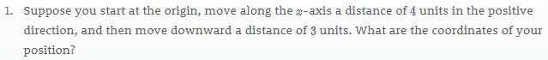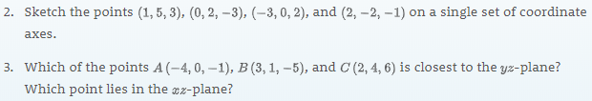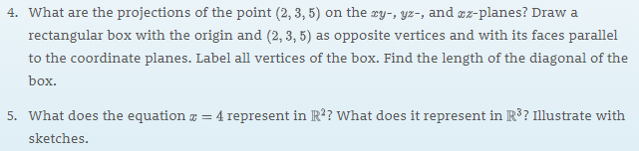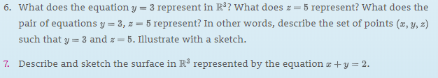
"...treat Nature by the sphere, the cylinder, and the cone..."
- Paul Cézanne (1839-1906)

