SURVIVAL SHEET: Math 263 – Section 002

Spring Semester 2019
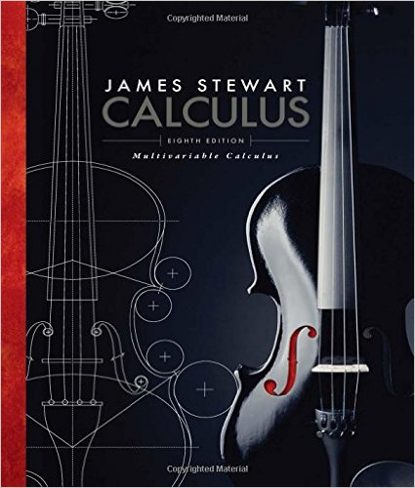
- James Stewart. Calculus: Early Transcendentals (WebAssign eBook)
8th edition, Cengage Learning
or
- James Stewart: Multivariable Calculus (WebAssign eBook) 8th edition, Cengage Learning

Supplementary reading:
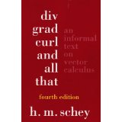
- H. M. Schey, div, grad, curl and all that: an informal text on vector calculus, 4th edition, paperback, Norton (2005)

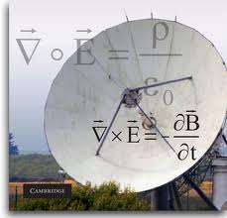
- Daniel Fleisch, A Student's Guide to Maxwell's Equations, paperback edition, Cambridge University Press (2008)
\

Calculator: The TI-83 Plus or TI-84 Plus graphing calculator or equivalent is recommended.
More powerful calculators (including the TI-89) are not permitted on quizzes, tests, or the final exam.
Software: Mathematica 11
Instructor: A. Saleski
BVM 612 (IES complex)
phone: (773) 508-3577
e-mail: asalesk@luc.edu or alan.saleski@gmail.com
Course URL: http://www.math.luc.edu/~ajs/courses/263spring2019/index.pdf

Office Hours MWF TBA TTh 9:30 – 10:30 am; or by appointment.

Ground Rules: The final grade is computed according to the following recipe:
Quizzes | 21 %
Tests | 26 %
Homework (WebAssign) | 12 %
Mathematica Labs | 7 %
Group work | 7 %
Piazza | 2 %
Final Exam | 25 %
Extra credit | 4 %

Important Dates:

• Tests: (all Fridays) February 8; March 15; April 12
- Quizzes: (all Fridays) January 25; February 1, 15, 22; March 22, 29; April 5
- Holidays:
- Dr. Martin Luther King Day: Monday, January 21st

- mid-semester break: Monday – Friday, March 4th – 8th
- Spring Equinox, Wednesday, March 20th | 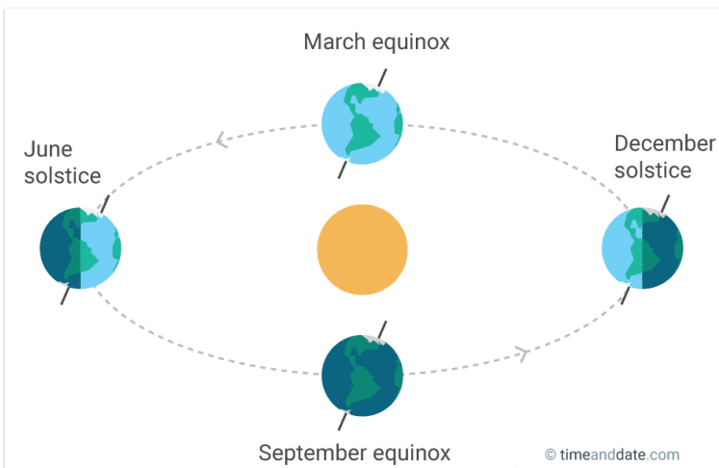
- Easter: Friday – Monday, April 19th – 22nd
- Last day To Withdraw without a WF:
Monday, March 25th (5 pm)
• Last day of Class: Friday, April 26th
• Final Exam, Monday, April 29th (9 am)
• Loyola Calendar (Spring 2019)

Grading scale:
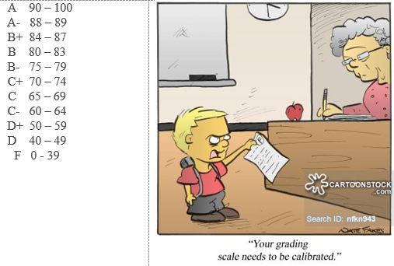

Remarks:
- Piazza will be our main form of communication outside of class. Upon receiving your welcome message from Piazza, you should join at once. All general questions/remarks/solutions should be posted in Piazza. If you wish to make a personal statement, you should send a private message in Piazza (or, if you prefer, use my Gmail account).
- The lowest of the seven quiz grades will be dropped.
- Late homework or late labs will be accepted but with a penalty.
- Each test will be about 50 minutes long. Quizzes will take about 10 – 15 minutes. Make-up tests and quizzes will be given only for non-frivolous reasons. The student should make prior arrangements with the instructor, if at all possible.
- The minimum penalty for cheating is failure in the course. A student who improperly aids another with a homework assignment, a test, a quiz, a lab, or the final exam is considered to be equally culpable. If you receive help on an assignment from anyone other than the instructor (this includes another student, the TA, a tutor, a family member, website, or friend), you should acknowledge this fact in a comment at the beginning of your homework. Incidents of academic dishonesty will be reported to the appropriate Dean.

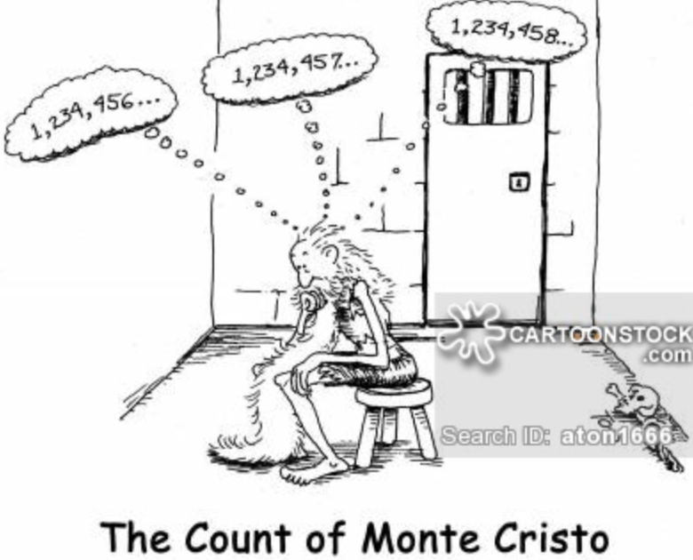

Course Home Page Department Home Page Loyola Home Page

