Math 263 - Multivariable Calculus

Spring Semester 2019

Section 002: MWF 10:25 am – 12:20 pm (233 Dumbach Hall)

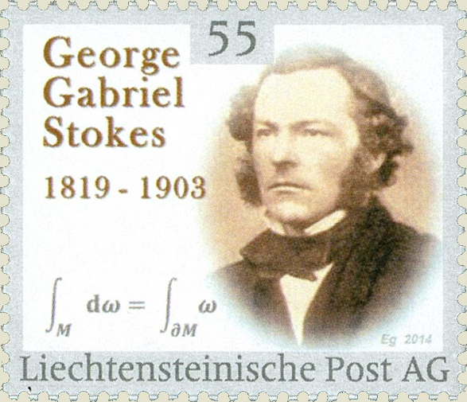

- Ground Rules
- Syllabus
- WebAssign
- Homework & Reading Assignments
- Piazza
- Questions for class discussion
- Mathematica Tutorials
- Mathematica Examples and Labs (Lab I; Graph examples)
- Practice Tests
- Quiz Solutions
- Test Solutions
- Useful References (Greek alphabet, supplementary texts)
- MIT OCW for Multivariable Calculus (18.02: Prof Denis Auroux; MV Calculus revisited: Prof Herb Gross)
- History: (Guido Fubini, Carl Jacobi, Michael Faraday, George Green, George Stokes, Carl Friedrich Gauss, Joseph-Louis LaGrange, William Hamilton, James Maxwell, Josiah Gibbs)

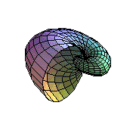
Department Home Page Loyola Home Page

