Math 351 - Introduction to Real Analysis I

Fall 2018
Section 001 (Lecture): MWF 10:25 – 11:15 am, 231 Dumbach Hall
Section 002 (Discussion): TBA
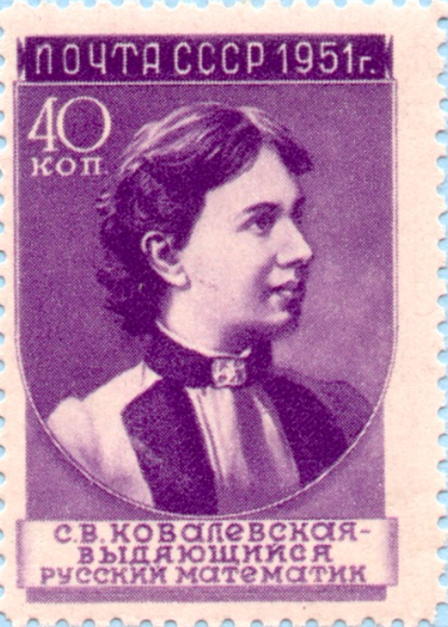
Sofia Kovalevskaya (1850 – 1891)
- Ground Rules
- Homework & Reading Assignments
- Homework Solutions
- Discussion sheets
- Piazza
- Practice Tests
- Test Solutions
- Writing Mathematical Proofs
- Useful References (websites and other resources; Greek alphabet)
O dear Ophelia!
I am ill at these numbers:
I have not art to reckon my groans.
- HAMLET (Act II, Sc. 2)

Department Home Page Loyola Home Page

