Math 351: Questions for class discussion, 29 August 2018
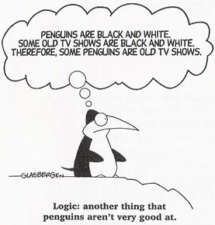
Reading Assignment: Carefully read (meaning several times) Chapter I (sections 1 – 3) and carefully review Appendix A.0 (sets and numbers) and A.4 (induction) of Mattuck.
- Define R, Z, Q, N (the natural numbers), N₀ (non-negative integers), $∅$ (the empty set) and C..
- Explain the difference between writing A$⊂B and A⊆B.$ Write the relationships among the six sets of (1) using this notation.

- Review (Closure Properties): For each of the following, decide if the set is closed under the operations of addition, subtraction, multiplication, and/or division. Give counterexample or proof.
Z, N, Q, R, C, R ~ {0}, Q ~ {0}, the set of even integers, the set of even positive integers, the set of odd integers, the set of odd positive integer, the set of prime numbers, the set of composite integers > 2, the set of irrational numbers, the set of integers that are perfect squares, the set of integers of the form 3k, the set of integers of the form 5k+1

- Define the following property on Q:
For x, y $∈Q, let x⋇y=xy+4x-19, let x⊠y=\frac{5x}{y^{4}+1} and let x⨂y=x+\frac{1}{y}$
Is Q closed under each of these operations?
Repeat this question replacing Q by N and then by R.

- Prove that $\sqrt{5}$ is irrational. Which assumptions about integers must you make?
- Prove that beween any two distinct rational numbers, there exists an irrational number.
- Define increasing sequence; decreasing sequence. Can a sequence possess both of these characteristics?

- Which of the following sequences is monotone? Which are bounded above? Which are bounded below? Which are bounded? For those that are both monotone and bounded, try to find the limit.
- $\left\{\frac{n}{n+1}\right\}$
- $\sqrt{1-\frac{1}{4n}}$
- $\left\{\frac{\sqrt{n^{2}-1}}{n}\right\}$
- $\left\{\frac{\sqrt{1+n^{4}}}{n^{2}}\right\}$
- $\left\{\cos{\frac{nπ}{2}}\right\}$
- $\left\{\frac{n}{n+1}-\frac{n+1}{n}\right\}$
- $\left\{\frac{n^{2}}{n+1}-\frac{n^{2}+1}{n}\right\}$
- $\left\{\frac{1}{1}+\frac{1}{3}+\frac{1}{5}+…\frac{1}{(2n+1)}\right\}$
- $\left\{\frac{n}{e^{n}}\right\}$
- $\left\{1+({-1)}^{n}\right\}$
- $\left\{1+99\ln\left(n^{2018}\right)\right\}$
- $\left\{\frac{1}{1}+\frac{1}{4}+\frac{1}{9}+…+\frac{1}{n^{2}}\right\}$

- Explain why $\left\{1+\frac{1}{1!}+\frac{1}{2!}+\frac{1}{3!}+\frac{1}{4!}+…+\frac{1}{n!}\right\}$ Is monotone and bounded above.

- Find the flaw in the following “proof”:
(from: A. J. Hildebrand, notes from University of Illinois)
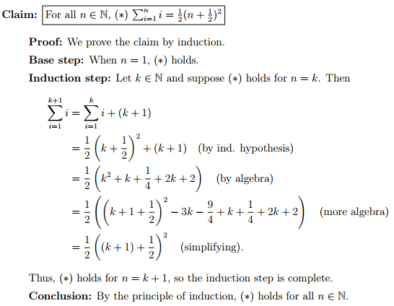
- Find the flaw in the following bogus proof:
- Step 1: Let a = b.
- Step 2: Then a² = ab
- Step 3: Then a² + a² = a² + ab
- Step 4: Then 2a² = a² + ab
- Step 5: Then 2a² – 2ab = a² + ab – 2ab
- Step 6: Then 2a² – 2ab = a² – ab
- Step 7: This can be written as 2(a² – ab) = 1(a² – ab)
- Step 8: Dividing each side by (a² – ab) yields 1 = 2

Review (Exercises in writing basic proofs). Prove each of the following statements:
