Math 351: Questions for class discussion, 12th November

Bolzano’s theorem; Intermediate value theorem
- (Review) Prove that, for any real numbers a and b, $\max\left\{a, b\right\}= \frac{a+b+|a-b|}{2}$ .
What is the corresponding statement for min{a, b}?
- Prove that if f is continuous then |f(x)| is continuous as well.
- (Review) Find four continuous functions y = f(x) satisfying y² = x².
- (Review) Write the negation of the statement: f(x) is continuous at x = p
- (Review) Let $f\left(x\right)=\left\{ \begin{aligned}1 if x=\frac{1}{n} for n∈N \\ 0 otherwise\end{aligned}\right.$
Prove, using the Sequential Continuity criterion, that f(x) is discontinuous at x = 0.
- Prove the Positivity Theorem for continiuous functions.
- [S. Abbott, Understanding Analysis, 2nd edition, Springer (2016)] Let f be a function defined on R.
- Let’s say f is onetinuous at c if for all $ε>0 we can choose δ=1 and it follows that \left|f\left(x\right)-f\left(c\right)\right|<ε$
whenever $|x-c|<δ$. Find an example of a function that is onetinuous on all of R.

- Let’s say f is equaltinuous at c if for all $ε>0 we can choose δ=ε and it follows that \left|f\left(x\right)-f\left(c\right)\right|<ε$
whenever $|x-c|<δ$. Find an example of a function that is equaltinuous on R but is nowhere onetinuous, or explain why there is no such function.

- Let’s say f is lesstinuous at c if for all $ε>0 we$ can choose $0<δ<ε$ and it follows that
$\left|f\left(x\right)-f\left(c\right)\right|<ε$ whenever$|x-c|<δ$. Find an example of a function that is lesstinuous on R that is nowhere equaltinuous, or explain why there is no such function.

- Is every lesstinuous function continuous? Is every continuous function lesstinuous? Explain.

- Assume that f and g are defined on all of R, and that $\lim_{x→p}{f(x)}=q and \lim_{x→q}{g(x)}=r$.
Give a counterexample to $\lim_{x→p} g({f(x))}=r$
- State and prove Bolzano’s theorem for a continuous function on a compact interval.
- Show that the Intermediate Value Theorem is a consequence of Bolzano’s theorem.
- State the Intersection Principle.

- Apply the intermediate value theorem to show that the equation $x^{5}-3x^{2}=-1$ has a solution in the interval [0, 1].
- Apply the intermediate value theorem to show that the equation $\sqrt{x^{6}+5x^{4}+9}=3.5$ has a solution in the interval [0, 1].
- Prove that f(x) = 9 sin x – x⁵ = 1 has at least one solution.
- State the Intersection Principle.
- State the Intermediate Value Property.
- Prove that if f(x) is strictly monotone and has the IVP on [a, b], then f is continuous on [a, b].
- State and sketch the proof of the Inverse Function Theorem.

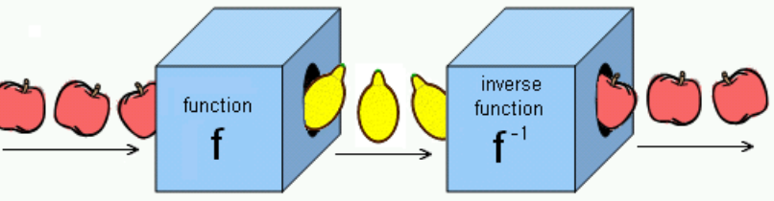
- Define sequentially compact for a subset of R.

- Prove the Sequential Compactness theorem.

