Math 351: Questions for class discussion, 30th November
Open & closed sets

- Metric Spaces: Rudin (2nd edition) , pp. 27 – 35
- Define Metric Space.
- Show that each of the following defines a metric on the given space:
- The prototype: the line R with its usual distance d(x, y) = |x – y|.
- The plane R² with the standard "Euclidean metric" :
$d\left(\left(x_{1}, y_{1 }\right), \left(x_{2}, y_{2 }\right)\right)=\sqrt{ {\left(x_{2}-x_{1}\right)}^{2}+{\left(y_{2}-y_{1}\right)}^{2}}$
- n-dimensional$Euclidean space, R^{n}, with the metric$
$$d\left(x, y\right)=\left\|x-y\right\|, where \left\|z\right\| denotes the vector norm of z.$$
- The modulus metric on the set of complex numbers, C: d(z, w) = |z – w|.
- The plane with the taxi cab metric d((x₁ , y₁), (x₂ , y₂)) = |x₁ - x₂| + |y₁ - y₂|.
$$This is also known as the Manhattan metic.$$
- The plane with the maximum metric, viz:
$d\left(\left(x_{1}, y_{1 }\right), \left(x_{2}, y_{2 }\right)\right)=max\left\{\left|x_{1} - x_{2}\right|, \left|y_{1} - y_{2}\right|\right\}$
- The discrete metric on any non-empty set, X:
$$d\left(x,y\right)=\left\{\begin{aligned}0 if x=y \\ 1 if x≠y\end{aligned}\right.$$
- Let X = $C$[0, 1], the set of all continuous real-valued function on the interval [0, 1].
Define $d\left(f,g\right)=\int_{0}^{1}{\left|f\left(x\right)-g\left(x\right)\right|dx}$.
- Let X = $C$ [0, 1]. Define$d\left(f,g\right)=\sqrt{\int_{0}^{1}{{\left(f\left(x\right)-g(x)\right)}^{2}dx}}$.
- Let X = $C$ [0, 1]. Define $d\left(f,g\right)=\max{\{f\left(x\right)-g\left(x\right) :} x∈[0, 1]\}$
- In information theory, linguistics and computer science, the Levenshtein distance is a string metric for measuring the difference between two sequences. Informally, the Levenshtein distance between two words is the minimum number of single-character edits (insertions, deletions or substitutions) required to change one word into the other. It is named after the Soviet mathematician Vladimir Levenshtein, who considered this distance in 1965. Levenshtein distance may also be referred to as edit distance, although that term may also denote a larger family of distance metrics.^{[2]:32} It is closely related to pairwise string alignments.
- Let X = R² and let d(x, y) = ||x||+ ||y|| be the sum of the Euclidean distances of x and y from the origin, unless x and y lie on the same line through the origin, in which case it is the Euclidean distance from x to y. In Britain, d is sometimes called the “British Rail” metric, because all the train lines radiate from London (located at the origin). To take a train from town x to town y, one has to take a train from x to 0 and then take a train from 0 to y, unless x and y are on the same line, in which case one can take a direct train.
- Review de Morgan’s laws.
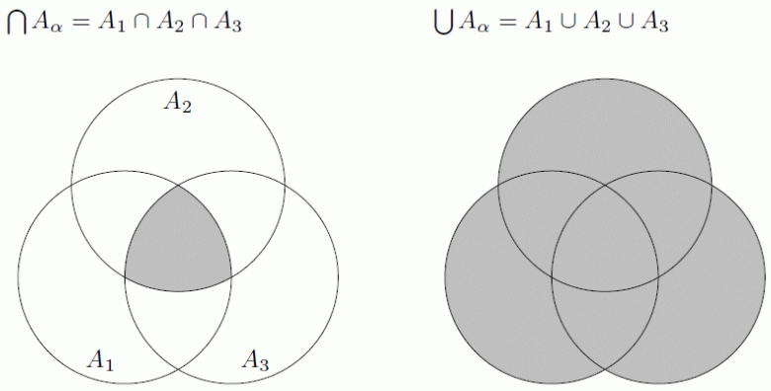
- Let (X, d) be a metric space and let N_{r}(p) represent the neighborhood of p with radius r, viz
$N_{r}\left(p\right)=\left\{x∈X\right|d\left(x,p\right)<r\}.$.Define interior point of a subset of a metric space.
- Prove that $N_{r}\left(p\right)$ is open.
- Define open subset of X.
- Prove that $N_{r}\left(p\right)$ is open.
- Define limit point of a subset, S, of a metric space.
- Define closed subset of X.
- Prove that a subset S of a metric space is open if and only if its complement S^{c} is closed.
- Is the union of a finite number of open sets open? Is the union of a finite number of closed sets closed?
- Is the intersection of a finite number of open sets open? Is the intersection of a finite number of closed sets closed?
- Answer questions 11 and 12 omitting the hypotheses that there are only a finite number of sets.
- Let (X, d) be a metric space and let N_{r}(p) represent the neighborhood of p with radius r, viz
$N_{r}\left(p\right)=\left\{x∈X\right|d\left(x,p\right)<r\}.$Prove that $N_{r}\left(p\right)$ is open.
- In examples (a) – (g) above, explain what the closed unit ball with center at the origin looks like.
- Let (X, d) be a metric space. Let Y be any non-empty subset of X. Explain why Y is a metric space with the “inherited” metric.
- Give an example of a countable collection of open sets in R whose intersection is closed, non-empty, and not all of R.
Consider R with the usual metric. Decide whether each of the following subsets of R are open, closed, both, or neither. If a set is not open, find a point in the set for which there is no neighborhood contained in the set. IF a set is not closed, find a limit point that is not contained in the set.
- Q (b) R (c) the empty set (d) $\left\{x∈R\right| x≠0\}$ (e) $\left\{1+\frac{1}{4}+\frac{1}{9}+…+\frac{1}{n^{2}}\right| n∈N\}$
(f) $\left\{x∈Q\right| 0<x<1\}$ (g) $\left\{{(-1)}^{n}+\frac{2}{n}\right| n∈N\}$
- Define Open Cover of a set S.
- Give an example of an open cover of (0, 1) that has no finite subcover.
