Math 351: class discussion, 10 October 2018
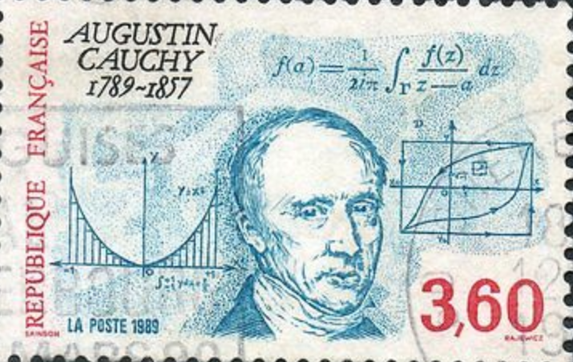
Cauchy sequences & supremum, infimum of sets
- Review: What is the Cauchy criterion for convergence?
- Given a sequence $\left\{a_{n}\right\} that has the property \left|a_{n}-a_{n+1}\right|≤ \frac{1}{2^{n }} .$ for all n. Must it follow that $\left\{a_{n}\right\}$be Cauchy?
- Show directly that $b_{n}= \frac{1}{1!}+ \frac{1}{2!}+\frac{1}{3!}+\frac{1}{4!}+…+\frac{1}{n!} a Cauchy sequence.$
Hint: First note that $\frac{1}{n!} ≤\frac{1}{2^{n}} for all n≥4.$
- Consider the following statement: “Given $any ϵ>0, { a_{n+1}}_{ ϵ}^{ ≈} a_{n}$ for n >>1”
Give an example of an increasing sequence that satisfies this condition, yet is not a Cauchy sequence.
- Given a sequence $\left\{a_{j}\right\} that has the property \left|a_{n}-a_{k}\right|≤ \frac{1}{n+k}$ for all n and k. Prove that $\left\{a_{n}\right\}$is Cauchy.
- Definitions: Let $S⊆R.$
- An upper bound for S is ____________.
- S is bounded above if ____________.
- The maximum of S is ________________.

- Definition: Let $S⊆R.$ The supremum of S (abbreviated sup S, aka lub S) is ___________________.
- Let $S⊆R.$ Prove that:
- If max S exists, then it is unique.
- If sup S exists, then it is unique.
- [exercises from a graduate Finance program]
- State what it means for a sequence not to be Cauchy. Use quantifiers.
- Prove that if $\left\{a_{j}\right\}$is Cauchy then $\left\{{a_{j}}^{2}\right\}$ is also Cauchy.
- Give an example of a Cauchy sequence $\left\{{a_{j}}^{2}\right\}$such that $\left\{a_{j}\right\}$ is not Cauchy.

- Prove the Completeness Property for sets, viz.
If S $⊆R$is non-empty and bounded above, then sup S exists.
- Introduce infimum of S (aka glb)
- Is there any sequence of numbers a₁, a₂, . . . such that the set {a₁, a₂, . . .} is bounded, but the sequence has no maximal and no minimal elements?
- Find the supremum for the following set and prove that your answer is correct. S = $\left\{\frac{1}{2}, \frac{2}{3},\frac{3}{4}, …,\frac{n}{n+1}\right\}$
- Consider the set A = { (−1)^{n} n : n ∈ N}. (a) Show that A is bounded from above. Find the supremum. Is this supremum a maximum of A?
- Show that A is bounded from below. Find the infimum. Is this infimum a minimum of A?
- (Mattuck, Example 6.4) Consider the recursively defined sequence $\left\{a_{j}\right\}, where a_{1}=1 and a_{n+1}=\frac{1}{a_{n}+1} ∀n≥1$.
Prove that this is a Cauchy sequence and determine its limit.
- Consider the set A = {x ∈ R: 1 < x < 2}.
(a) Show that A is bounded from above. Find the supremum. Is this supremum a maximum of A?
(b) Show that A is bounded from below. Find the infimum. Is this infimum a minimum of A?
15. Prove that if S ⊂ R is non-empty and bounded below, then it has an infimum.

16. (UC, Berkeley) For S ⊂ R a non-empty subset that is bounded above and x ∈ R, let xS be the set {xs: s ∈ S}.
(a) Show that if x > 0, then sup (xS) = x sup (S).
(b) Show that if x < 0, then inf (xS) = x inf (S).

17. (UC, Berkeley) Let S, T $⊆$ R be non-empty subsets that are bounded from above, and define
S + T = {s + t: s ∈ S, t ∈ T}.
Show sup(S + T) = sup(S) + sup(T). Then, use this to prove that if x ∈ R and S +x is the set {s+x: s ∈ S}, then
sup(S + x) = sup(S) + x.

Additional Exercises (S. Abbott, Understanding Analysis, 2nd edition, Springer)
- Decide whether each of the following statements is True or False. Provide either a brief justification or a counterexample.
- If every proper subsequence of $\left\{x_{n}\right\}$ converges, then $\left\{x_{n}\right\}$ converges as well.
- If $\left\{a_{n}\right\} contains a divergent subsequence, then \left\{a_{n}\right\} diverges.$
- If $\left\{a_{n}\right\} is bounded and diverges, then there exist two subsequences of \left\{a_{n}\right\} that converge$
to different limits.
- If $\left\{a_{n}\right\} is monotone and contains a convergent subsequence, then \left\{a_{n}\right\} converges.$.

- If $\left\{a_{n}\right\} and \left\{b_{n}\right\}$ are Cauchy sequences, then one easy way to prove that $\left\{a_{n}+b_{n}\right\}$ is Cauchy is to use the Cauchy criterion. Explain!
- Give a direct argument that $\left\{a_{n}+b_{n}\right\}$is Cauchy that does not use the Cauchy criterion.
- Do the same for the product, $\left\{a_{n}b_{n}\right\}$.
- Let $\left\{a_{n}\right\} and \left\{b_{n}\right\}$ be Cauchy sequences. Decide whether or not each of the following is Cauchy, justifying each conclusion.

- $c_{n}=\left|a_{n}-b_{n}\right|$
- $c_{n}={(-1)}^{n}a_{n}$
- $c_{n}=⟦a_{n}⟧$ where $⟦x⟧$ refers to the greatest integer less than or equal to x.

- Consider the following (invented) definition: A sequence $\left\{a_{n}\right\}$is pseudo-Cauchy if, for all $ϵ>0, there exists an N such that if n≥N, then{ |a}_{n+1}-a_{n}$| < $ϵ.$ Decide which one of the following two statements is True. Provide a counterexample for the other.
- Pseudo-Cauchy sequences are bounded.
- If $\left\{a_{n}\right\}$ and $\left\{b_{n}\right\}$ are pseudo-Cauchy, then $\left\{a_{n}+b_{n}\right\}$is pseudo-Cauchy as well.

