Math 351: class discussion, 17 October 2018
lim sup; lim inf; intro to series
Review:
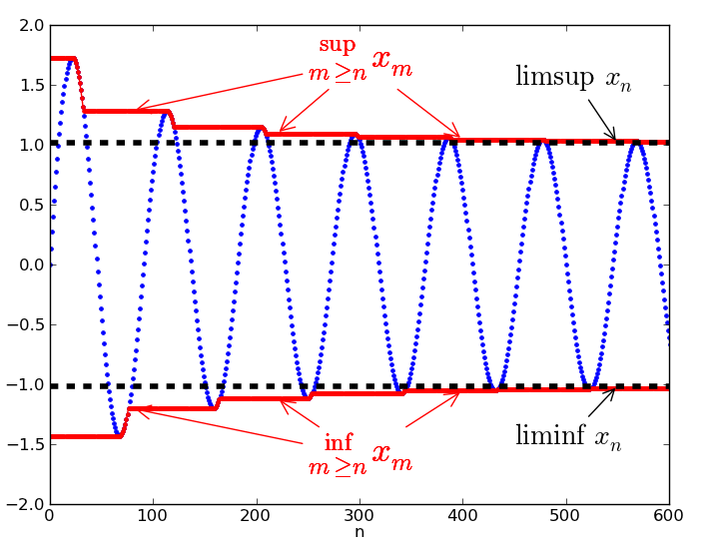
An illustration of limit superior and limit inferior. The sequence x_{n} is shown in blue. The two red curves approach the limit superior and limit inferior of x_{n}, shown as dashed black lines. In this case, the sequence accumulates around the two limits. The superior limit is the larger of the two, and the inferior limit is the smaller of the two. The inferior and superior limits agree if and only if the sequence is convergent (i.e., when there is a single limit). (Wikipedia)
- (Purdue)
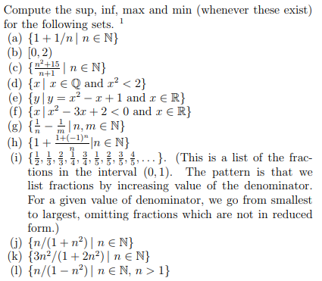
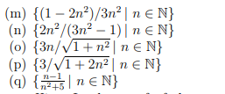
(s) $\left\{n^{{(-1)}^{n}}| n≥1\right\}$
- (Mattuck; 6.5.3) Assume that A and B are bounded non-empty subsets of R. Prove the following (for each part you can assume any of the preceding parts).
If c is a constant then we define cA = {ca | a$∈A$}.
Also, we define A + B = {a + b: a ∈ A, b ∈ B}.
- 𝐴$⊆B ⇒\sup\left(A\right)≤sup⁡(B)$
- $A⊆B ⇒\inf\left(A\right)≥inf⁡(B)$
- If c > 0, then sup cA = c sup A
- If c > 0, then inf ca = c inf A
- sup(-A) = - inf A
- inf (-A) = - sup A
- sup(A + B)$≤\sup{A+\sup{B}}$
- inf(A + B) $≥$inf A + inf B

- Let {a_{n}} be a bounded sequence, recall the definitions of lim sup a_{n} and lim inf a_{n}.
- For each of the following sequences $\left\{a_{n}\right\}, deteminelim sup{a_{n} andlim inf{a_{n}.}}$
- $a_{n}={(-1)}^{n}$
- $a_{n}=\cos{\frac{nπ}{2} }$
- $a_{n}=\left(arc\tan{n}\right)\sin{\frac{nπ}{2} }$
- $a_{n}=\frac{1+{(-1)}^{n}2n}{1+3n}$ .
- Let $a_{n}={\left(-1\right)}^{n}+\frac{1}{n}+3\sin{\frac{πn}{2}.}$ Let A = {$a_{n}$| n ≥ 1 $\}$.
Find sup A, inf A, lim sup $a_{n}$ and lim inf $a_{n}.$
- Define the sequence$\left\{a_{n}\right\} as follows:$
$$a_{n}= \left\{\begin{aligned}2^{\frac{1}{n+1} } if n is odd \\ \\ 1 if n is even\end{aligned}\right.$$
Calculate lim sup $a_{n}$and lim inf $a_{n}$.

- Let $\left\{a_{n}\right\} be the sequence 0, 1, 2, 1, 0, 1, 2, 1, 0, 1, 2, 1….$ and let $\left\{b_{n}\right\} be the sequence 2, 1, 1, 0, 2, 1, 1, 0, 2, 1, 1, 0…$ . Find:

$$\left(a\right)lim inf{a_{n}+lim inf{b_{n}}}$$
(b) lim inf ($a_{n}$ + $b_{n}$)
(c) $lim inf{a_{n}+lim sup{b_{n}}}$
(d) lim sup ($a_{n}$ + $b_{n}$)
(e) lim sup $a_{n}$ + lim sup $b_{n}$

- Prove that lim sup ($a_{n}+b_{n})$ ≤ $lim\sup{a_{n}}+lim\sup{b_{n}}$ Give an example when equality does not hold.
- Prove that lim inf $a_{n}+ lim\inf{b_{n}}$≤ lim inf ($a_{n}+b_{n})$ Give an example when equality does not hold.
- Prove the Proposition: If lim sup $a_{n}=s^{*}, then there exists a subsequence of \left\{a_{n}\right\} that converges to s^{*}.$

Numerical series
- Define: infinite series; sequence of partial sums; convergent series; divergent series; sum of a series
- Review the series (a) $\sum_{n=1}^{∞}{\frac{1}{n}}$ and (b) $\sum_{n=0}^{∞}{r^{n}}$ for |r| < 1
- How can a sequence be converted into a series?
- State and prove the n^{th} term test for divergence of series.
- State the Tail-convergence theorem for series.
- State and prove the Linearity theorem for series.
- State and prove the Comparison theorem for positive series.
- State and prove the Ratio test for series.
- State and prove the Integral test for positive series.
- State and prove the n^{th} root test for series.

MIT 18.01 (calculus) exercises on series:
7A-1 For each of the following series, determine convergence or divergence? Justify your answer. If the series converges, find its sum.

Constructing the Cantor set

