Math 351: class discussion, 24 October 2018
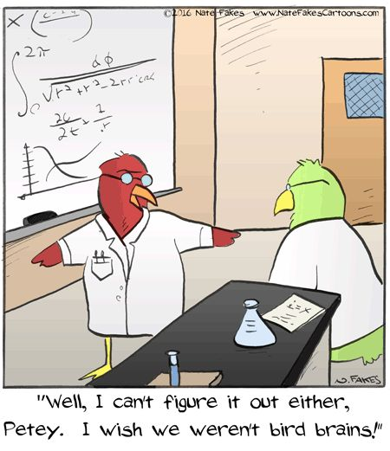
Series: Ratio test, root test, asymptotic convergence test, absolute convergence, cauchy’s theorem, rearrangements
Continuation: Numerical series
- Review the series (a) $\sum_{n=1}^{∞}{\frac{1}{n}}$ and (b) $\sum_{n=0}^{∞}{r^{n}}$ for |r| < 1
- What is meant by a “telescoping series”?
- What is the Cantor set?
- Review: Define conditional convergence; absolute convergence; alternating series
- Review: Prove that absolute convergence implies convergence. Is the converse true?
- State and prove the Ratio test for series.
- State and prove the Integral test for positive series.
- State and prove the n^{th} root test for series.
- State and prove the Asymptotic Comparison Test.
- State and prove Cauchy’s test for conditional convergence of an alternating series.
- What is a rearrangement of a series?
- State and prove the rearrangement theorems.
7A-1 For each of the following series, determine convergence or divergence? Justify your answer. If the series converges, find its sum.
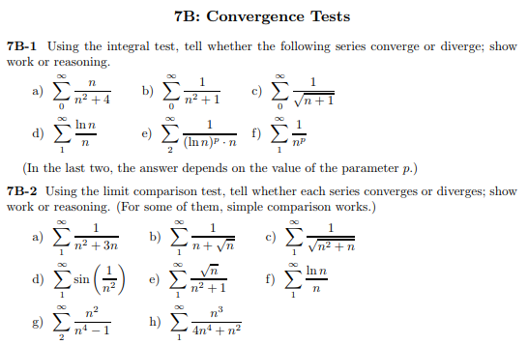
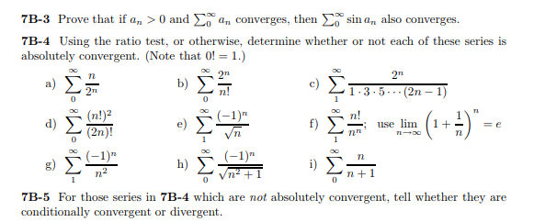

Challenge problems: Stewart, Calculus
1.
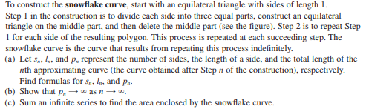
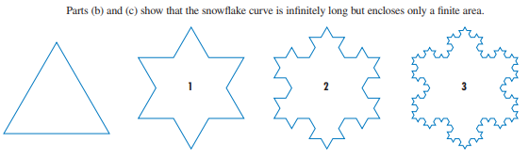
2.
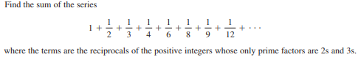

3. Sum the series
4. A sequence $\left\{a_{n}\right\}$ is defined recursively by the equations
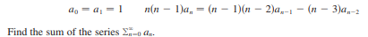
5.
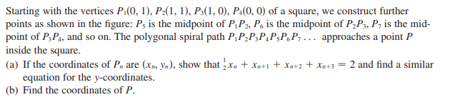
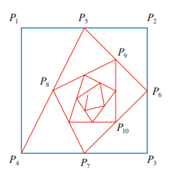

6. Right-angled triangles are constructed as in the figure. Each triangle has height 1 and its base is the
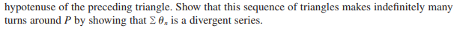
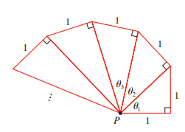

The notion of infinity is our greatest friend; it is also the
greatest enemy of our peace of mind.
- James Pierpont

Constructing the Cantor set

