Math 351: Questions for class discussion, 26th October
Brief look at Power series
Functions of one variable: continuity
Review:
Define conditional convergence; absolute convergence; alternating series; rearrangement
State and prove Cauchy’s test for conditional convergence of an alternating series.
Prove that absolute convergence implies convergence. Is the converse true?
State and prove the rearrangement theorems.
I Define: radius of convergence
- Prove the theorem: For each power series $\sum{a_{n}x^{n}}$ there is a unique R ≥ 0 such that $\sum{a_{n}}x^{n}$ converges absolutely for |x| < R and diverges for |x| > R.

- Find the radius of convergence (and the sum) of each of the following power series:
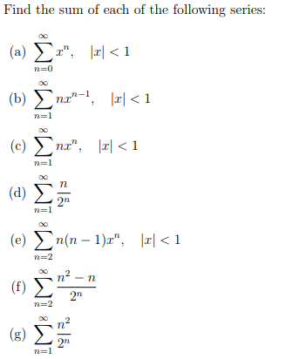
(h)
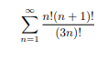
(i)
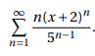

(Smith College exercises)
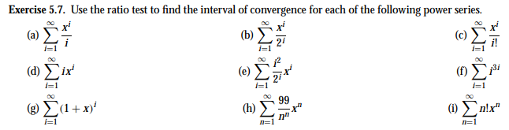
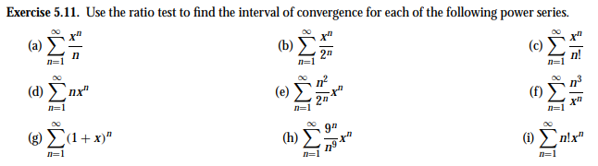

II Continuity & limits
1. Define function, domain, graph.
Let f(x) be defined on (a, b) and let p$∈\left(a,b\right).$ Define: f(x) is continuous at x = p.
Give both the “Mattuck” definition and the $ϵ, δ definitions.$

Define: f(x) is continuous on (a, b).

- Prove, using only the definition of continuity, that each of the following functions is continuous on the given interval.
- f(x) = x² on (-∞, ∞)
- f(x) = 1/x on (0, ∞)
- f(x) = $2x^{3}-4x$ on (-∞, ∞)
- f(x) = $\frac{x}{3+x^{2}}$ on (-∞, ∞)
- Prove that g(x) = sin x is continuous on (-∞, ∞). Hint: show that |sin a – sin b| ≤ |a – b| .
- Using (3) prove that $v\left(x\right)= \int_{0}^{π}{\frac{\sin{xt}}{t}} dt is continuous everywhere.$
- What are the four types of discontinuities?
- Define: right-continuity, left-continuity. Define: f(x) is continuous on [a, b].

- Using (3) prove that $G\left(x\right)= \int_{0}^{π}{\frac{\sin{xt}}{t}} dt is continuous everywhere.$ Which fact(s) about the Riemann integral are you taking for granted?

- What are the four types of discontinuities? For each of the four, provide an example.

- Let f be defined for x near p. Define: the limit of f(x) as $x→p$ equals L.

- What is the relationship between continuity and limit? Define: limit as x$→∞ or x →-∞$
- Prove each of the following results, using only the definition of limit.
- $\lim_{x→0}{x\sin{\frac{1}{x}}}$
- $\lim_{x→3+}{\frac{\left|x^{2}-9\right|}{x-3}}$
- $\lim_{x→∞}{\frac{1}{3+x^{2}}}$
- $\lim_{x→1}{\frac{x^{3}-125}{x-5}}$

