Math 351: class discussion, 3 October 2018
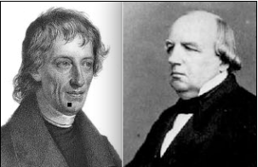
- Complete the proof of the Nested Intervals Theorem.
- Show that, for any $α∈ R, there exists a sequence of nested intervals having intersection \left\{α\right\}.$
- Example. Let $a_{0}=0, and for n≥1, let a_{n}=1-\frac{1}{2}+\frac{1}{3}-\frac{1}{4}+…+({-1)}^{n-1}\frac{1}{n}$
Using the nested interval theorem, prove that $\left\{a_{n}\right\} converges.$

- Definition: K is a cluster point of $\left\{a_{n}\right\}$means that, for all ε > 0, there exist infinitely many n for which
|a_{n} – K| < ε.

- Find any (and all) cluster points for each of the following sequences:
(a) ½, 1/3, ¼, 1/5, …
(b) 1, 2, 3, 4, 5, …
(c) 1, 0, 1, 0, 1, 0, …
(d) 1, 1, 2, 1, 2, 3, 1, 2, 3, 4, 1, 2, 3, 4, 5, …
(e) 2, 3, 5, 7, 11, 13, …

- Prove the Cluster Point Theorem: A sequence $\left\{a_{n}\right\}$ has a cluster point, K, if and only if there exists a subsequence of $\left\{a_{n}\right\}$ that converges to K.
- Prove the Bolzano-Weierstrass Theorem: A bounded sequence $\left\{a_{n}\right\} has a convegent subsequence.$

Exercises:
- Give an example of each of the following or argue that no such example exists:
- A sequence that has a subsequence that is bounded but contains no subsequence that converges.
- A sequence that does not contain 0 or 1 as a term but contains subsequences converging to each of these two values.
- A sequence that contains subsequences converging to every point in the infinite set
{1/2, 1/3, ¼, 1/5, …}.
- A sequence that contains subsequences converging to every point in the infinite set
{1, 1/2, 1/3, ¼, 1/5, …}, and no subsequences converging to points outside of this set.
- Decide whether each of the following statements is True or False. Provide either a brief justification or a counterexample.
- If every proper subsequence of $\left\{x_{n}\right\}$ converges, then $\left\{x_{n}\right\}$ converges as well.
- If $\left\{a_{n}\right\} contains a divergent subsequence, then \left\{a_{n}\right\} diverges.$
- If $\left\{a_{n}\right\} is bounded and diverges, then there exist two subsequences of \left\{a_{n}\right\} that converge$
to different limits.
- If $\left\{a_{n}\right\} is monotone and contains a convergent subsequence, then \left\{a_{n}\right\} converges.$

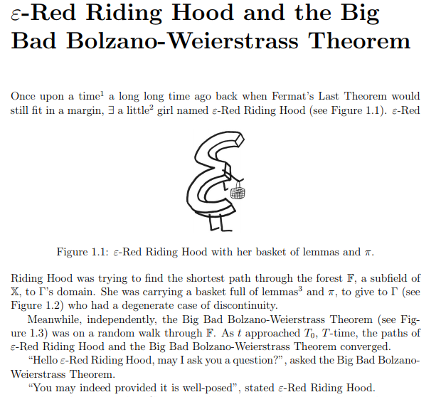
https://people.maths.ox.ac.uk/macdonald/errh/101_analysis_bedtime_stories_(epsilon_red_riding_hood).pdf

