Math 351: class discussion, 19 September
Limit Theorems
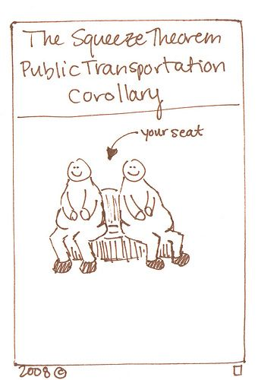
Review:
- Using the error-form principle, prove that if $a_{n}→L, then |a_{n}|→\left|L\right|.$ Is the converse true? Proof or counterexample.
- $If{ a}_{n}=\frac{25n^{3}+n^{2}-n+2018}{5n^{3}-13n^{2}+1789}=5$ find an M such that |e_{n}| < 0.02 for all n > M.
- Review: Let |a| < 1. For n ≥ 1, let $S_{n}=1+a+a^{2}+…+a^{n}.$
Using the error-form principle, prove that $\lim_{n→∞}S_{n}{=\frac{1}{1-a}.}$Hint: Show that ${ e}_{n}=-\frac{a^{n+1}}{1-a}.$
- State the three main limit theorems for sequences and prove each using the error-form principle.
- Using the limit theorems prove that
$$\lim_{n→∞}{\frac{25n^{3}+n^{2}-n+2018}{5n^{3}-13n^{2}+1789}=5}$$
- (Review of calculus) Derive a recursive form of Newton’s method for finding roots of a differentiable function y = f(x).
- (a) Applying Newton’s method to the polynomial p(x) = x² – 2, find a recursive sequence that converges to $\sqrt{2} .$ Use the error-form principle to prove the result.
(b) Practice exercise: using (a) as a guide, find a recursive sequence that converges to $\sqrt{5} .$
_____________________________________________________________________________
Two more major theorems of the week (in addition to the three limit theorems that you have stated in question 4 above.)
- Prove the Squeeze theorem, viz:
Given three sequences, $\left\{a_{n}\right\}, \left\{b_{n}\right\}, \left\{c_{n}\right\} satisfying a_{n}≤b_{n}≤c_{n} for n≫1.$
Suppose that $a_{n}→L and c_{n}→L . Then b_{n}→L .$
- Example: Let α be given. Then $\sqrt[n]{2+\cos{nα}}→1.$
Hint: Use the result of exercise 3.4/5, viz. If c > 0 then $\sqrt[n]{c} →1.$
- Example: Prove that $\lim_{n→∞}{\frac{ln⁡(n!)}{n\ln{n}}}=1.$ Hint: $\ln\left(n!\right)=\ln{1+\ln{2+\ln{3+…+\ln{n}}}}$
- Find $lim⁡n(a+\cos{n π}$) for different values of a.
- Prove the Sequence location theorem, viz:
$If \left\{a_{n}\right\} converges$ and lim a_{n} < M, then a_{n} < M for n >> 1.

- State the corresponding version of the Sequence location theorem for a convergent sequence bounded below.
- (a) Prove the Limit location theorem, viz:
$If \left\{a_{n}\right\} converges and ∃M such that a_{n}≤M for n≫1,$then $\lim_{n→∞}{a_{n} ≤M.}$
$\left(b\right)$State the corresponding version of the Limit location theorem for a convergent sequence bounded below.
- Prove the following useful Corollary to the LLT, viz. Let {a_{n}} and {b_{n}} be convergent sequences and assume that
a_{n} ≤ b_{n} for n >> 1. Then lim a_{n} = lim b_{n}.

Exercises from Apostol
In Exercises 1 through 10, compute the limits and explain which limit theorems you are using in each case.
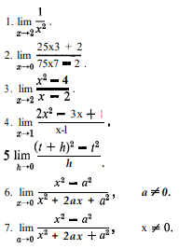 | 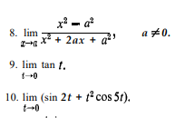
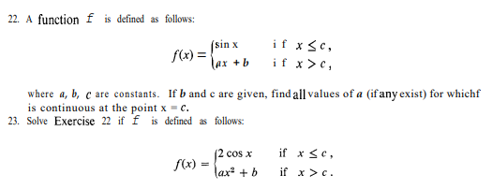

Calculus has its limits.
- Anonymous

