Math 351: class discussion, 24 September
Subsequences; nested intervals theorem
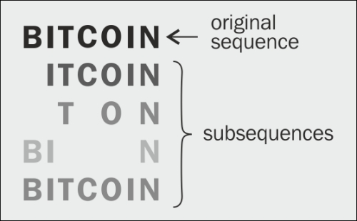
Review:
- Example: Let α be given. Then $\sqrt[n]{2+\cos{nα}}→1.$
- Example: Prove that $\lim_{n→∞}{\frac{ln⁡(n!)}{n\ln{n}}}=1.$ Hint: $\ln\left(n!\right)=\ln{1+\ln{2+\ln{3+…+\ln{n}}}}$.
Note: This is a simplified version of Sterling’s formula.
- Prove the Sequence Location Theorem, viz:
$If \left\{a_{n}\right\} converges$ and lim a_{n} < M, then a_{n} < M for n >> 1.

- State the corresponding version of the Sequence location theorem for a convergent sequence bounded below.
- (a) Prove the Limit Location Theorem, viz:
$If \left\{a_{n}\right\} converges and ∃M such that a_{n}≤M for n≫1,$then $\lim_{n→∞}{a_{n} ≤M.}$
$\left(b\right)$State the corresponding version of the Limit location theorem for a convergent sequence bounded below.
- Prove the following useful Corollary to the LLT, viz. Let {a_{n}} and {b_{n}} be convergent sequences and assume that
a_{n} ≤ b_{n} for n >> 1. Then lim a_{n} ≤ lim b_{n}.
_______________________________________________________________________________________
- Define subsequence of a sequence {a_{n}}. Consider the sequence 1, 2, 1, 2, 3, 1, 2, 3, 4, 1, …
Find several convergent subsequences and several divergent sequences.
- (a) If {a_{n}} is monotone for n>>1, is every subsequence of {a_{n}} monotone for n>>1?
(b) If {a_{n}} is bounded for n>>1, is every subsequence of {a_{n}} bounded for n>>1?
(c) If a_{n} $→∞$, must every subsequence b_{n} $→∞ ?$
- Find an example of a sequence that has countably many subsequences each having a distinct limit.
- Find an example of a sequence that has uncountably many subsequences, each having a distinct limit.
- State and prove the Subsequence Theorem.
- Prove, using the subsequence theorem, that the sequence {$\sin{(\frac{nπ}{2})}$} does not converge.
- Prove, using the subsequence theorem, that the sequence {$\sin{n\}}$ does not converge.
Hint: Consider the region where $\sin{n} ≥\frac{\sqrt{2}}{2}$.
- What is meant by a nested sequence of intervals? Give several examples, some of which have intersection (a) containing only one point; (b) containing infinitely many points; (c) empty.
- State the Nested Intervals Theorem. Give a proof. Can any of the hypotheses be eliminated or weakened?

- Show that, given any $α∈ R, there exists a sequence of nested intervals having intersection \left\{α\right\}.$

- Example. Let $a_{0}=0, and for n≥1, let a_{n}=1-\frac{1}{2}+\frac{1}{3}-\frac{1}{4}+…+({-1)}^{n-1}\frac{1}{n}$
Using the nested interval theorem, prove that $\left\{a_{n}\right\} converges.$

- Define cluster point of a sequence.

- Find any (and all) cluster points for each of the following sequences:
(a) ½, 1/3, ¼, 1/5, …
(b) 1, 2, 3, 4, 5, …
(c) 1, 0, 1, 0, 1, 0, …
(d) 1, 1, 2, 1, 2, 3, 1, 2, 3, 4, 1, 2, 3, 4, 5, …
(e) 2, 3, 5, 7, 11, 13, …

