Math 351: Questions for discussion, 5 September 2018
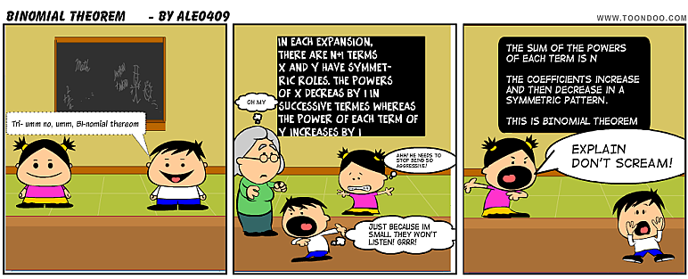
Questions revisited from last week.
- Define $\left(\begin{aligned}n \\ r\end{aligned}\right)$. State some interesting identities.
- Prove that the sequence $\left\{{\left(1+\frac{1}{2^{n}}\right)}^{2^{n}}\right\} is increasing.$ Hint: Begin with (1+b)² > 1+2b for b ≠ 0. Then raise each side to the power 2^{n}.

- State the binomial theorem for (1 + x)^{n} where n is a positive integer.
Prove the binomial theorem using induction. Also, give a combinatorial argument for the binomial theorem. Prove that the sequence $\left\{{\left(1+\frac{1}{k}\right)}^{k}\right\}$ is bounded above. Can we conclude that the sequence $\left\{{\left(1+\frac{1}{2^{k}}\right)}^{2^{k}}\right\}$ converges? Why?
- Define Euler’s number, $γ.$ Prove the existence of Euler’s number.

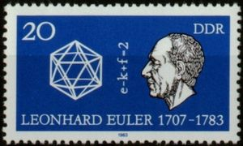
- What does n>>1 mean? Prove that if {a_{n}} and {b_{n}} are increasing sequences for n>>1, then {a_{n} + b_{n}} is increasing for n>>1.
- What is an Equivalence Relation on a set X?
Review exercises on equivalence relations:
Let R be a relation on a set S. What does it mean for R to be Reflexive? Symmetric? Transitive? What is an equivalence relation on S? Explain how an equivalence relation corresponds to a partition on the set S. What does the term equivalence class mean?
- Determine which of the three properties “reflexive,” “symmetric,” and “transitive,” apply to each of the following relations on the set of integers. For each relation that is an equivalence relation, describe the equivalence classes.

a R b iff
- a = b
- a < b
- a < b
- a | b
- |a| = |b|
- a² + a = b² + b
- a < |b|
- ab > 0
- ab > 0
- a + b > 0
- a ≡ b mod 4
- a ≡ b mod m (where m > 0)
- Do the same as in (A) for the following relations on the set of all people. p R q iff
  - p “is a father of” q
  - p “is a sister of” q
  - p “is a friend of” q
  - p “is an aunt of” q
  - p “is a descendant of” q
  - p “has the same height” as q
  - p “likes” q
  - p “knows” q
  - p “is married to” q

Exercises for groupwork.
  - Prove that the sequence $\left\{\frac{n}{3^{n}}\right\}$ is monotone.
  - Let $a_{n}=\sum_{j=1}^{n}{\frac{1}{\sqrt[3]{j}}} for n≥1.$ Prove that $\left\{a_{n}\right\} is unbounded.$
  - Using the Completeness Property of R, prove that the sequence $a_{n}=\frac{1∙3∙5∙…(2n+1)}{2∙4∙6∙…(2n)}$ converges.
  - Prove that the sequence $\sqrt{2}, \sqrt{2+\sqrt{2}}, \sqrt{2+\sqrt{2+\sqrt{2}}},$… converges. Can you find its limit? Note that this sequence can also be defined recursively, viz.
$$a_{1}=\sqrt{2} ;$$
$$For n≥1, { a}_{n+1}=\sqrt{2+a_{n}}$$

