Math 351: Questions for discussion, 7 September 2018
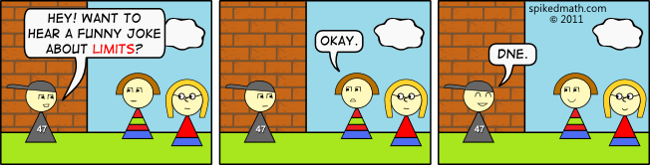

- Exercises (continued from last meeting)
  - Prove that the sequence $\left\{\frac{n}{3^{n}}\right\}$ is monotone.
  - Let $a_{n}=\sum_{j=1}^{n}{\frac{1}{\sqrt[3]{j}}} for n≥1.$ Prove that $\left\{a_{n}\right\} is unbounded.$
  - Using the Completeness Property of R, prove that the sequence $a_{n}=\frac{1∙3∙5∙…(2n-1)}{2∙4∙6∙…(2n)}$ converges.
  - Prove that the sequence $\sqrt{2}, \sqrt{2+\sqrt{2}}, \sqrt{2+\sqrt{2+\sqrt{2}}},$… converges. Can you find its limit? Note that this sequence can also be defined recursively, viz.
$$a_{1}=\sqrt{2} ;$$
$$For n≥1, { a}_{n+1}=\sqrt{2+a_{n}}$$
- LIMITS
- What does n>>1 mean? Prove that if {a_{n}} and {b_{n}} are increasing sequences for n>>1, then
{a_{n} + b_{n}} is increasing for n>>1.

- Define absolute value. State and prove the multiplicative property and the triangle inequality. State and prove, using induction, the extended triangle inequality. Show that the inequality |a – b| ≥ |a| – |b| (called the difference form of the triangle inequality) follows directly from the triangle inequality.

- Let s_{n} = c₁ cos t + c₂ cos 2t +…+ c_{n} cos nt where $c_{j}= \frac{1}{2^{j}}$ . Prove that {s_{n}} is bounded by 1.
- Define the notation: ${a }_{ϵ}^{≈}$ b where $ϵ>0.$ What are the “reflexive property”, “symmetry property”, the “transitive property” and the “additive property”?
- Let $b_{n}= \frac{2n+7}{n-9}.$ Guess the limit, L, of the sequence {$b_{n}$}. For which (positive) values of n is ${b_{n} }_{0.1}^{≈} L ?$

- Let $b_{n}= \frac{n+3}{n^{2}+n+19}.$ Guess the limit, L, of the sequence {$b_{n}$}. For which (positive) values of n is ${b_{n} }_{0.001}^{≈ } L ?$
- Let {b_{n}} be a sequence. Give the definition of: {b_{n}} converges.
Give the definition of: {b_{n}} converges to L.
- Let $z_{n}= \frac{1789+ cos{(2018n)}}{3n+88}.$ Prove that {z_{n}} converges to a limit L.
- Let $e_{n}= \sqrt{n^{2}+5n+1789}- \sqrt{n^{2}+n+1689} .$ Prove that {e_{n}} converges to a limit L.
- Prove that if a sequence converges to L, then L is unique.
- Prove that if {a_{n}} is a non-negative sequence converging to 0, the sequence$\left\{\sqrt{a_{n}}\right\}$ must converge to 0 as well.
- Prove that the sequence $a_{n }= \frac{1}{n+1}+ \frac{3}{n+2}$ converges.
- Define $lim$ a_{n} = ∞.
- Prove that the sequence a_{n} = 1+ n² $→∞$.
- Which of the following sequences tend to ∞? For those that do, prove it.
- (-1)²
- $\frac{n}{n+4}$
- (-1)^{n} n²
- $\sqrt[3]{n+1}$
- 1+ n²
- ${(-1)}^{n}+\sin{n} + e^{n}$
- sin n + ln n
- Prove the theorem:$If a>I then \lim_{n→∞} a^{n}= ∞.$
$$Hint: let a=1+k where k>0. Then apply the binomial theorem$$
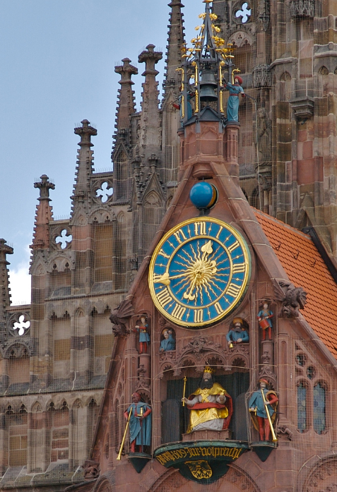
The definition of a limit is essentially [Cauchy’s] creation and is as much of a miracle as those fantastic Swiss clocks of the period in which hundreds of gleaming cogs are made to celebrate not only the time and date but the phases of the moon."
-- David Berlinski

