Questions for class discussion: MATH 351
Fall 2018

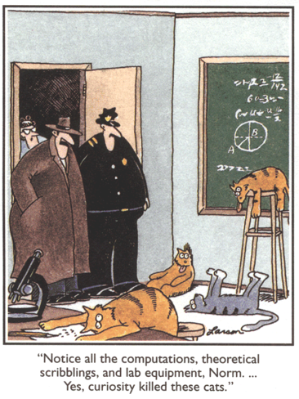

27 August videos (Abbott & Costello, Colbert, Ramanujan summation)
29 August real number system; closure properties of sets with a binary operator
31 August monotone sequences; Completeness Property of R; convergence of$\left\{{\left(1+\frac{1}{2^{n}}\right)}^{2^{n}}\right\}$; combinations
5 September binomial theorem; Euler’s number; equivalence relations
7 September notation ($ε$ close, for large n); limits of sequences
10 September K-$ε$ principle; more on limits
12 September limits, continued
14 September error term analysis
17 September laws of limits; subsequences
19 September squeeze theorem
21 September location theorems; subsequences
24 September subsequences; nested interval theorem
26 September nested intervals, subsequences, continued
28 September practice test review
1 October Test I
3 October cluster points, Bolzano-Weierstrass theorem
5 October Bolzano-Weierstrass, Cauchy sequences
10 October Cauchy sequences; supremum, infimum of a set
12 October Completeness theorem; intro to lim sup
15 October Continuity
17 October lim sup, lim inf, introduction to series
22 October Test II
24 October series (ratio and root tests; asymptotic convergence test; integral test; Cauchy’s test)
26 October power series and intro to functions
29 October functions
31 October continuity; limits
2 November functions of one variable; continuity; limits; sequential continuity
5 November limit theorems; sequential continuity
9 November Bolzano’s theorem
12 November Bolzano’s theorem; IVT
14 November Compactness; Extreme Value Theorem
16 November Maximum theorem; continuous mapping theorem; review for test 3
19 November Test III
26 November mappings; uniform continuity
28 November metric spaces

Work! God wills it. That, it seems to me, is clear.
- Gustave Flaubert (letter to Louise Colet, 1845)
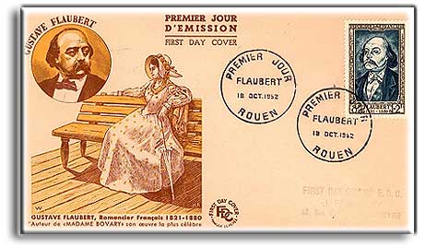

Course Home Page Department Home Page Loyola Home Page

