SURVIVAL SHEET: MATH 351

Fall Semester 2018

Text: Arthur Mattuck, Introduction to Analysis, 1st edition, latest printing, Prentice-Hall (1999)
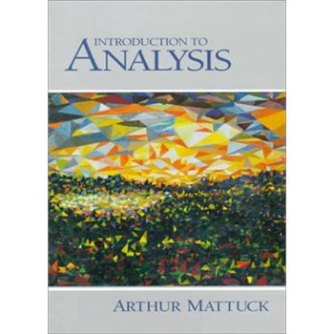
Instructor: A. Saleski, BVM 612 (IES complex)
phone: (773) 508-3577; e-mail: asalesk@luc.edu or alan.saleski@gmail.com
Course URL: http://www.math.luc.edu/~ajs/courses/351fall2018/index.pdf
Office Hours: MWF 12 noon – 1:00 pm; 4:00 – 4:45 pm TTh 11:30 am – 1:00 pm or by appointment.

Discussion Section: TBA
Ground Rules: The final grade is computed according to the following recipe:

Tests | 31 %
Homework | 31 %
Piazza contributions | 3 %
Group Work | 4 %
Project | 5 %
Final Exam | 26 %

Piazza: https://piazza.com/luc/fall2018/math351001fall2018/home

Grading scale:
A 90 – 100
A- 87 – 89
B+ 85 – 86
B 80 – 84
B- 75 – 79
C+ 70 – 74
C 65 – 69
C- 60 – 64
D+ 50 – 59
D 40 – 49
F 0 - 39

Important Dates:
• Tests: (all Mondays) October 1; October 22; November 19
- Holidays:
- Labor Day: Monday, September 3rd

- mid-semester break: Monday & Tuesday, October 8th – 9th
- Thanksgiving break: Wednesday – Sunday, November 21st – November 24th
- Last day to withdraw without a grade of WF:
Midnight, Friday, November 2nd
• Last day of Class: Friday, December 7th
• Final Exam, Monday, December 10th (9:00 – 11:00 am)
• Loyola Calendar (Fall 2018)

Remarks:
1. Late homework will not be accepted. Further instructions about writing up the homework will be given in class.

2. The minimum penalty for cheating is failure in the course. A student who improperly aids another with a test, the final exam, or with homework is considered equally culpable. On the homework, you must acknowledge with whom you may have collaborated. Using the web to obtain solutions to take-home tests will result in a grade of F for both portions of the test.
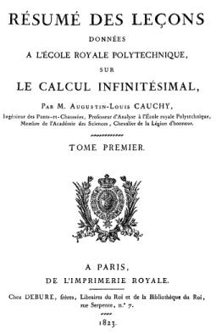Augustin-Louis Cauchy (1789 – 1857) was the first to embark upon a rigorous study of the conditions for convergence of infinite series in addition to his rigorous definition of an integral. His famous text, Cours d'analyse, published in 1821 and designed for students at l’École Polytechnique, was devoted to developing the basic theorems of the calculus as rigorously as possible.

Course Home Page Department Home Page Loyola Home Page

