HOMEWORK: MATH 351
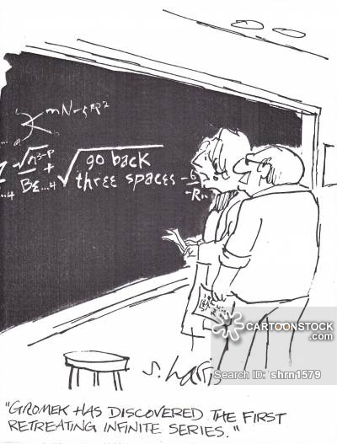

Remarks: In general, each solution should be on a separate page. State the problem at the top of the page. Refine your solution until you feel that it is logical, coherent, and complete. (This may require several versions before you are satisfied with the outcome.) In addition to correctness, neatness and clarity will be significant criteria in determining your homework grade. Also, be certain to staple your pages together and label the number of the homework assignment. In your solution, skip lines so that the grader can make comments. As you learned in Math 201, a proof is not considered readable if you fail to include appropriate words, phrases, and sentences.
If you collaborate with other students or faculty, you must acknowledge this at the beginning of the assignment. Similarly, if you are inspired by a website (or websites), you must also list the website(s).
If you fail to follow the above rules, the homework will not be graded. Late homework will not be accepted.
Homework 0: (Due: midnight, Wednesday, 29 August 2018)
Briefly provide (in one or two paragraphs) information about yourself that will help me get to know you. If you wish, you may let the following questions serve as a guide: why are you taking Math 351? What are your goals after graduation? If you have not taken Math 201, please explain. Describe your experience in Math 201. Are you enrolled in other math courses this semester? Do you have any minors or second major?
(Please post your response as a private message in Piazza with the subject HW 0.)
Homework I: (Due: Wednesday, 12 September)
Purchase or download a copy of Tom Apostol’s One-Variable Calculus, volume 1.
Read and reread Chapter 1 of Mattuck. Study Appendix A (sections A.0, A.1, A.2, and A.3) and Appendix B (all 3 sections). Begin reading Chapter 2.
Review the questions at the end of each section of Mattuck’s chapter 1 and the end of A.0. A.1, A.2, and A.3. (Note that the solutions to all of the questions are provided in the text.)
Solve carefully the following exercises on pages 12 – 13: 1.2.1, 1.3.1, 1.3.2, 1.4.1, 1.5.1, 1.5.3, 1.5.4, 1.6.1, 1.6.4. Solve 14 / problems 1.1, 1.2.
Submit solutions to the following:
- Mattuck, pg. 13 / exercises 1.4.2 and 1.6.3
- Mattuck, pg 14/problem 1-1.
- Apostol, 36/5:
- Prove that the following sequence converges:
- Guess a general law that simplifies s_{n}.
Homework II: (Due: Wednesday, 19 September)
Read carefully Chapters 2 and 3. Review Appendix A, as needed.
Solve exercises 2.1.1, 2.1.2, 2.1.4, 2.2.1(b), 2.3.1, 2.4.1, 2.4.2, 2.5.1, and 2.5.2 on pages 30 – 32. Also, solve problems 2.3 and 2.4 on page 32. Solve exercises 3.1.1 (b, c, d), 3.1.2, 3.2.1, 3.2.2, 3.2.4, 3.4.1, 3.4.2, 3.4.3
Submit: Mattuck,
p. 32 / exercises 2.6.3, 2.6.4 (b)
p. 32 / problem 2.1
pg. 46 / exercises 3.1.1 (a) and 3.2.3
pg. 48 / problems 3.1, 3.2
Homework III: (Due: Wednesday, 3 October)
Review Chapter 3. Study carefully Chapter 4 and sections 5.1, 5.2 and 5.3 of chapter 5.
Solve exercises 3.4.5, 4.1.1, 4.2.1, 4.3.1, 4.3.2, 4.3.3; exercises 5.1.1, 5.2.1, 5.2.3, 5.3.1, 5.3.2, 5.3.3, 5.3.4, 5.3.5; problems 4.1, 5.2, 5.3
Submit: exercises 3.6.1 (a), 3.7.1, 5.1.4, 5.2.4; problems 5.1(a, b)
Prepare for Test I (1 October). Study chapters 1 – 5 and 6.1, 6.2, 6.3. Also review appendices A and B.
Homework IV: (Due: Friday, 19th October)
Carefully read Chapter 6. Also, you are encouraged to begin reading the first two sections of Chapter 7.
Solve exercises 6.2.1, 6.2.1, 6.2.2, 6.3.1, 6.4.1, 6.4.3, 6.5.1, 6.5.2, 6.5.3; problems 6.3 6.6, 6.7
Submit: exercises 6.4.2, 6.5.4, problems 6.1, 6.5a

Prepare for Test II (22 October). Study chapter 6 and chapter 7 (sections 7.1, 7.2, and 7.3) including all the Questions in each section.

Homework V: (Due: Friday, 2nd November) (REVISED)
Carefully read Chapter 7 and section 8.1. The remainder of Chapter 8 is optional reading. Read Chapter 9; this is mostly a review of topics in pre-calculus. Skim Chapter 10; this distinction between global and local properties will play little role in the remainder of the text. Carefully read section 11.1.
Solve exercises 7.1.1, 7.1.2, 7.1.3, 7.4.1, 7.6.1, 7.7.1; problems 7.6, 7.7
Submit exercises 7.2.1 and 7.2.2 and problems 7.1 and 7.4.

Homework VI: (Due: Friday, 9th November)
Read Chapter 11. Solve exercises 11.1.1, 11.1.6, 11.2.2, 11.3.1, 11.3.2, 11.4.1, 11.5.1, 11.5.4, 11.3a; 11.5.2
Submit: exercises 11.2.1, 11.2.3, 11.3.3 (a), 11.5.3

Homework VII: (Due: Friday, 16th November)

Carefully read sections 12.1, 12.2, and 12.3. Skim section 12.4.
Begin studying chapter 13.
Solve exercises 12.1.1, 12.1.3, 12.1.5, 12.2.1, 12.2.2, 13.1.1, 13.1.2; Problems 13.2, 13.4
Submit (revised): exercises 12.2.1, 13.1.1, 13.3.1; problems 12.2
Review for Test III

Homework VIII: (Due: Friday, 7th December)

Carefully read chapter 13 of Mattuck. Begin reading Appendix F (compactness via open sets)
Solve exercises 13.2.2, 13.4.1, 13.4.2, 13.5.1, 13.5.4, 13.5.6
Submit: exercises 13.5.3; problems 13.1, 13.5, 13.6
Prepare for Final Exam.

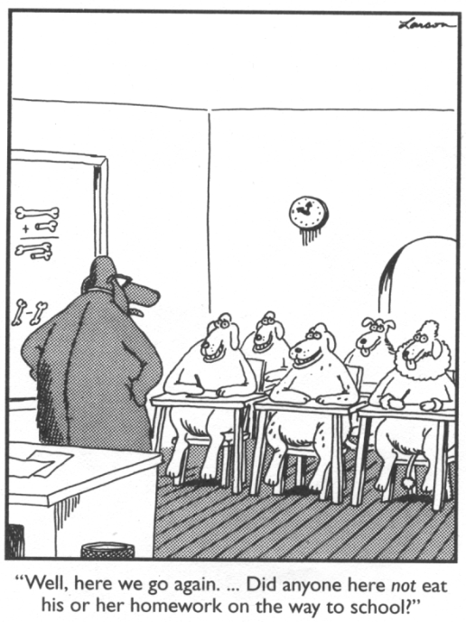

Never work when hungry.
- Hippocrates
Where our work is, there let our joy be.
- Tertullian
Let us work without protest; it is the only way to make life endurable.
- Voltaire
Work! God will it. That, it seems to me, is clear.
- Flaubert
Course Home Page Department Home Page Loyola Home Page

