Math 351 solutions: HW II

*Solutions to the following:*

Mattuck

p. 32 / exercises 2.6.3, 2.6.4 (b)

p. 32 / problem 2.1

pg. 46 / exercises 3.1.1 (a) and 3.2.3

pg. 48 / problems 3.1, 3.2

**Exercise 2.6.3**

Prove that if $ε>0 is given, then \frac{n}{n+2}{ }_{ϵ}^{≈ }1, for n≫1.$

**Solution:** Choose $N=\frac{2}{ϵ}$.

Then, for n > N, $\left|\frac{n}{n+2}-1\right|=\left|\frac{2}{n+2}\right|<\frac{2}{n}<\frac{2}{N}<ϵ$

**Exercise 2.6.4 (b)**

Prove that {an} is decreasing for n>>1, if **a6** = 1 and

(b)

**Solution:**

$$\left(b\right) \frac{a_{n+1}}{a_{n}}=\frac{n^{2}+15}{(n+1)(n+2)}<\frac{n^{2}+15}{(n+1)n}=\frac{1+\frac{15}{n}}{1+n}<1 when n>6$$

**Problem 2.1**

Let {an} be a sequence. We construct from it another sequence {bn} as follows:



1. Prove that if {an} is increasing, then {bn} is also increasing.
2. Prove that if {an} is bounded above, then {bn} is also bounded above.

**Solution:**

***Part (a):***Assume that {an} is increasing. Then an+1 ≥ an for all n∈**N**.

Now $b_{n+1}-b_{n}=$

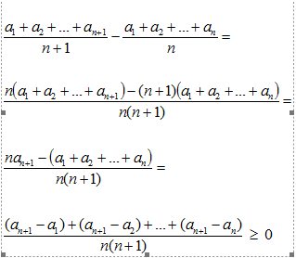

Hence{bn} is increasing.

***Part (b):***Assume that {an} is bounded above. Then, by definition, there exists *c*∈**R** such that an ≤ c for all

n ≥ 1. Thus



and hence, for all n ≥ 1:



Thus {bn} is bounded above.

**Exercise 3.1.1 (a)**

Show that $\lim_{n→∞}{\frac{sin n-cos n}{n}=0 }$ directly from the definition of limit.

**Solution**: Let $ε>0 be given.$

Then, invoking the triangle inequality,

$\left|\frac{sin n-cos n}{n}-0\right|= \frac{1}{n}$ $\left|sin n-cos n\right|≤\frac{1}{n}$ $\left(|sin n| + |cos n|\right)≤\frac{2}{n}<ε when$ $n>\frac{2}{ε}$

**Exercise 3.2.3 (a)**

Let $a_{n}= \frac{1}{n+1}+\frac{1}{n+2}+…+\frac{1}{2n}.$ Prove that an → 0.

1. Prove that {an} converges.

**Solution:**

***Part (a):*** *The sequence {an} is bounded above by 1 since:*

$a_{n}= \frac{1}{n+1}+\frac{1}{n+2}+…+\frac{1}{2n} ≤ \frac{1}{n+1}+\frac{1}{n+1}+$ $…+$ $\frac{1}{n+1}=\frac{n}{n+1}<1$

*Next, observe that:*

$$a_{n+1}-a_{n}=$$

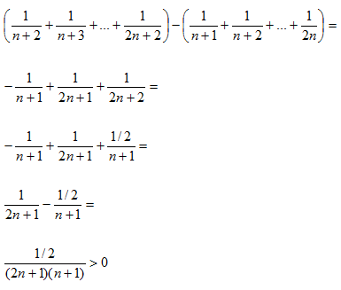

*Thus {an} is strictly increasing.*

*Now, since {an} is bounded above and increasing, we invoke the Completeness Theorem to conclude that {an} converges.*

**Problem 3.1:**

Let {an} be a sequence. As before, let {bn} be defined as follows:



1. Prove that if an → 0, then bn → 0.
2. Deduce from part (a) in a few lines that if an → L, then bn → L.

**Solution:**

*Part (a):* Assume that an → 0.

Let ε > 0 be given. Choose n*∈ **N,** n ≥ 2, such that |an – 0| < ε when n ≥ n*.

Choose m*∈ **N** such



Next, let r* = max{n*, m*}.

Thus, invoking the K-principle, bn 0.

*Part (b):* Assume that an → L.

Define dn = an – L. We first show that dn → 0. Let  > 0 be given. Then an is -close to *L* for large *n*. Using the additivity property, dn = an – Lis -close to *L* – *L = 0*. So dn → 0.

Using part (a), we obtain yn 0, where



Since



we obtain



Using the “-close”argument given above, we obtain:



**Problem 3.2:** To prove an was large if a > 1, we used “Bernoulli’s inequality.”

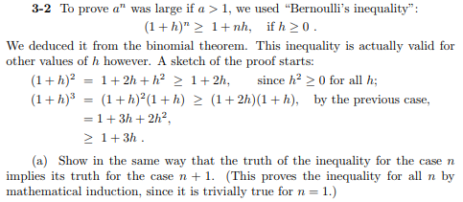

**Solution:** Assume that h $≥$ 0 and that $n≥0.$

Let P(n) be the statement that (1 + h)n

Base case: n = 0

LHS = ${(1+h)}^{0}=1$

RHS = 1 + 0 h = 1

This establishes the base case.

Inductive step: Assume that ${(1+h)}^{n}≥1+nh.$

Then ${(1+h)}^{n+1}=\left(1+h\right){\left(1+h\right)}^{n}≥\left(1+h\right){\left(1+h\right)}^{n}≥\left(1+h\right)\left(1+nh\right)=1+nh+nh^{2}≥$

$$1+h+nh=1+\left(n+1\right)h$$

This proves P(n+1) which completes induction.



**Solution:**

If $-1≤h≤0$, then the induction argument above remains valid.

The key observation is that, $1+h≥0 when-1≤h≤0.$ And so then the inequality

$\left(1+h\right){\left(1+h\right)}^{n}≥\left(1+h\right)\left(1+nh\right)$*is still valid because ${(1+h)}^{n}≥1+nh≥0$.*