Math 351 test 2 preparation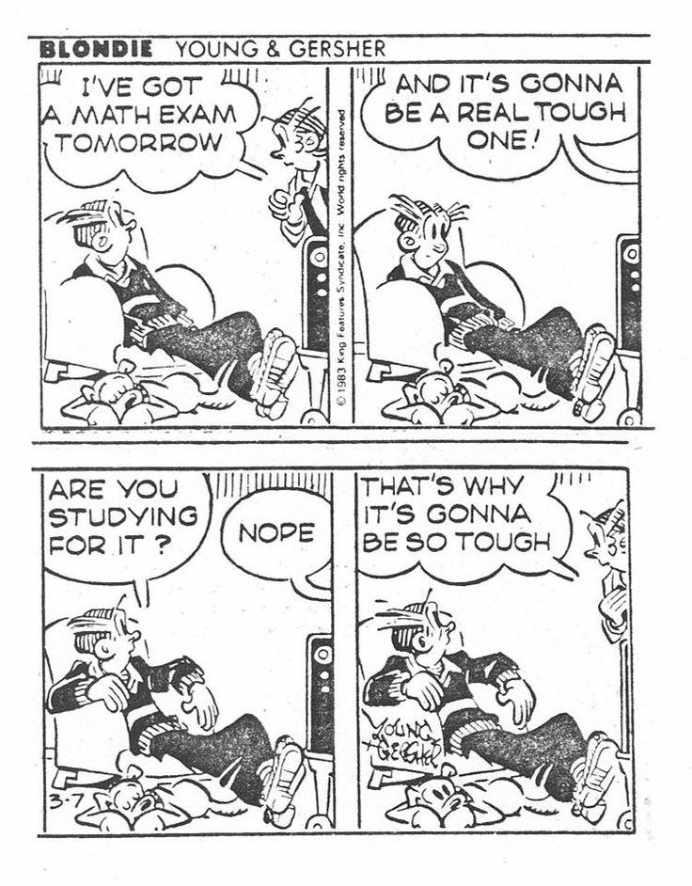
How best to prepare? Review the homework exercises. Study the practice test.
Study chapter 6 and chapter 7 (sections 7.1, 7.2, and 7.3) including all the Questions in each section.

1. Learn all the definitions (exactly as they appear in Mattuck).
This includes the definition of lim sup and lim inf of a sequence as well as convergent series, absolutely convergent series, and conditionally convergent series.
Know statements of all the named theorems.

2. True and False questions may include converse, inverse, or contrapositive of well-known results in the text as well as statements that may test your intuition.
For example,
If ${\left(a_{n}\right)}^{2}→0, then \sum_{1}^{∞}{a_{n} converges.}$
If A and B are non-empty bounded sets, t$hen\inf\left(A+B\right)≤\inf{A}+\inf{B}$
If A and B are non-empty bounded sets, t$hen\sup{A}=-\inf{(-A)}$

3. Computational problems

Finding the sup, inf, max, min of a given sequence.
Finding lim sup, lim inf of a bounded sequence.
Determine if a given sequence is Cauchy using only the definition
geometric series
Sum a series
Elementary convergence tests.

4. Proofs
Cluster point theorem
Bolzano-Weierstrass theorem
completeness property for subsets of the reals
properties of sup and inf.
n^{th} term test for divergence
linearity theorem for series
tail-convergence theorem
comparison test
absolute convergence theorem

