**MATH 351 Practice TEST III 14th November 2018**

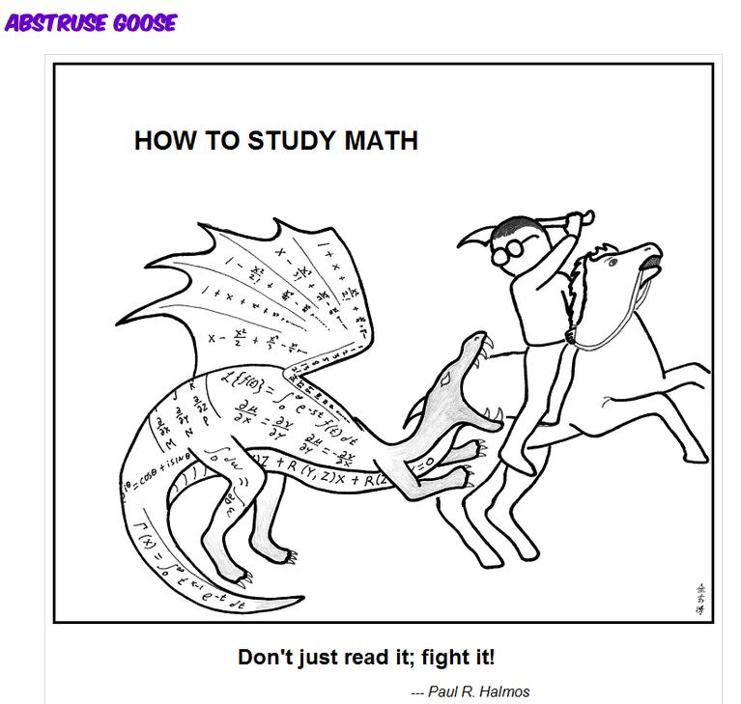

**Part I** *Definitions and statements of theorems*

**Part II** (*Each of the following 14 assertions is false.* *Give an explicit counter-example to illustrate this.*

1. If H: (0, 1) → **R** is continuous, then *H* is unbounded.
2. If G: **R** → **R** is discontinuous at every x ∈**R**, then G2 is discontinuous at every x∈**R**.
3. There does not exist a function g: **R** → **R** that is discontinuous *only* at every x∈ **N**.
4. There does not exist a function f: **R** → **R** that is continuous *only* at every x∈ **N**.
5. If G: [0, 1] → **R** is continuous then the set S = {x ∈ [0, 1]: G(x) = 0} is either uncountable or finite (possibly empty).
6. Let I = (0, 1). There does not exist a function g: I → **R** such that g(I) is a compact interval of positive length.
7. If two functions, f: **R** → **R** andg: **R** → **R** satisfy the conditions that



and *f* is continuous at x = 3,



1. If F: [0, 1] → **R** is continuous and {xn} ⊂ [0, 1] is a sequence for which F(xn) converges then {xn} must converge.
2. If f: [a, b] → **R** satisfies the Intermediate Value Property on [a, b], then *f* is continuous on [a, b].
3. Let F: **R**→ **R** be continuousand let A, B⊆ **R**. Then F(A ∩ B) = F(A) ∩ F(B).
4. If *S* and *T* are sequentially compact subsets of R, then $A∖B$ ={x∈S | x∉T} is sequentially compact.
5. Let G: (0, 1) → **R** be a continuous function and let {an} ⊂ (0, 1) be a Cauchy sequence. Then {G(an)} is a Cauchy sequence.
6. Let h: [0,1] → **R** be a function that achieves a maximum value on the interval [0, 1]. Then the function F(x) = (h(x))2 also achieves a maximum value on the interval [0, 1].
7. Let f: **R** → **R** and g: **R** → **R** each have a jump discontinuity at x = 5. Then f + g has a jump discontinuity at x = 5.

**Part III**

*Instructions:**Select any 3 of the following 4 problems. You may answer all 4 to obtain extra credit.*

1. Let I = [a, b] be a compact interval. Prove that *I* is sequentially compact.
2. Using *only the definition of limit*, prove that 
3. Let G: (a, b) → **R** be a uniformly continuous function and let {xn} ⊂ (a, b) be a Cauchy sequence. Prove that {G(xn)} is a Cauchy sequence.
4.  be defined on **R** and let x0∈**R**. Prove, using the definition of continuity, that *f* is continuous at x = x0.

(*Hint:* You may use, without proof, the lemma for bounding |sin A – sin B|.)

**Part IV**

*Instructions:**Select any 4 of the following 5 problems. You may answer all five to obtain extra credit.*

1. State and prove the Squeeze Theorem for functions.
2. $Let g\left(x\right)=\int_{0}^{2}{\frac{t^{3}}{ 1+x^{2}t^{5}+x^{4}t^{9}}}dt.$ Prove that exists and find its value.

*Hint:* Use the squeeze theorem.

1. Let *f* and *g* be uniformly continuous functions on **R**, and let *a* and *b* be constants. Prove that the linear combination, *h = af + bg*, is also uniformly continuous on **R**.
2. Let f: **R** → **R** be a function that satisfies the condition that, for any compact interval *I*,

f(I) is a compact interval. Note that we are *not* assuming *f* to be continuous.

1. Prove that, on any compact interval, *f* achieves a maximum value.
2. Prove that on any compact interval, *f* satisfies the Intermediate Value Property.
3. Let G: [0, 1] → **R** be continuous.We know from the Boundedness Theorem that

 = sup G([0, 1]) exists. Let {an} be a sequence of points in [0, 1] satisfying

G(an) >  – 1/n for all integers n ≥ 0.

1. Must it follow that {an} converge? Explain!
2. Suppose that an → p. Prove that G(p) = .

*We are usually convinced more easily by reasons we have found ourselves than by those which occurred to others.*

- Blaise Pascal

*This isn't right; this isn't even wrong.*

- Wolfgang Pauli (1900-1958), upon reading a young physicist's paper

