Math 100 Extra credit Essay Topics
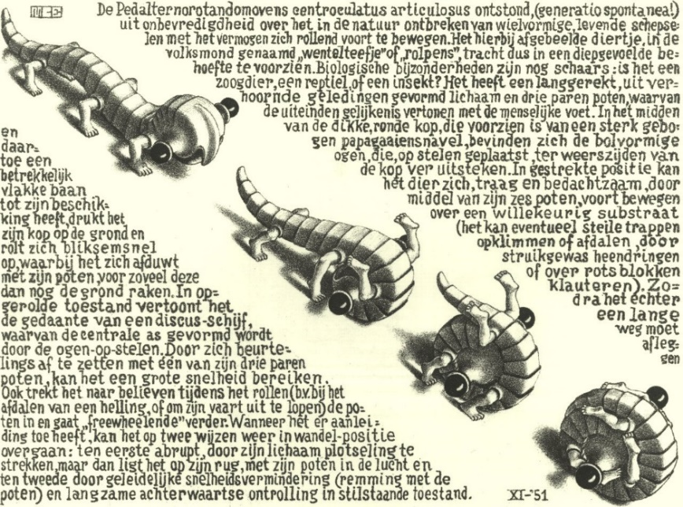
Curl Up, M. C. Escher
Write a 3 – 5 page essay on one of the following topics. Your paper will be evaluated based on content, style, grammar, and originality. Be sure to give credit to all of your sources (including the web) at the end of the paper. Quality is far more critical than quantity. Avoid dullness.
Due date: 6 December 2019

- Explore fractal music, https://plus.maths.org/content/os/issue55/features/kormann/index
and http://www.tursiops.cc/fm/

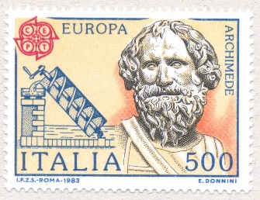
- Many people have heard of the “History of Math,” but what about the “Mathematics of History”? Cf. Jean-Baptiste Michel, TED talk: https://www.ted.com/talks/jean_baptiste_michel_the_mathematics_of_history
http://www.matematicadelahistoria.cat/llengua/the-mathematics-of-history
http://theconversation.com/maths-is-revolutionising-the-study-of-history-heres-how-85710
- Mathematics in the Movies:
http://www.math.harvard.edu/~knill/mathmovies/
https://www.youtube.com/watch?v=zBuykQHFQ1Q
http://www.qedcat.com/moviemath/index.html

- Mathematics in Poetry: https://www.maa.org/sites/default/files/images/upload_library/4/vol6/Growney/MathPoetry.htmlPerhaps you would like to write your own poems?
- Read John Allen Paulos, Innumeracy: Mathematical Illiteracy and Its Consequences, Hill and Wang paperback (2001). In reviewing Paulos' best-selling book, Douglas Hofstadter, author of Gödel, Escher, and Bach, wrote: "To combat [innumeracy] John Allen Paulos has concocted the perfect vaccine: this book, which is in many ways better than an entire high school math education! Our society would be unimaginably different if the average person truly understood the ideas in this marvelous and important book. It is probably hopelessly optimistic to dream this way, but I hope that Innumeracy might help launch a revolution in math education that would do for innumeracy what Sabin and Salk did for polio." Do you agree with Hofstadter's statement? Justify your position, preferably drawing from personal experience.

Read George Pólya, How To Solve It, Ishi Press (2009). In this highly readable book, renowned mathematician Polya describes a four-step problem-solving procedure. Describe this process in your own words. Using exercises from your homework assignments as examples, show how Polya's process can be applied to design solutions to calculus problems.
- D’Arcy Thompson’s On Growth and Form, CreateSpace (2011), has been called by Nobel laureate P. Medawar "the finest work of literature in all the annals of science that have been recorded in the English tongue." Others have called him “the first bio-mathematician." The central thesis of On Growth and Form is that zoologists of his time overemphasized the role of evolution, and underemphasized the functions of physics and mathematics as determinants of the form and structure of living organisms. Perhaps the most essential part of the work is Chapter IX (of the abridged version), "On the Theory of Transformations, or the Comparison of Related Forms." Here Thompson explores the degree to which differences in the forms of related animals could be described employing relatively simple mathematical transformations. Choose a topic or an example from Thompson that particularly intrigues you; describe and discuss this example in your paper. Explain why you find this topic remarkable.

Read Nate Silver’s critically acclaimed book, The Signal and the Noise: Why So Many Predictions Fail -- But Some Don't, Penguin Press (2012) in which“Silver examines the world of prediction, investigating how we can distinguish a true signal from a universe of noisy data. Most predictions fail, often at great cost to society, because most of us have a poor understanding of probability and uncertainty. Both experts and laypeople mistake more confident predictions for more accurate ones. But overconfidence is often the reason for failure. If our appreciation of uncertainty improves, our predictions can get better too. This is the ‘prediction paradox’: The more humility we have about our ability to make predictions, the more successful we can be in planning for the future.” Discuss how this book has influenced your views toward predicting the future.

- Read Jonathan Swift’s Gulliver’s Travels (or at least several chapters). Write an essay in the style of Swift describing your adventures in visiting a new land that developed a reasonably advanced civilization that does not include calculus.

- Read: Sheila Tobias, Overcoming Math Anxiety, W. W. Norton & Co. (1995). The first edition of this book, written in 1978, made "math anxiety" a household term. In the revised version, Tobias explains her view that math anxiety is a political issue and that math competence doesn't have to be determined by gender or class. Do you agree with Tobias' thesis? Justify your position. Give examples from your own experience.
Be sure to consider more recent research, such as that of William Harms Dr. Sian L. Beilock, math anxiety expert at The University of Chicago’s Psychology Department: When Math Hurts: Math Anxiety Predicts Pain Network Activation in Anticipation of Doing Math

- The great Argentine writer, Jorge Luis Borges, was fascinated by the infinite. Read several of the short stories in Borges’ Labyrinths: Selected Stories and Other Writings. Discuss the relationship between the study of the infinite in the differential calculus and Borges’ vision of the infinite. Alternatively, write a short story in the style of Borges that engages the reader in a particular encounter with the differential calculus.

Stephen Jay Gould, in his brilliant work, The Mismeasure of Man, Norton (1996), argues forcefully how the misuse of science and mathematics has been used as an instrument of discrimination, using the I.Q. test as a significant example. Read and discuss your personal reaction to this work that is regarded by many as “a major contribution toward deflating pseudo biological ‘explanations’ of our present social woes.”

- Write a creative and imaginative short story in which calculus plays a central role.
Try to compose such a sketch featuring the birth of a calculus theorem or technique that we have (or will) study this semester.

- You may wish to choose a topic not listed here. If so, you must obtain prior approval from your instructor.
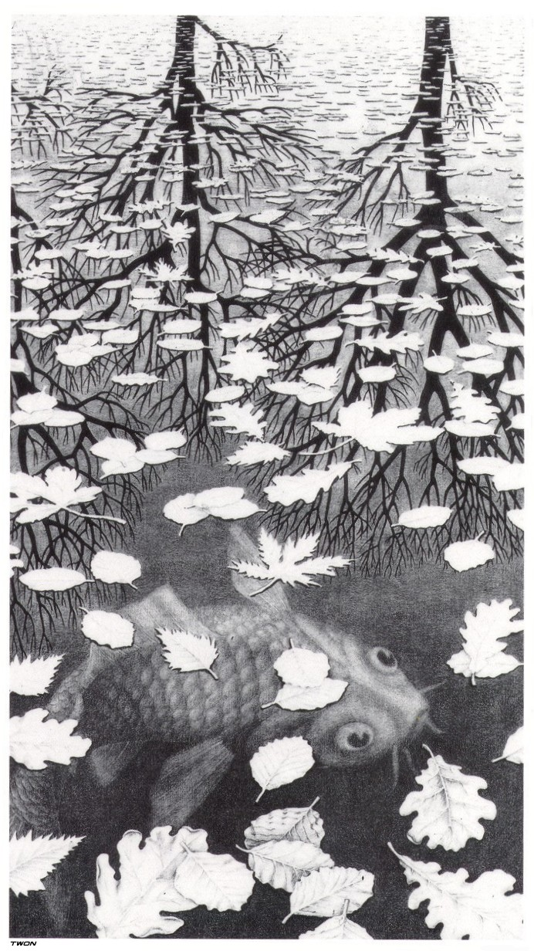
Three Worlds, M. C. Escher

