Survival Sheet: Math 100

Intermediate Algebra

Fall 2019

Required Text: McCallum, Connally, Hughes-Hallett et al. Algebra: Form and Function. 2nd edition. (with WileyPlus ebook)
Note: Students buying used textbooks should arrange to purchase WileyPlus separately. Instructions for students to obtain the e-book and WileyPlus: use your Loyola email address to create a WileyPlus account.
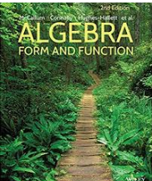

Calculator: Only a basic non-graphing calculator is appropriate for this class. Indeed, many quizzes and tests may be “calculator free.”
Instructor: A. Saleski, 612 BVM Hall (contiguous with IES) building # 37 on map (6349 N. Kenmore Ave., Chicago, IL 60660)
e-mail: asalesk@luc.edu OR alan.saleski@gmail.com
office phone: (773) 508-3577
Course URL:
http://www.math.luc.edu/~ajs/courses/fall2019/100/index.pdf
WebAssign: https://www.webassign.net/luc/login.html
Office Hours: MW 10:30 – 11:30 am TTh 10 – 11 am F 4:15 – 5:15 pm or by appointment.

Ground Rules: The final grade is computed according to the following recipe:
quizzes | 13 %
tests | 38 %
homework (WileyPlus) | 8 %
groupwork | 4%
Piazza | 4 %
final exam | 33 %
extra credit | At most 3 %
Grading standards
Supplemental Instruction (SI), led by Zoë Christenson, zchristenson@luc.edu, is an excellent resource! Discussion hours and locations will be soon be announced by Zoë. Check Piazza!

Tutoring Services:
The Tutoring Center offers FREE tutoring services to all LUC students!

Important Dates:
- Quizzes: (each on a Thursday)
September 12, 19; October 10, 24, 31; November 7
• Tests: (each on a Thursday)
September 26; October 17; November 14
- Holidays:
- Labor Day: Monday, September 2nd

- mid-semester break: Monday & Tuesday, October 7th – 8th
- Thanksgiving break: Wednesday – Sunday, November 27th – December 1st
- Last day to withdraw without a grade of WF: Midnight, Friday, November 1st
• Last day of Class: Thursday, December 5th
• Final Exam, Saturday, December 14th (4:15 – 6:15 pm)
• Loyola Calendar (Fall 2019)

Remarks:

- Quizzes will be based upon recent class discussion. Each quiz will require about 15 minutes. The lowest of the six quiz grades will be dropped. There will be no make-up quizzes unless the circumstances are extraordinary.

- Each test will require the full class period. Make-up tests and quizzes will be given only for non-frivolous reasons. In such cases, the student should make prior arrangements with the instructor.

- The final exam is cumulative.

- The minimum penalty for cheating is failure in the course. A student who improperly aids another with a homework assignment, a test, or the final exam is considered to be equally culpable. Smart-phones, Fitbits, headphones, etc., are not permitted during quizzes/tests/final. Incidents of academic dishonesty will be reported to the appropriate Dean. The minimum penalty is failure on the quiz, test, etc. The maximum penalty is failure in the course. Additional and more precise information about the University’s policy on cheating is available at academic integrity.

- Extra credit may be earned in many ways, including finding errors or dead links on webpages, critiquing appropriate films or outside lectures, and reviewing appropriate articles or books.

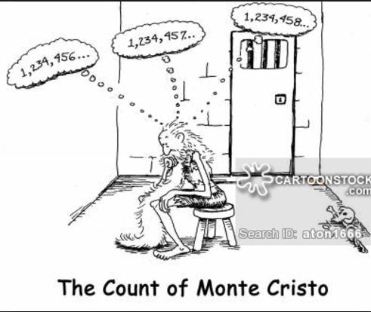

The institutionalized values school instills are quantified ones. School initiates young people into a world where everything can be measured, including their imaginations, and, indeed, man himself. But personal growth is not a measurable entity. It is growth in disciplined dissidence, which cannot be measured against any rod, or any curriculum, not compared to someone else's achievement. In such learning, one can emulate others only in imaginative endeavor, and follow in their footsteps rather than mimic their gait. The learning I prize is immeasurable re-creation.
- Ivan Illich, Deschooling Society

Course Home Page Department Home Page Loyola Home Page

