Math 100 – Intermediate Algebra

Rambler Success

Fall 2019
Section 012: Tues/Thurs 2:30 – 3:45 pm
111 IES
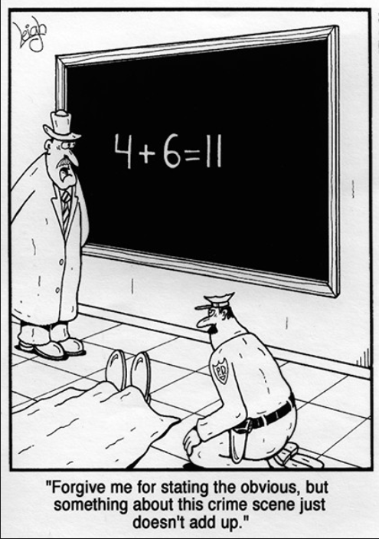
- Ground Rules
- Syllabus
- Piazza
- Homework & Reading Assignments
- WileyPlus
- Practice Tests (test 1, test 2 )
- Quiz Solutions (qz 1, qz 2, qz 3 )
- Test Solutions (test 1, test 2, test 3)
- Discussion Questions
- Tutoring Services and Schedule
- Advice from Hall & Knight
- Useful References (Greek alphabet; relevant websites & texts)
- History of Algebra (I, II, III)

“Every minute dies a man. Every minute one is born.” I need hardly point out to you that this calculation would tend to keep the sum total of the world’s population in a state of perpetual equipoise, whereas it is a well-known fact that the said sum total is constantly on the increase. I would, therefore, take the liberty of suggesting that in the next edition of your excellent poem the erroneous calculation to which I refer should be corrected as follows: “Every moment dies a man, And one and a sixteenth is born.” I may add that the exact figures are 1.067, but something must, of course, be conceded to the laws of meter.

- Charles Babbage, letter to Alfred Lord Tennyson, about a couplet in his “The Vision of Sin.”

Department Home Page Loyola Home Page

