SURVIVAL SHEET: Math 161

Fall 2019

Required Text: James Stewart, Calculus: Single Variable with Early Transcendentals, 8th edition, Cengage Learning (2016), packaged with WebAssign or WebAssign stand-alone.
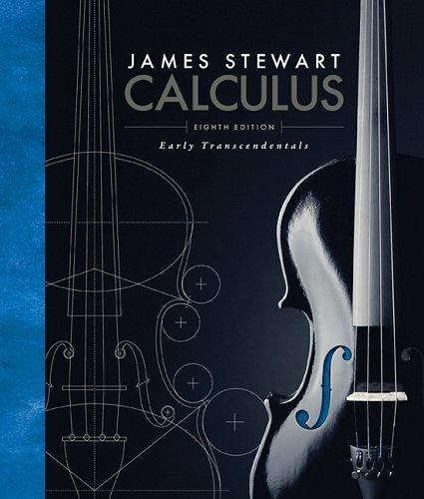

Calculator: An inexpensive, scientific, non-graphing calculator is required. (For example, the Casio fx-300MSPLUS2 Scientific Calculator.) More powerful calculators are not permitted during quizzes or tests.
Software: Mathematica 12
Instructor: A. Saleski, 612 BVM Hall (contiguous with IES): building # 39 on the map (6349 N. Kenmore Ave., Chicago, IL 60660)
e-mail: asalesk@luc.edu OR alan.saleski@gmail.com;
office phone: (773) 508-3577
Course URL: http://www.math.luc.edu/~ajs/courses/fall2019/161/index.pdf
WebAssign: https://www.webassign.net/luc/login.html
Piazza: http://piazza.com/luc/fall2019/math161004/home
Office Hours: MW 10:30 – 11:30 am; TTh 10 – 11 am; F 4:15 – 5:15 pm or by appointment
Ground Rules: The final grade is computed according to the following recipe:
quizzes | 13 %
tests | 31 %
homework (WebAssign) | 8 %
Mathematica labs | 4 %
groupwork | 4 %
homework (written) | 4 %
Piazza | 3 %
final exam | 33 %
extra credit | (max of 3%)
Grading standards
Tutoring Services:
The Tutoring Center offers FREE tutoring services to all LUC students.
For more information, view www.luc.edu/tutoring.

Important Dates:
- Quizzes: (each on a Friday)
September 6, 13, 20; October 11, 25; November 1, 8
• Tests: (each on a Friday)
September 27; October 18; November 15
- Holidays:
- Labor Day: Monday, September 2nd

- mid-semester break: Monday & Tuesday, October 7th – 8th
- Thanksgiving break: Wednesday – Sunday, November 27th – December 1st
- Last day to withdraw without a grade of WF: Midnight, Friday, November 1st
• Last day of Class: Friday, December 6th
• Final Exam, Friday, December 13th (9:00 – 11:00 am)
• Loyola Calendar (Fall 2019)

Remarks:
- Quizzes will be based upon recent class discussion, recent homework and, occasionally, assigned videos and readings. Each quiz will last about 15 minutes. There will be no make-up quizzes unless the student makes prior arrangements with the instructor. The lowest of the 7 quiz grades will be dropped.

- Each test will require, roughly, 1.5 hours. Make-up tests will be given only for non-frivolous reasons. In such cases, the student should make prior arrangements with the instructor, if at all possible.

- WebAssign homework will be accepted within two weeks beyond the posted deadline.

- The minimum penalty for cheating is failure in the course. A student who improperly aids another with a homework assignment, a test, the final exam, or with a Mathematica lab is considered to be equally culpable. If you receive help on a Mathematica lab assignment from anyone other than the instructor (this includes another student, a TA, an SI, a tutor, a family member, website, or friend), you should acknowledge this fact in a comment at the beginning of your lab. Smart-phones, Fitbits, headphones, etc., are not permitted during quizzes/tests/final.
Incidents of academic dishonesty will be reported to the appropriate Dean. The minimum penalty is failure on the quiz, test, etc. The maximum penalty is failure in the course.
Additional and more precise information about the University’s policy on cheating is available at academic integrity.

- Extra credit may be earned in many ways, including finding errors or dead links on web pages, critiquing appropriate films or outside lectures, and reviewing appropriate articles or books.

The institutionalized values school instills are quantified ones. School initiates young people into a world where everything can be measured, including their imaginations, and, indeed, man himself. But personal growth is not a measurable entity. It is growth in disciplined dissidence, which cannot be measured against any rod, or any curriculum, not compared to someone else's achievement. In such learning, one can emulate others only in imaginative endeavor, and follow in their footsteps rather than mimic their gait. The learning I prize is immeasurable re-creation.
- Ivan Illich, Deschooling Society

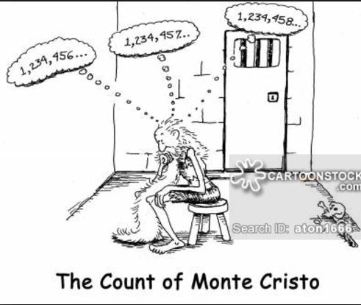

Course Home Page Department Home Page Loyola Home Page

