Math 161 - 004

Calculus I

Fall 2019

MWF 12:35 – 2:30 pm

(235 Dumbach Hall)
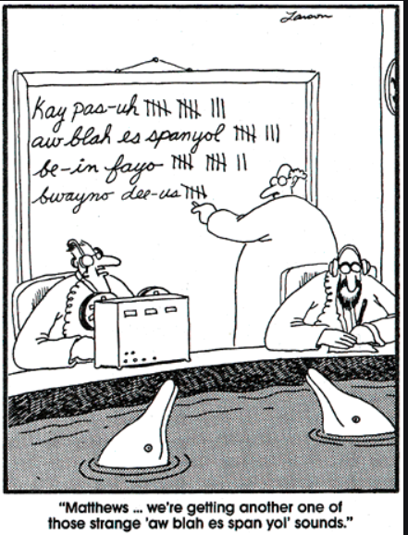
- Ground Rules
- Syllabus
- WebAssign
- WebAssign Homework & Reading Assignments
- Class Discussion Questions
- Piazza
- Tutoring Services: Math
- Mathematica Labs
(nb: lab 1, lab 2)
(pdf: lab1, lab 2)
(lab 3)
- Practice Tests (test 1, test 2, test 3)
- Practice Finals (A, B)
- Quiz Solutions (qz 1, qz 2, qz 3, qz 4, qz 5, qz 6, qz 7)
- Test Solutions (test 1, test 2, test 3)
- University of Michigan calculus exams
- MIT OCW for Calculus
- Essay topics
- Useful References (Greek alphabet; Mathematica tutorials & websites; supplementary texts, calculus websites, Mathematica videos
- History of Calculus
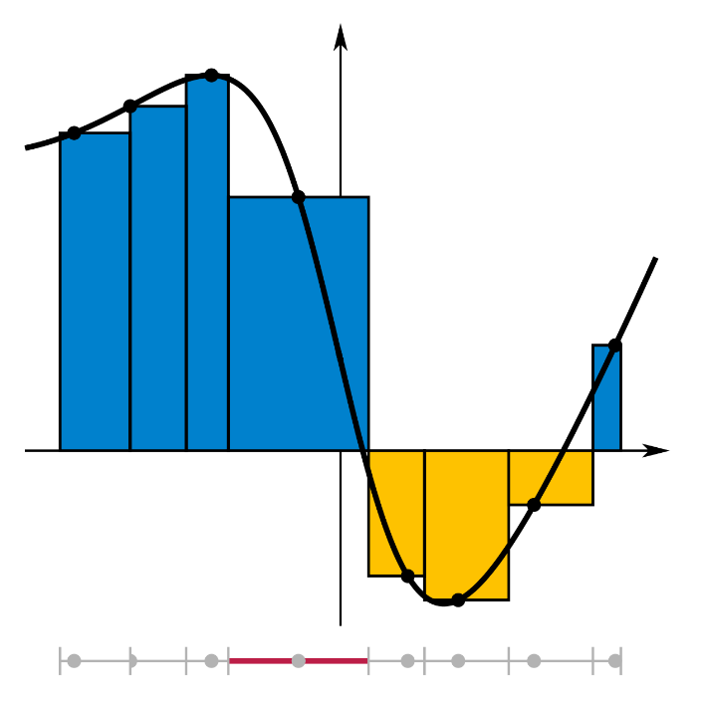

Department Home Page Loyola Home Page

