Websites & texts of note

Precalculus Websites
Here are some suggestions for reviewing pre-calculus:
The first lecture of Princeton's calculus class is a review of precalculus ("a review of the review"). I would encourage you to watch it in its entirety (although you needn't watch it all at once).
In addition, the first chapter of The Calculus Lifesaver: All the Tools you Need to Excel at Calculus by Adrian Banner is available as a pdf. This first chapter covers precalculus in a similar vein to Banner's online lecture.

On a lighter note, coolmath.com has an excellent set of examples for each major pre-calc topic. I especially encourage you to make sure that you understand all of the examples and exercises.
On the first day of class, we will discuss some of these exercises.

MIT has a self-paced study guide in algebra which should serve to be quite helpful at:
http://web.mit.edu/jorloff/www/18.01a-esg/OCWAlgebra.pdf

Mathematica websites
Stephen Wolfram’s introduction to the Wolfram language
A student’s introduction to Mathematica
Quick tour of Mathematica

Other Web sites of interest
Zombies and Calculus: Microsoft lecture: Colin Adams
Zombies and Calculus video, part I (NOVA PBS Official)
Zombies and Calculus video, part II (NOVA PBS Official)

Recommended Supplementary Texts
- Tom Apostol, Calculus, volume 1: One-Variable Calculus with an introduction to Linear Algebra, 2nd edition, Wiley (1967)

- J. Marsden & A. Weinstein, Calculus I (Undergraduate Texts in Mathematics), Springer-Verlag (1985)

- McCallum, Hughes-Hallett, Gleason, et al, Calculus, 6th edition, Wiley (2012)

- Larson & Edwards, Calculus, 9th edition, Brooks/Cole (2009)

- G. Simmons, Calculus with Analytic Geometry, 2nd edition, McGraw-Hill Science/Engineering/Math (1996)

- G. B. Thomas, J. Hass & M. Weir, Thomas’ Calculus with Early Transcendentals, 13th edition, Pearson (2014)

Lighter reading
- Colin Adams, Zombies and Calculus, Princeton University Press (2014)

- Adams, Hass, Thompson, How to Ace Calculus, The Streetwise Guide, Freeman (2003)

- Jason Bardi, Calculus Wars, Thunder’s Mouth Press (2006)

- Petr Beckmann, History of π, St. Martin’s Press (1971)

- David Berlinski, Tour of the Calculus, Vintage Books (1995)

- Sergiy Klymchuk, Counterexamples in Calculus, MAA (2010)

- Sergiy Klymchuk and Susan Staples, Paradoxes and Sophisms in Calculus, MAA (2013)

- Eli Maor, The Facts on File Calculus Handbook, Facts on File Science Handbooks (2003)

- Eli Maor, To Infinity and Beyond, Princeton University Press (1991)

- editor James Newman, The World of Mathematics, 4-volumes, reprinted by Dover Publications (2003)

- George F. Simmons, Calculus Gems, MAA (2007)

- David Foster Wallace, Everything and More: A Compact History of Infinity, W. W. Norton (2010)
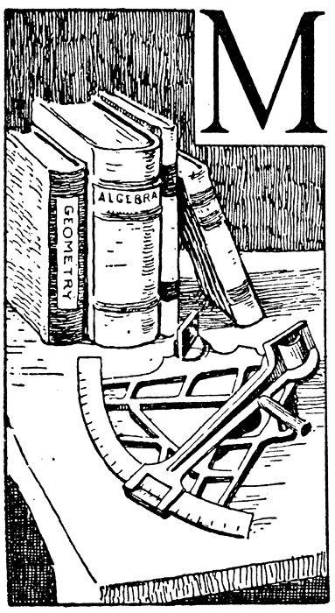
With an absurd oversimplification, the "invention" of the calculus is sometimes ascribed to two men, Newton and Leibniz. In reality, the calculus is the product of a long evolution that was neither initiated nor terminated by Newton and Leibniz, but in which both played a decisive part.
- Richard Courant and Herbert Robbins

Course Home Page Department Home Page Loyola Home Page

