Math 201: Class Discussion
29 Aug 2019

Introduction to sets

Study carefully sections 1.1 – 1.4 of Hammack

The following notation is commonly used: Z for the set of integers; N for the set of positive integers (the “natural numbers”), Q for the set of all rational numbers; R for the set of all real numbers, and $∅$the empty set$.$

- List the elements of each of the following sets: (a) {x∈ R : x⁴ – 1 = 0} (b) {x∈ Z : -1/3 < x < 5.99}
(c) {x ∈ N | x ≤ 4} (d) {unicorns| unicorn lives in Illinois} (e) {} (f) {φ}
(g) {1, {2}}

- Write in set notation: (a) {4, 9, 16, 25, …} (b) {1/1, 1/3, 1/5, 1/7, …} (c) {…l/8, ¼, ½, 1, 2, 4, 8, …}

- Determine the cardinality of each set in (A).

- Find cardinality of each of the following sets:

$$\left\{Kansas City, Phoenix, Sacramento, Denver\right\}$$
{{Friday}, {blue moon}, {dragonfly}}
{{1, 2}, {{7, 0, 3}}}
{p$∈N| p is prime and p≤25\}$
{{1}, {2, {3, 4}}, $∅$}
{{1, 4}, a, b, { {3, 4}}, $\{∅$}}
{x$∈Z | \left|x\right|<10\}$

- Sketch the following sets of points in the xy-plane.
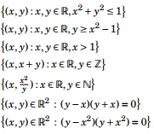

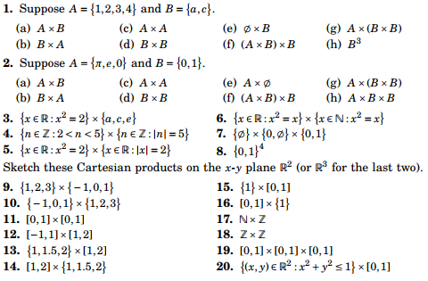

- Find the power set of each of the following sets:

9. in general if |S| = n, what is |P(S)|?

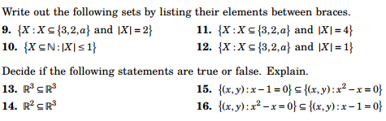

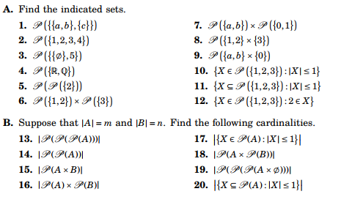

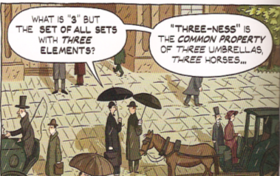

Course Home Page Department Home Page Loyola Home Page

