Naïve set theory continued
Aug 29: part B

Study carefully sections 1.5 – 1.7 of Hammack

1. Let A, B and C be three sets such that:
Set A = {2, 4, 6, 8, 10, 12}, set B = {3, 6, 9, 12, 15} and set C = {1, 4, 7, 10, 13, 16}.

Find explicitly, each of the following:

(i) A ∪ B
(ii) A ∩ B
(iii) B ∩ A
(iv) B ∪ A
(v) B ∪ C
(vi) A – B
(vii) A – (B ∪ C)
(viii) A – (B ∩ C)
(ix) Is A ∪ B = B ∪ A?
(x) Is B ∩ C = B ∪ C?

2. Complete each of the following:
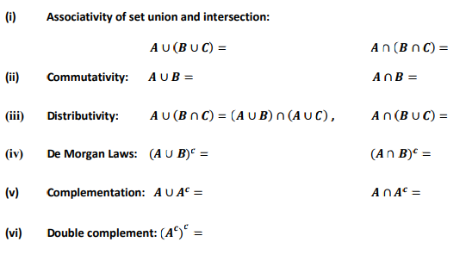
3. True or False? Give a geometric proof or a counterexample.

(a) 𝐴 ∪ 𝐵 ⊆ A∩B

(b) 𝐴 ∪ (𝐵 ∩ 𝐶) ⊆ (𝐴 ∪ 𝐵) ∩ ( Α ∪ 𝐶)

(c) 𝐴 ∪ (𝐵 ∩ 𝐶) ⊇ (𝐴 ∪ 𝐵) ∩ (𝐴 ∪ 𝐶)

(d) A – (B∩ C) = (A –B) ∪ (A – C)

(e) A – B = B^{c} – A^{c}

(f) (𝐴 ∪ 𝐵) ∩ 𝐶 ⊇ (𝐴 ∪ 𝐵) ∩ (𝐴 ∪ 𝐶)

4. [Halmos, Naïve Set Theory]
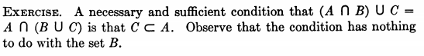
5. [Halmos, Naïve Set Theory]
(a) Prove that P(E) ∩ P(F) = P(E ∩ F)
(b) Prove that P(E) ∪ P(F) ⊆ P(E ∪ F)

Course Home Page Department Home Page Loyola Home Page

