Math 201: Class discussion 3 December 2019

Pigeon-Hole Principle

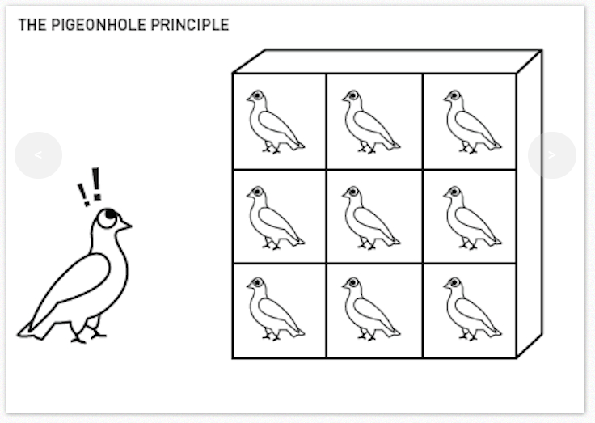
I State the basic pigeon-hole principle. State the strong pigeon-hole principle (n pigeon holes, and at least kn+1 pigeons).

II Solve each of the following problems by using the pigeon-hole principle.
- A bag contains balls of five colors: blue, purple, black, green and red. What is the smallest number of balls that must be drawn from the bag (without looking) so that among the drawn balls there are at least two of the same color? (Who are the pigeons and what are the pigeon-holes?)
- Fifteen students in French 103 were given a dictation quiz. Albertine made 13 errors. Each of the other students made fewer errors. Prove that at least two students made the same number of errors.
- There are 30 students in Spanish 103. On a dictation quiz, Carlos made 13 errors and all the other students made fewer errors. Prove that at least three students made the same number of errors.
- Given 12 integers, show that two of them can be chosen whose difference is divisible by 11. (Hint: Let the pigeons represent the twelve integers, and let the numbers mod 11 be the pigeon holes.)
- Show that among n positive integers there exist two whose difference is divisible by n-1.
- Prove that for any m positive integers, the sum of some of these integers (possibly only one number) is divisible by m.
- There are 50 people in a room. Some of them are acquainted with each other, some not. (Assume that “acquainted with” is a symmetric relation.) Prove that there are two persons in the room who have an equal number of acquaintances. (Hint: Let the pigeons be the 50 people. Consider two cases: Either everyone is acquainted with at least one other person, or else at least one person has no acquaintances.)
- 51 points were placed, in an arbitrary way, into a unit square. Prove that one can find 3 of these points that are contained in a circle of radius 1/7. (Hint: Cut the square into 25 equal sub-squares.)

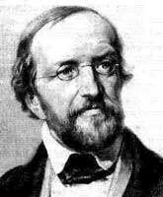
Johann Peter Gustav Lejeune Dirichlet first stated the pigeon-hole
principle (also known as Dirichlet’s box principle) in 1834

