Math 201 Class Discussion: Mappings, continued

21 November 2019

I (Injections, Surjections, and Bijections) Which of the following functions are injective, surjective, and bijective on their respective domains. Take the domains of the functions as those whose values of x for which the function is well-defined.
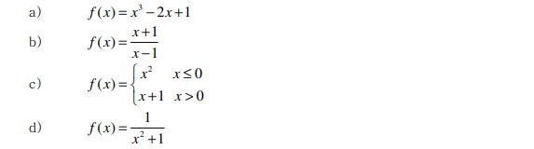
II Let X, Y, Z be non-empty sets. Assume that F: X→Y and G: Y→Z are (well-defined) mappings. For each of the following statements give a proof or counterexample.
- If F and G are injective, then G$∘$F is injective.
- If F and G are surjective, then G$∘$F is surjective.
- If F and G are bijective, then G$∘$F is bijective.
- If G$∘$F is injective, then G is injective.
- If G$∘$F is injective, then F is injective.
- If G$∘$F is surjective, then F is surjective.
- If G$∘$F is surjective, then G is surjective.
III Let f: X→Y be a function. When does f possess an inverse?
For each of the following, decide if an inverse exists. If yes, find it.
- f: N→Z defined by f(j) = -j
- f: R→ R defined by f(x) = x⁵
- g: R→ (0, $∞)$ defined by g(x) = e^{x}
- h: Z → Z defined by h(j) = j + 13
- f: (0, $∞)$ → (0, $∞)$ defined by f(x) = 1/x
- G:[0, $∞)$ → [0, $∞)$ defined by f(x) = x²

IV Find a bijection from
(i) R to R; (ii) N to Z (iii) Z to N ; (iv) [0, 5] to [7, 17]; (v) (0, 1] to R; N to Q$∩$ (0, 1)

V Show that a mapping G: X→ Y may also be regarded as a mapping from P(X) to P(Y).

VI What does it mean to say that two sets have the same cardinality? What does it mean to say that a set is countably infinite?
VII Show that each of the following sets is countable:
- The set of non-negative integers.
(b) The set of integers greater than or equal to 13.
(c) Z
(d) The set of positive even integers.
(e) The set of even integers.
(f) The set of odd integers.
(g) The set of rational numbers strictly between 0 and 1.
VIII (a) Show that a subset of a countable set is either finite or countable.
(b) Show that if A and B are disjoint countable sets, then so is the union of A and B. What if A and B are not disjoint?
(c) Show that if A and B are countable sets, then so is the Cartesian product of A and B.
(d) Prove that a countable union of countable sets is countably infinite.
(e) Prove that the set of rational numbers strictly between 0 and 1 is countable.
(f) Demonstrate that Q is countable.
IX Show that if S is a collection of sets, then cardinality is an equivalence relation on S.
X Using Cantor’s diagonal argument, prove that R is not countable.
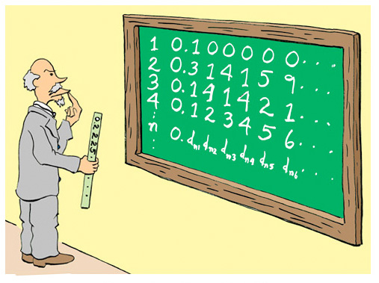
IX (a) Let X be a set. Recall the definition of the power set, P (X), of X.
Show that the power set of a finite set is finite. In such a case, describe the relationship between |X| and | P (X)|.
- Let X = {a, b, c, d} and let F: X → P (X) be defined by:
F(a) = {a, c, d}, F(b) = {a, d}, F(c) = φ, F(d) = {d}
Find D* = $\left\{j∈X| j∉F(j)\right\}$
- Let X = Z⁺ and let G: X → P(X) be defined by:
G(a) = {all prime numbers, p, such that a ≤ p ≤ 2a}
Find D* = $\left\{j∈X| j∉G(j)\right\}$
- Let X = Q and let H: X → P (X) be defined by:
$H\left(z\right)=$ {all prime numbers, p, such that z ≤ p ≤ 2z}
Find D* = $\left\{q∈X| q∉H(q)\right\}$
- Let X = R and let V: X → P (X) be defined by:
$V(a)=\left\{\begin{aligned}\left\{0\right\} if a≤0 \\ \left(a, a+1\right) if a∈Q^{+}\sim Z \\ \left[a-1, a\right] if a is a positive irrational number \\ \left\{a, a+3\right\} if a∈Z^{+} \end{aligned}\right.$
Is V well-defined? If so, find D* = $\left\{z∈X| z∉V(z)\right\}$
- Prove Cantor’s Theorem: X and P(X) are not of the same cardinality.
Highly recommended: MIT lecture notes on cardinality, 24.118 (paradox and infinity)
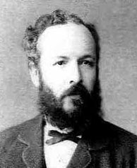
Georg Ferdinand Ludwig Cantor (1845 – 1918) is best known for
his discovery of transfinite numbers and the creation of Set Theory

Lenore nodded. ‘Gramma really likes antinomies. I think this guy here (looking down at the drawing on the back of the label) ‘is the barber who shaves all and only those who do not shave themselves’.
- David Foster Wallace, The Broom of the System

