Class discussion: Mathematical Induction
1 October 2019

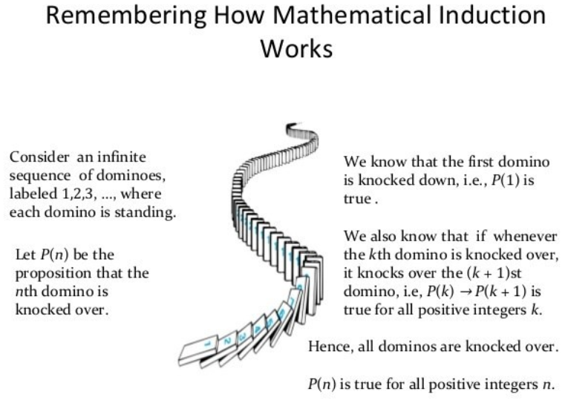
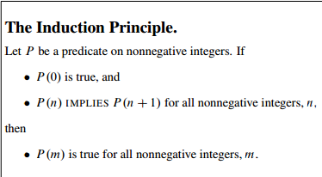

Since we are going to consider several useful variants of induction later, we will refer to the induction method described above as ordinary induction when we need to distinguish it.

I State the Principle of (ordinary) Mathematical Induction.

II Using the method of mathematical induction, verify each of the following:

- 3 is a divisor of (n³ + 2n) for all natural numbers, N.
- 5 is a divisor of (7^{n} – 2^{n}) for all non-negative integers, n.
- 1 + 3 + 5 + … + (2n – 1) = n² for all natural numbers, n
- (1 + x)^{n} ≥ 1 + nx for all real x > -1 and all non-negative integers.
(This is called Bernoulli’s inequality.)

- 1 + 2 + 3 + … + n = n(n+1)/2 for all natural numbers, n.

- 1² + 2² + 3² + … + n² = n(n+1)(2n+1)/6 for all natural numbers, n.

- 2 + 2² + 2³ + … + 2^{n} = 2^{n+1} – 2 for all natural numbers, n.
- 4n < 2^{n} for all natural numbers n ≥ 5.
- (1)(2) + (2)(3) + (3)(4) + … + (n)(n+1) = n(n+1)(n+2)/3 for all natural numbers, n.

- 133 | (12^{2n} – 11^{n}) for all non-negative integers n.

III 1. Discuss the “proof” that all spiders are tarantulas.
2. Discuss the triomino tiling problem.
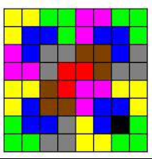
3. Discuss the postage stamp problem.

IV State the Principle of Strong Induction.

  - Using strong induction, prove the 3 cent/5 cent postage stamp problem (again).
  - Consider the Lucas series 1, 3, 4, 7, 11, 18, 29, 47, 76, …. This sequence is defined recursively by: a₁ = 1, a₂ = 3, and, for all n ≥ 3, a_{n} = a_{n-1} + a_{n-2}. Using strong induction prove that a_{n} < (7/4)^{n} for
all positive integers n.
  - Define a sequence recursively by: b₁ = 1, b₂ = 2, b₃ = 3, and, for all
n ≥ 4, b_{n} = b_{n-1} + b_{n-2} + b_{n-3}. Using strong induction, prove that b_{n} < 2^{n} for all natural numbers, n.

  - Using strong induction prove that every integer n ≥ 2 can be expressed as a product of primes.

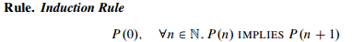
implies that
A Template for Induction Proofs (MIT notes)

1. State that the proof uses induction. This immediately conveys the overall structure of the proof, which helps your reader follow your argument.

2. Define an appropriate predicate P(n). The predicate P(n) is called the induction hypothesis. The eventual conclusion of the induction argument will be that P(n) is true for all non-negative n. A clearly stated induction hypothesis is often the most important part of an induction proof, and its omission is the largest source of confused proofs by students. In the simplest cases, the induction hypothesis can be lifted straight from the proposition you are trying to prove, as we did with equation (*). Sometimes the induction hypothesis will involve several variables, in which case you should indicate which variable serves as n.

3. Prove that P(0) is true. This is usually easy, as in the example above. This part of the proof is called the base case or basis step.

4. Prove that P(n) implies P(n+1) for every nonnegative integer n.
This is called the inductive step. The basic plan is always the same:
assume that P(n) is true for some given non-negative integer, n, and then use this assumption to prove that P(n+1) is true.
These two statements should be fairly similar, but bridging the gap may require some ingenuity. Whatever argument you give must be valid for every nonnegative integer n, since the goal is to prove that all the following implications are true:
P(0)$→$P(1), P(1)$→P\left(2\right), P\left(2\right)→P\left(3\right),$…

5. Invoke induction. Given these facts, the induction principle allows you to conclude that P(n) is true for all non-negative n. This is the logical capstone to the whole argument, but it is so standard that it’s usual not to mention it explicitly.

Always be sure to explicitly label the base case and the inductive step. Doing so will make your proofs clearer and will decrease the chance that you forget a key step—such as checking the base case. Below is the formula for the sum of the nonnegative integers up to n. The formula holds for all nonnegative integers, so it is the kind of statement to which induction applies directly. We’ve already proved this formula using the Well Ordering Principle, but now we’ll prove it by induction, that is, using the Induction Principle.

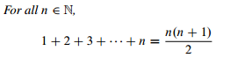(eqn *)

To prove the theorem by induction, define predicate P(n) to be the equation (*). Now the theorem can be restated as the claim that P(n) is true for all n $∈$N. This is great, because the Induction Principle lets us reach precisely that conclusion, provided we establish two simpler facts:

So now our job is reduced to proving these two statements.
The first statement follows because of the convention that a sum of zero terms is equal to 0. So P(0) is the true assertion that a sum of zero terms is equal to 0(1)/2 = 0.
The second statement is more complicated. But remember the basic plan for proving the validity of any implication: assume the statement on the left and then prove the statement on the right.
In this case, we assume P(k), for a given n $∈N,$ ---- namely, equation (*) —in order to prove P(n+1), which is the equation

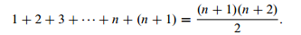(eqn **)

These two equations are quite similar; in fact, adding n+1 to both sides of equation (*) and simplifying the right side gives the equation (**), viz:
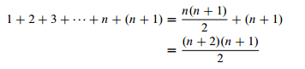
Thus, if P(n) is true, then so is P(n+1). This argument is valid for every nonnegative integer n, so this establishes the second fact required by the induction proof.
Therefore, the Induction Principle says that the predicate P(m) is true for all nonnegative integers, m. The theorem is proved.

A Clean Write-up

The proof of (*) given above is perfectly valid; however, it contains a lot of extraneous explanation that you won’t usually see in induction proofs. The write-up below is closer to what you might see in print and should be prepared to produce yourself.

Revised proof of (*).

We use induction. The induction hypothesis, P(n), will be equation (*).

Base case: P(0) is true because both sides of equation (*) equal zero when n=0.

Inductive step:

Let n, a non-negative integer, be given. Assume that P(n) is true, that is equation (*) holds for some nonnegative integer n. Then adding n + 1 to both sides of the equation implies that (by easy algebra):
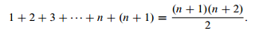
By simple algebra, which proves P(n+1).
So it follows by induction that P(n) is true for all non-negative n.

It probably troubles you that induction led to a proof of this summation formula but did not provide an intuitive way to understand it nor did it explain where the formula came from in the first place.
This is both a weakness and a strength. It is a weakness when a proof does not provide insight. But it is a strength that a proof can provide a reader with a reliable guarantee of correctness without requiring insight.

History (Wikipedia)
In 370 BC, Plato's Parmenides may have contained an early example of an implicit inductive proof.[ The earliest implicit traces of mathematical induction may be found in Euclid's[ proof that the number of primes is infinite and in Bhaskara's "cyclic method."
An opposite iterated technique, counting down rather than up, is found in the Sorites paradox, where it was argued that if 1,000,000 grains of sand formed a heap, and removing one grain from a heap left it a heap, then a single grain of sand (or even no grains) forms a heap.
An implicit proof by mathematical induction for arithmetic sequences was introduced in the al-Fakhri written by al-Karaji around 1000 AD, who used it to prove the binomial theorem and properties of Pascal's triangle.
None of these ancient mathematicians, however, explicitly stated the induction hypothesis. Another similar case (contrary to what Vacca has written, as Freudenthal carefully showed)[ was that of Francesco Maurolico in his Arithmeticorum libri duo (1575), who used the technique to prove that the sum of the first n odd integers is n². The first explicit formulation of the principle of induction was given by Pascal in his Traité du triangle arithmétique (1665). Another Frenchman, Fermat, made ample use of a related principle, indirect proof by infinite descent. The induction hypothesis was also employed by the Swiss Jakob Bernoulli, and from then on, it became more or less well known. The modern rigorous and systematic treatment of the principle came only in the 19th century, with George Boole,^{[10]} Augustus de Morgan, Charles Sanders Peirce,^{[11][12]} Giuseppe Peano, and Richard Dedekind.^{[7}

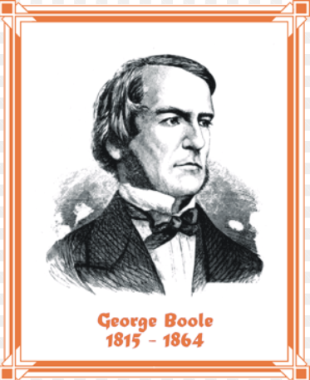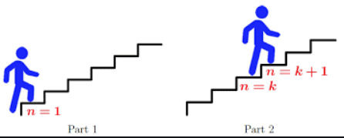

Counting (“loose ends”)

- In how many ways can 15 distinguishable candy bars be distributed among 5 students?
- In how many ways can 12 identical cans of Coke be distributed among 4 thirsty high-school students?
- How many solutions (in non-negative integers) exist for x₁ + x₂ +x₃ + x₄ = 13 ?
- How many solutions (in positive integers exist for x₁ + x₂ +x₃ + x₄ + x₅ = 123 ?

