Math 201 class discussion: Induction, continued
10 October 2019
I Review exercises
- Prove that $∀n≥0 3|\left(n^{3}-n\right)$
- Prove that $∀n≥0 2^{3n+1}+5 is always a multiple of 7.$

- Consider the following definition of a recursive sequence:
$$Let a_{1}=\frac{5}{2}.$$
$$For n≥1, let a_{n+1}=\frac{1}{5}({a_{n}}^{2}+6)$$
Prove that the sequence {$a_{n}$} is decreasing.
II Find the flaw(s) in each of the following “proofs.”
- If any of n spiders is a tarantula, then all n spiders are tarantulas?

- I can lift all the sand on the beach.

Proof. Here we use the method of induction.
The proof is by induction.
For $n≥1$ let P(n) be the predicate, “I can lift n grains of sand.”

Base Case: P(1) is true because I can certainly lift one grain of sand.

Inductive Step: Assume that I can lift n grains of sand.
I want to prove that I can lift n + 1 grains of sand.
If I can lift n grains of sand, then surely I can lift n + 1; one grain of sand will not make any difference.
Therefore P(n) ⇒ P(n + 1).
By induction, P(n) is true for all n ≥ 1.

- Claim: Given a set of n points in the plane, then these points are collinear (that is, lie on one line).

Proof: Here we use the method of induction.
For any non-negative integer, n, let P(n) assert that given any n points in the plane, then these n points lie on one line.

Base case: Clearly, if n = 1, one point lies on one line. So P(1) has been verified.
Inductive Step: Let n be a fixed positive integer.
Now assume that, given any set of n points, then these points are collinear.
Now consider a set of n + 1 points.
Consider any subset of n points. Then these lie on a line. Consider another subset of n points. Then these too lie on a line.
The intersection of these sets contain n – 1 points. So these lines are clearly the same.
Hence P(n+1)
Flaw?
- Find the flaw in the following example of Donald Knuth, the distinguished computer scienctist.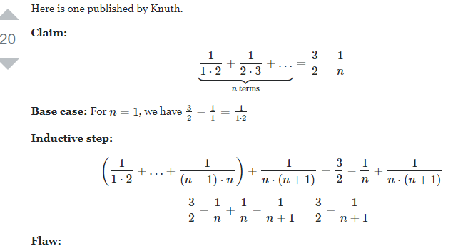
- Find the flaw:
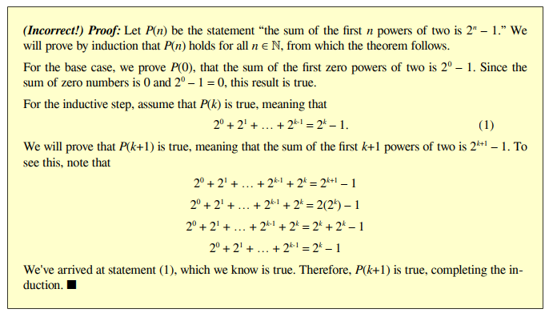
III Strong Induction
- State the Principle of Strong Induction

- Making Change (MIT)
The country Inductia, whose unit of currency is the Strong, has coins worth 3Sg (3 Strongs) and 5Sg. Although the Inductians have some trouble making small change like 4Sg or 7Sg, it turns out that they can collect coins to make change for any number that is at least 8 Strongs. Prove this.

- Find the flaw:

Claim: For every non-negative integer n, 5n = 0.
Proof: Here we use the method of strong induction
Base case: Let n = 0. Then 5n = 0. Hence P(0) is true.

Inductive step: Let $n≥0 be a fixed integer.$
Assume that 5j = 0 for all non-negative integers j with $0≤j<n.$
Write n + 1 = i + j where i and j are non-negative numbers, each less than n + 1.
Using the induction hypothesis,
5(k + 1) = 5(i + j) = 5i + 5j = 0 + 0 = 0
Flaw
- Find the flaw in the following argument: 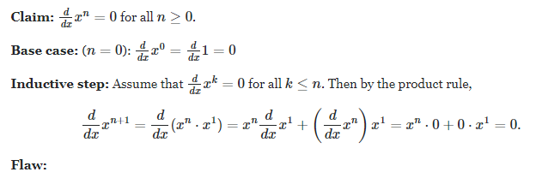
Proof. First, let us find the value of n for which we will prove the statement. (does the statement hold for n = 1, 2, 3, . . . ? Have you found n for which this is true?) Let P(n) : 2n < n! be the statement. We will show that it holds for all n ≥ . . . • BASE STEP (show P(n) holds for n smallest possible) • INDUCTION HYPOTHESIS P(k) : . . . (state the assumption for P(k)) • INDUCTION STEP (keep in mind what you are trying to prove - it helps to note it on the side) (hint: notice that 2 < k + 1 ∀k > 1) • CONCLUSION (finish the proof by writing the conclusion)
Result true, proof false Stanford
In practice, it can be easy to inadvertently get this backwards. Here's an incorrect proof that the sum of the first n powers of two is 2n – 1. (Note that the result that it proves is true, but the proof itself has a logical error that we'll discuss in a second).
(Incorrect!) Proof: Let P(n) be the statement “the sum of the first n powers of two is 2n – 1.” We will prove by induction that P(n) holds for all n ∈ ℕ, from which the theorem follows. For the base case, we prove P(0), that the sum of the first zero powers of two is 20 – 1. Since the sum of zero numbers is 0 and 20 – 1 = 0, this result is true. For the inductive step, assume that P(k) is true, meaning that 20 + 21 + … + 2k-1 = 2k – 1. (1) We will prove that P(k+1) is true, meaning that the sum of the first k+1 powers of two is 2k+1 – 1. To see this, note that 2 0 + 21 + … + 2k-1 + 2k = 2k+1 – 1 2 0 + 21 + … + 2k-1 + 2k = 2(2k ) – 1 2 0 + 21 + … + 2k-1 + 2k = 2k + 2k – 1 2 0 + 21 + … + 2k-1 = 2k – 1 We've arrived at statement (1), which we know is true. Therefore, P(k+1) is true, completing the induction. ■ This proof is, unfortunately, incorrect, but it might not immediately be clear why. The setup of the
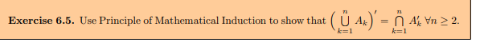
What is the principle of strong induction?
Every integer greater than 1 is a product of primes

Making Change (MIT)
The country Inductia, whose unit of currency is the Strong, has coins worth 3Sg (3 Strongs) and 5Sg. Although the Inductians have some trouble making small change like 4Sg or 7Sg, it turns out that they can collect coins to make change for any number that is at least 8 Strongs.
Strong induction makes this easy to prove for n C 1 11, because then .n C 1/ 3 8, so by strong induction the Inductians can make change for exactly .n C 1/ 3 Strongs, and then they can add a 3Sg coin to get .n C 1/Sg. So the only thing to do is check that they can make change for all the amounts from 8 to 10Sg, which is not too hard to do. Here’s a detailed writeup using the official form
In principle, a proof should establish the truth of a proposition with absolute certainty. In practice, however, many purported proofs contain errors: overlooked cases, logical slips, and even algebra mistakes. But in a well-written proof, even if there is a bug, one should at least be able to pinpoint a specific statement that does not logically follow. See if you can find the first error in the following argument.
MIT False Theorem 1. 420 > 422 Proof. We will demonstrate this fact geometrically. We begin with a 20 × 21 rectangle, which has area 420:
Proof. We will demonstrate this fact geometrically. We begin with a 20 × 21 rectangle, which has area 420:
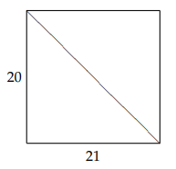 Now we cut along the diagonal as indicated above and slide the upper piece parallel to the cut until it has moved exactly 2 units leftward. This leaves a couple stray corners, which are 2 units wide and just over 2 units high.
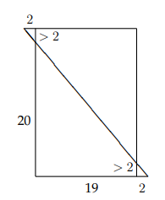 Finally, we snip off the two corners and place them together to form an additional small rectangle:
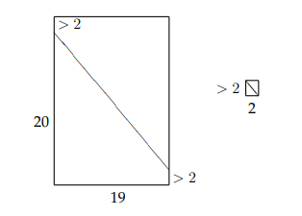 Now we have two rectangles, a large one with area just over (20 + 2) × 19 = 418 and a small one with area just over 2 × 2 = 4. Thus, the total area of the resulting figure is a bit over 418 + 4 = 422. By conservation of area, 420 is equal to just a little bit more than 422. Where is the error?

