Math 201 Class discussion: 15 October 2019
Direct Proofs: Number theory
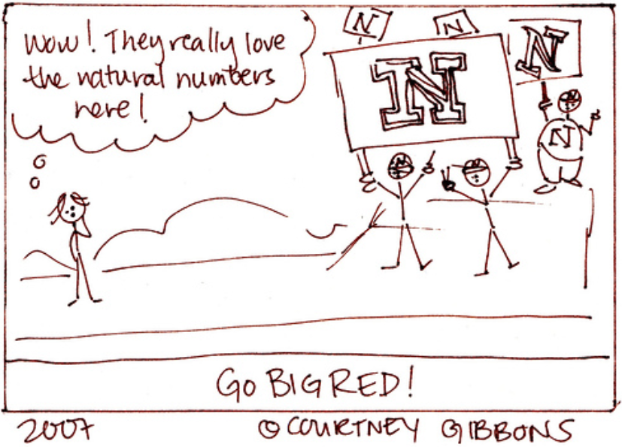

Write direct proofs for each of the following, inserting parenthetical remarks to explain the rationale behind each step.
- Prove that if n is even, then so is n^{2,} and if n is odd, then so is n².
- Prove that the sum of two odd numbers is even.
- Prove that the sum of two even numbers is even.
- Prove that the sum of an even number and an odd number is odd.
- Prove that the product of two odd numbers is odd.
- Prove that the product of an even number and any other number is even.
- Let a, b, c be integers. Prove that if a|b and b|c, then a|c.
- Prove that x is odd if and only if |x| is odd.
- If x and y are integers and x² + y² is even, prove that x + y is even.
- Let n be any integer. Prove that n² + 3n + 4 is even. Hint: consider cases.
- Prove that if $n∈N, then 1+{\left(-1\right)}^{n}\left(2n-1\right) is a multiple of 4.$ Hint: Use cases.
- Prove that every multiple, k, of 4 can be expressed as $1+{\left(-1\right)}^{n}\left(2n-1\right)$ for some positive integer n. Hint: use 3 cases depending on the sign of k.
- Prove that if two integers have opposite parity, then their sum is odd.
- Prove that if n is the form 3K + 1, then n² is of the form 3L + 1.
- Prove that if n is the form 5K + 3, then n² is of the form 5L + 4.
- Let n be larger than 6. Prove that n² – 25 cannot be prime.
- Let a, b, c, d $∈Z$. Prove that if a|b and c|d, then ac|bd.
- Let n be an integer larger than 3. Then n³ – 8 cannot be prime.
- Prove that the geometric mean of any two positive real numbers is less than or equal to its arithmetic mean. Hint: Begin with (a – b)² ≥ 0.
- Prove that if n is odd, then n³ is odd.
- Prove that if two integers have opposite parity, then their product is even.
- Let a, b, c be integers. Prove that if a² | b and b³|c, then a⁶|c.
- Let x and y be real numbers. Prove that if x² + 5y = y² + 5x. Prove that either x = y or x + y = 5.
- Let m and n be integers. Prove that if m and n are perfect squares, then mn is also a perfect square.

The theory of Numbers has always been regarded as one of the most obviously useless branches of Pure Mathematics. The accusation is one against which there is no valid defense, and it is never more just than when directed against the parts of the theory, which are more particularly concerned with primes. A science is said to be useful if its development tends to accentuate the existing inequalities in the distribution of wealth, or more directly promotes the destruction of human life. The theory of prime numbers satisfies no such criteria. Those who pursue it will, if they are wise, make no attempt to justify their interest in a subject so trivial and so remote, and will console themselves with the thought that the greatest mathematicians of all ages have found it in it a mysterious attraction impossible to resist.

- G. H. Hardy from a 1915 lecture on prime numbers

