Class discussion: 22 October 2019

Proof by contrapositive
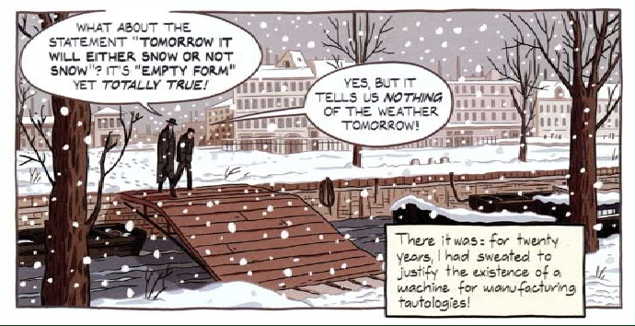
- Attention! Read and reread daily, Writing Proofs, pg 133 – 135.
Review of Direct Proofs:
Write direct proofs for each of the following, inserting parenthetical remarks to explain the rationale behind each step.
- Prove that if n is the form 3K + 1, then n² is of the form 3L + 1.
- Prove that if n is the form 5K + 3, then n² is of the form 5L + 4.
- Let n be larger than 6. Prove that n² – 25 cannot be prime.
- Let a, b, c, d $∈Z$. Prove that if a|b and c|d, then ac|bd.
- Let n be an integer larger than 3. Then n³ – 8 cannot be prime.
- Prove that if n is odd, then n³ is odd.
- Let a, b, c be integers. Prove that if a² | b and b³|c, then a⁶|c.
- Let x and y be real numbers. Prove that if x² + 5y = y² + 5x
then either x = y or x + y = 5.
- Let m and n be integers. Prove that if m and n are perfect squares, then mn is also a perfect square.

Prove each of the following by the contrapositive method.
- If x and y are two integers for which x + y is even, then x and y have the same parity.
- If x and y are two integers whose product is even, then at least one of the two must be even.
- If x and y are two integers whose product is odd, then both must be odd.
- If n is a positive integer of the form n = 3k + 2, then n is not a perfect square.
- Let x$∈Z. If x^{2}-6x+5 is even, then x is odd.$
- Let x$, y∈Z. If 7∤xy, then 7∤x and 7∤y.$
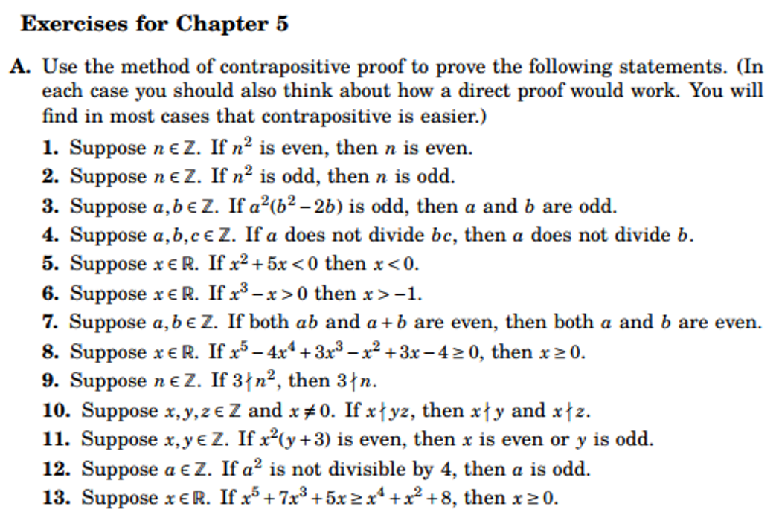
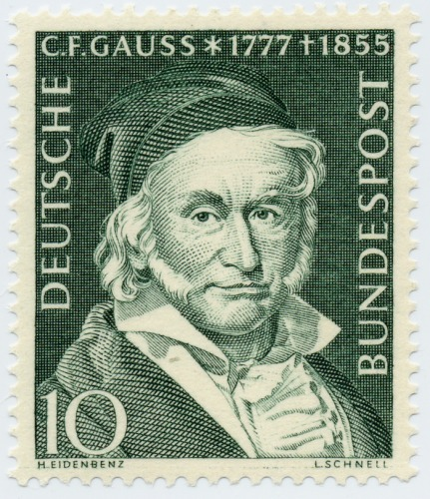
Johann Carl Fredrich Gauss (1777–1855) introduced modular arithmetic.

MODULAR ARITHMETIC: Define a ≡ b mod m (for m > 0). Show that this is an equivalence relation on the set of integers, Z. In the following, assume that a, b, c, d, m are integers and that m > 0.
    - Show that if a ≡ b mod m, then
      - a + c ≡ b + c mod m
      - a – c ≡ b – c mod m
      - ac ≡ bc mod m
    - Show that if ac ≡ bc mod m (and c is not 0) then it need not follow that a ≡ b.
    - Show that if d = gcd(c, m) and ac ≡ bc mod m, then a ≡ b mod m/d.
    - Show that as a special case of the above we have:
If c and m are relatively prime and ac ≡ bc mod m, then a ≡ b mod m.
    - Suppose that a ≡ b mod m and c ≡ d mod m. Prove that:
- a + c ≡ b + d mod m
- a – c ≡ b – d mod m
- ac ≡ bd mod m
    - Define addition and multiplication in Z₄ and in Z₅.
    - Using modular arithmetic,
- find the remainder when 2¹²⁵ is divided by 7.
- find the remainder when (4¹⁹)(7⁹⁹) is divided by 5.

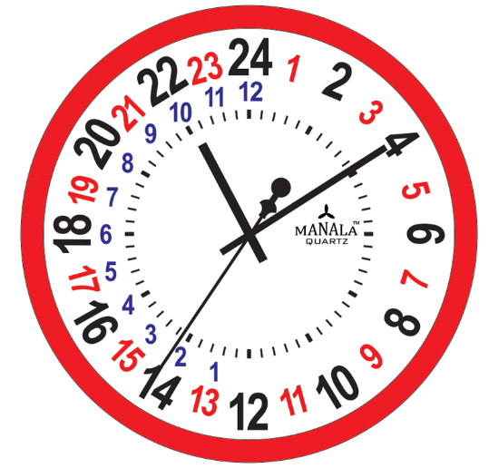The 24-hour time system has its origins in the Egyptian astronomical system of decans and has been used for centuries by scientists, astronomers, navigators, and horologists. In East Asia, time notation was 24-hour before westernization in modern times. Western-made clocks were changed into 12 dual-hours style when they were shipped to China in the Qing dynasty. There are many surviving examples of clocks built using the 24-hour system, including the famous Orloj in Prague, and the Shepherd Gate Clock at Greenwich.
(Wikipedia)

