# Class discussion: 10 September 2019

# First-order Predicate logic

# Existential and Universal Quantifiers

*Once master the machinery of Symbolic Logic, and you have a mental occupation always at hand, of absorbing interest, and one that will be of real use to you in any 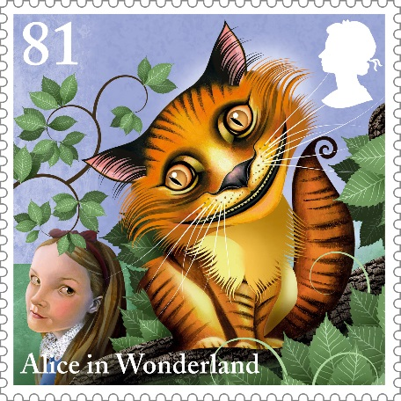subject you may take up. It will give you clearness of thought - the ability to see your way through a puzzle - the habit of arranging your ideas in an orderly and get-at-able form - and, more valuable than all, the power to detect fallacies, and to tear to pieces the flimsy illogical arguments, which you will so continually encounter in books, in newspapers, in speeches, and even in sermons, and which so easily delude those who have never taken the trouble to master this fascinating Art.*

- [Lewis Carroll (Charles Lutwidge Dodgson)](https://www.britannica.com/biography/Lewis-Carroll)

*Definitions:* A **predicate** is a proposition whose truth depends upon the value of one or more variables. For example, consider “*n* is odd.” The predicate is true for n = 1789 but not for n = 1492.

If this predicate is named *P*, we could write P(n) = “n is an odd number.” Often the predicate is true for some values of *n* but not for all values. In general, we must specify our “**universe of discourse**” (or *domain*) of possible *n*.(For example, real numbers, integers, rational numbers, complex numbers, odd numbers, prime numbers, students at Loyola University Chicago.)

How would we describe the following predicate P = “n is a perfect square”?

Certainly this is true for some positive integers but not for all.

Quantification expresses the extent to which a predicate is true over a universe of discourse.

If the predicate is true *for at least one* positive integer *n*, we introduce an *existential quantifier*:

Let S (the universe of discourse) be the set of all positive integers.

$∃n∈S P(n)$

If a predicate is true *for all values* of *n*, we use a *universal quantifier*:

Let *T* (the universe of discourse) be the set of all positive odd integers. Let *Q* be the predicate “n2 is odd.” Then

$∀n∈T Q(n)$

1. Employing existential and/or universal quantifiers (∃ or ∀), convert each statement into one that uses quantifiers. Assume that *X*, *A*, *B*, *C,* are sets.
2. For every *x* in *A,* there exists a *y* in *B* satisfying the condition that 3*x* > *y*.
3. For all *x* in *A* and all *y* in *B* there exists a *z* in *C* satisfying the condition *x* < *z* < *y*.
4. For each *a* in
5. *A* there is a *b* in *B* such that, for every *c* in C, *c* > *a*+*b*.
6. There exists an *x* in *X* such that for all *y* in *A* there exists a *z* in *B* such that

*x < z < y*.

1. For every *p* in *A,* there exists a *q* in *B* such that for all *r* in X

either *r* < 3*p* or *r* > 5*q*.

1. Translate each of the following into an English sentence.

$∀x∈R ∀ε>0 ∃r∈Q \left|x-r\right|<ε$

1. 
2. 
3. 
4. Let variables x, y, z denote people at Loyola University Chicago. Let *L* be the predicate L(x, y) = “x loves y.”

Translate each of the following statements into a logical statement.

1. Swann loves himself.
2. Everybody loves Albertine.
3. There is someone whom Albertine doesn’t love.
4. Albertine loves no one.
5. Everybody loves someone.
6. There is someone whom everybody loves.
7. There is someone whom no one loves.
8. There is someone who loves everybody.
9. There is no one who loves everyone.
10. There is no one who loves no one.

**IV**  Translate from English into 1st order predicate calculus. Define an appropriate universe of discourse.

1. There is a math major who is not a biology major.
2. There is a student who likes to swim but dislikes skiing.
3. There is a student who loves *Stranger Things* but dislikes *Black Mirror.*
4. There is a student who likes either to kayak or to compete in half marathons but not both.
5. There is a student who likes Joyce Carol Oates and Clive Barker but not Sir Arthur Conan Doyle.
6. Every Actuarial Science minor plans to become an Actuary.
7. Not every Actuarial Science minor plans to become an Actuary.

**V** Translate the following from natural language into an appropriate logical statement. Let the universe of discourse, S, be the set of all positive integers.

1. If *n* is even then *n3* is even.
2. If *n* is an odd number, then *n* *+ 2* is also odd.
3. If *n* is a perfect square, then *5n* is a perfect square.
4. If *n* is a multiple of 8, then *n* is a multiple of 16.
5. If *n* is a multiple of 9, then *n* is a multiple of 3.

**VI** Explain why the following are equivalent:

 and 

Analogously,  and  are equivalent.

Give examples from natural language.

**VII** Distribute the negation through each of the following statements.

1. 
2. 
3. 
4. 
5. 
6. 

**VIII**

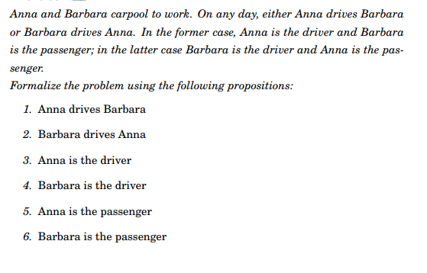

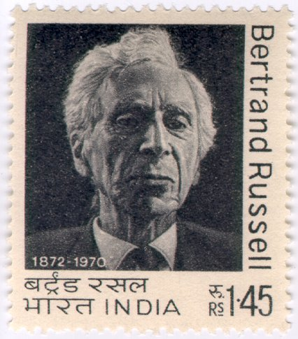[Bertrand Russell](http://plato.stanford.edu/entries/russell), British philosopher, logician, essayist, and social critic, is perhaps best known for his work in mathematical logic and analytic philosophy[. Friedrich Ludwig](http://plato.stanford.edu/entries/frege) [Gottlob Frege](http://plato.stanford.edu/entries/frege)'s earlier treatment of quantification went mostly unnoticed until Bertrand Russell's 1903 **Principles of Mathematics**.

**REVIEW problems from Hammack:**

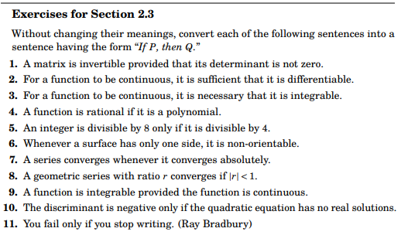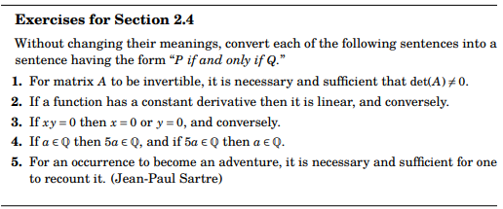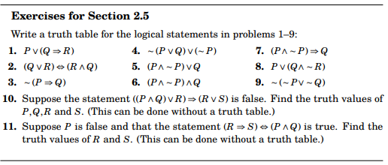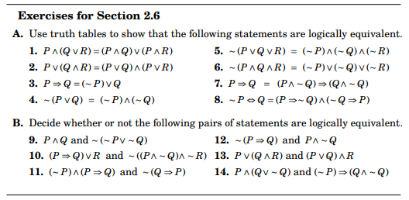

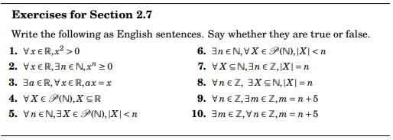

[Course Home Page](http://www.math.luc.edu/~ajs/courses/fall2019/201/index.pdf) [Department Home Page](http://www.math.luc.edu/) [Loyola Home Page](http://www.luc.edu/)