Class discussion: 17 September 2019

Counting: an introduction

- What is the multiplication principle? How many 3-character license plates can be manufactured if the first character is any upper-case letter, the second character is a vowel, and the third character is one-digit integer?
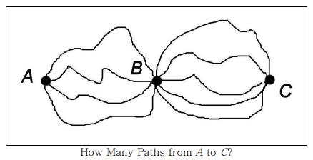
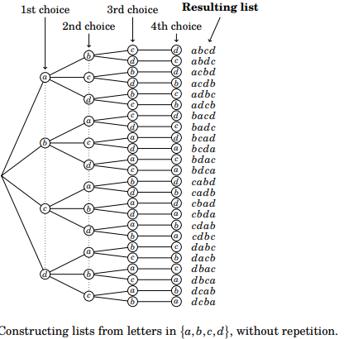

- State the addition and subtraction principles.

- (a) How many words of length 4 can you create using the letters a, b, c, and d?
(b) What if no letter in the word can be repeated?
(c) What if one letter is to appear exactly 3 times?
(d) What if no letter can appear 4 times?

4. Same question as exercise 3, but this time we have four letters {a, b, c, d} in our alphabet.

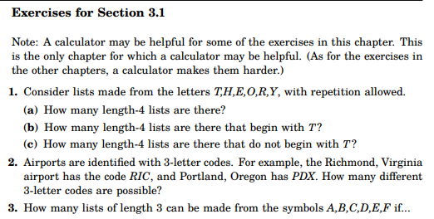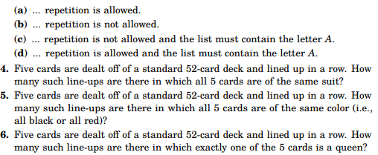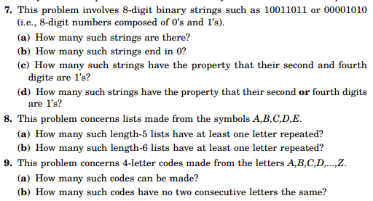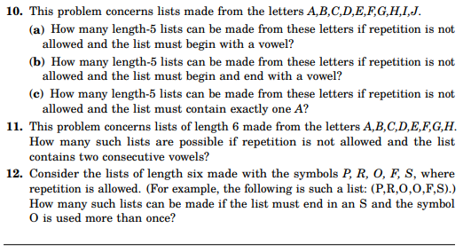

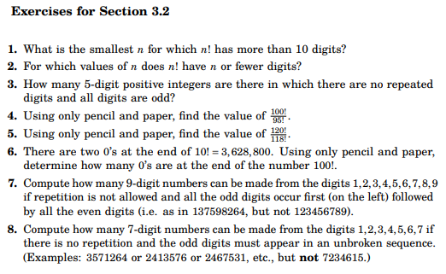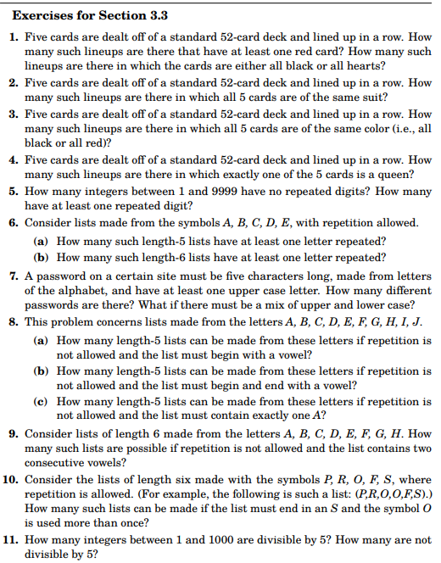

Combinatorics exercises: Stephan M. Wagner
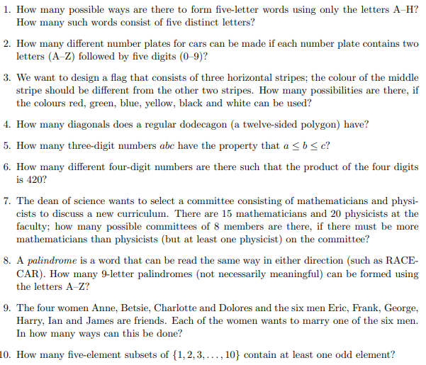

How many really basic mathematical objects are there? One is surely the `miraculous' jar of the positive integers 1, 2, 3 . . . Another is the concept of a fair coin. Though gambling was rife in the ancient world and although prominent Greeks and Romans sacrificed to Tyche, the goddess of luck, her coin did not arrive on the mathematical scene until the Renaissance. Perhaps one of the things that had delayed this was a metaphysical position which held that God speaks to humans through the action of chance. . . . The modern theory begins with the expulsion of Tyche from the Pantheon. There emerges the vision of the fair coin, the biased coin. This coin exists in some mental universe and all modern writers on probability theory have access to it. They toss it regularly and they speculate about what they 'observe.'

- Philip Davis & Reuben Hersh, The Mathematical Experience

Course Home Page Department Home Page Loyola Home Page

